Michigan Wheat Program Final Report

Title: Winter Wheat Herbicide Effects on Cover Crop Establishment - Year 2
MWP Project #: 20-08-06-BS
MSU PD#: 46812
Researcher: Christy Sprague, Professor and Extension Specialist
Claudia Walz, M.S. Graduate Student
Plant, Soil and Microbial Sciences, Michigan State University,
517/353-0224, sprague1@msu.edu
Date: March 1, 2023

Project goals and values for Michigan Wheat Growers: This research is being used to develop recommendations on what cover crops can be safely planted following applications of herbicides commonly used in Michigan winter wheat production. These recommendations will help ensure the successful of establishment of cover crops that can be used to improve soil health, organic matter, and fertility, while reducing soil erosion, disease and insect pressure, suppressing weeds, that ultimately lead to increases in crop yield. This project fits with the Michigan Wheat Program’s priorities to:
- study the use and benefits of cover crops.
- evaluate opportunities for double cropping (i.e., cover crops).
- evaluate the efficacy of fungicides, herbicides, and insecticides.

RESULTS OF PROJECT:
Cover crops have been shown to benefit cropping systems through erosion protection, nutrient mineralization, increased nitrogen availability (legume covers), suppression of plant pathogens and weeds, improved soil health, and beneficial insect attraction. Planting cover crops after wheat harvest provides farmers with an excellent opportunity to include cover crops into their crop rotation. One of the areas of cover crop information that is currently lacking is the tolerance of cover crops to herbicides. If a cover crop is sensitive to herbicide residues from applications in the previous crop the cost to a grower can be high, including seed costs and the benefits that the cover crop would have provided to the cropping system. Therefore, the objective of this research was to: Evaluate the effects of commonly used wheat herbicides on cover crop establishment and growth following winter wheat harvest.

A field experiment was established by planting winter wheat in the falls of 2020 and 2021 at three field locations, the MSU Agronomy Farm (MSUEL), the Kellogg Biological Station (KBS), and at the Saginaw Valley Research and Extension Center (SVREC). In the spring, wheat was sprayed in April when wheat was between Feekes stages 4 and 5, with nine different herbicide treatments, including the untreated control. Throughout the growing season wheat was evaluated to determine if there are any unforeseen injury issues with any of the herbicide treatments. Wheat was harvested from studies where injury was significant. After harvest, nine different cover crop species were no-till drilled into winter wheat stubble in late-July between 85-118 d after application of nine different spring wheat herbicides. These cover crops were evaluated for establishment and injury at three different locations with sandy clay loam, loam, and clay loam soils. Precipitation ranged between 4.78 to 15-inches between herbicide application and cover crop planting. In late fall, prior to the first frost, two 0.25 m² samples of each cover crop plot were evaluated for injury, counted for establishment, and harvested for above ground biomass.

Although not the major objective of this experiment, in 2021 significant wheat injury was present at MSUEL, with the greatest injury from a spring application of Osprey Xtra of 25%, 14 DAT. This injury persisted throughout the growing season. Wheat injury from Affinity BroadSpec, PowerFlex HL, and Axial Bold was also present at MSUEL, even though it was 10% or less and it did not persist. Wheat injury at this location was likely significant due to low day/night temperatures (<50º F) around application at MSUEL. Wheat injury from Osprey Xtra at MSUEL resulted in 23.4 bushel per acre lower yields (34%) compared with the untreated control (Figure 1). Yield was also lower with PowerFlex HL compared with the untreated control due to the cold temperatures at application.
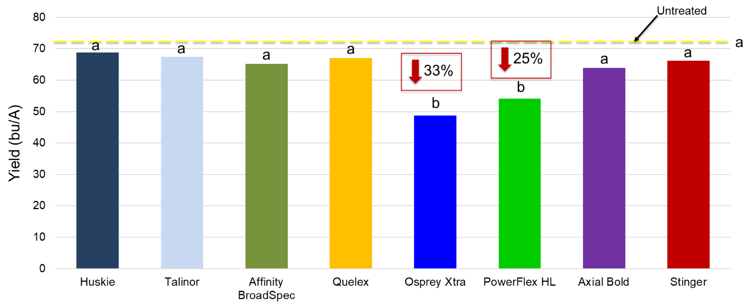
All cover crops, with the exception of Austrian winter pea in 2021 established well at all locations by 28 days after planting (DAP) (Figure 2).
Figure 1. Wheat yield at MSUEL compared with the untreated control. Temperatures less than 50% were present at herbicide application.
Figure 2. Establishment of 9 different cover crops, 28 DAP.
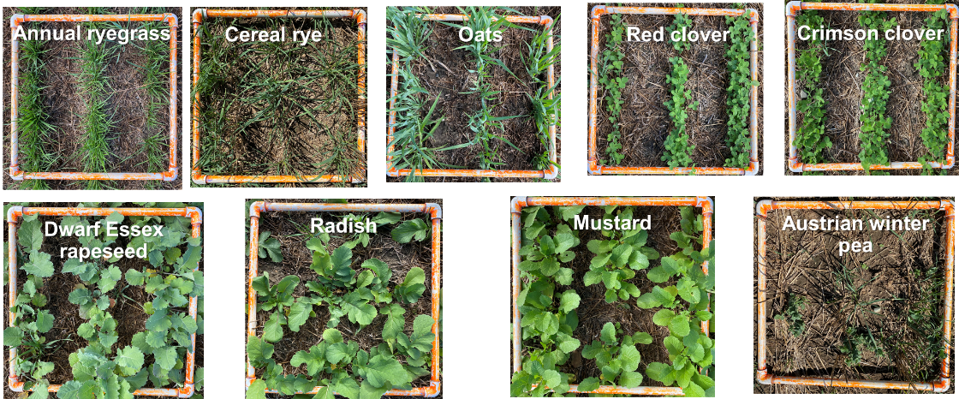

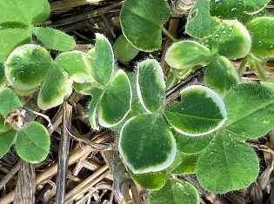
Across the 6 site-years there was less than 10% injury, no reductions in stand, or end of the season biomass for annual ryegrass, oat, cereal rye, mustard, radish, dwarf Essex rapeseed, and crimson clover. Huskie injury to red clover, 4 weeks after seeding, ranged from 0 to 40% across the 6 site-years. Injury consisted of bleaching around the outer leaf edges (Figure 3). This injury did not result in any reductions in stand or final biomass. Huskie, Talinor, and Affinity BroadSpec applications caused injury to winter pea 4 weeks after seeding, but there was not an effect on final biomass.
Figure 3. Clover injury 28 d after planting from Group 27 herbicides.
Table 1 provides our current recommendations for planting cover crops after winter wheat herbicide applications after two years of research.

Table 1. Cover crops that can be safely planted after wheat harvest when various herbicides are spring-applied. Data is from two years. This research is being repeated in 2023.
Herbicide | Annual ryegrass | Cereal  rye | Oats | Crimson clover | Red  clover | Oilseed radish | Mustard Caliente | Dwarf Essex rapeseed | Austrian winter pea²
Axial Bold | Y¹ | Y | Y | Y | Y | Y | Y | Y | Y
Talinor | Y | Y | Y | Y | Y | Y | Y | Y | C
Huskie | Y | Y | Y | Y | C | Y | Y | Y | C
Affinity BroadSpec | Y | Y | Y | Y | Y | Y | Y | Y | C
Osprey² | Y | Y | Y | Y | Y | Y | Y | Y | Y
Osprey Xtra | Y | Y | Y | Y | Y | Y | Y | Y | Y
PowerFlex HL | Y | Y | Y | Y | Y | Y | Y | Y | Y
Quelex | Y | Y | Y | Y | Y | Y | Y | Y | Y
Stinger | Y | Y | Y | Y | Y | Y | Y | Y | Y
¹ Y = Yes cover crop can be seeded with no injury or impact on biomass; C = Caution should be taken with seeding (injury between 20%-50%; but no impact on biomass); N = No do not seed (injury > 50% or significant biomass reduction).
² Osprey and Austrian winter pea data are only from 2022.

SUMMARY OF PROJECT:
Planting cover crops after wheat harvest provides farmers with an excellent opportunity to include cover crops in their crop rotation and can also broaden the spectrum of cover crop species that can be seeded. Cover crops can improve soil health, organic matter, and fertility; reduce soil erosion; suppress weeds; reduce disease and insect pressure; and some cover crops can provide N credits for the following crop. All these benefits can ultimately lead to increased crop yields. Spring herbicide applications in winter wheat are commonly used to manage weeds. However, wheat herbicides applied in the spring may limit establishment and growth of different cover crop species. Currently, there is little to no information available on the tolerance of several of these cover crop species seeded after winter wheat harvest to spring applied wheat herbicides. This lack of information leads us to the question, “If I apply ‘X’ wheat herbicide, what cover crops can I safely plant after wheat harvest?”. Understanding the tolerance of various cover crop species to commonly applied wheat herbicides will benefit Michigan wheat farmers’ overall cropping system. To date, after two years of research over three locations with adequate rainfall we have found that Austrian winter pea can be difficult to establish, and that caution should be taken when planting red clover after Huskie applications or Austrian winter pea after application of Talinor, Huskie, and Affinity BroadSpec in winter wheat. We are currently continuing this research to get additional data under different conditions to strengthen our recommendations. These recommendations will help ensure the successful of establishment of cover crops that can be used to improve soil health, organic matter, and fertility, while reducing soil erosion, disease and insect pressure, suppressing weeds, ultimately leading to increases in crop yield. Results from this research will be added to the MSU Weed Control Guide for Field Crops (E-434), continue to be presented at extension meetings, and posted on www.MSUweeds.com.

FUTURE WORK:
We plan to repeat this experiment at three locations in 2023. This information has been and will continue to be used for future extension meetings and recommendations that will be included in the MSU Weed Control Guide for Field Crops.

PROJECT CHANGES:
None requested.

BUDGET NARRATIVE:
On track.

INTELLECTUAL PROPERTY:
None developed.

APPROACH TO DISSEMINATE RESEARCH:
This research will be used to continue to examine wheat tolerance to commonly used herbicides and develop recommendations on what cover crops can be safely planted following these wheat herbicide applications. These recommendations will help ensure the successful of establishment of cover crops that can be used to improve soil health, organic matter, and fertility, while reducing soil erosion, disease and insect pressure, suppressing weeds, ultimately leading to increases in crop yield. This information will be shared with Michigan wheat farmers and will be included in the Michigan Weed Control Guide for Field Crops (E0434). Research data and resulting recommendations will be presented at extension meetings, MWP summer field day, in newsletter articles (i.e., Wheat Wisdom), and included in a factsheet on cover crop tolerance to winter wheat herbicides, and on the web at www.msuweeds.com. Additionally, when the research is completed, we will write a peer-reviewed manuscript for Weed Technology to communicate with the Weed Science discipline.

