Final Report for: Sustainable Intensification of Wheat Production in Michigan: Field Trials and Simulation Approaches
MWP Tracking Number: 23-08-01-AS
MSU Number (optional):
Researchers: Dr. Bruno Basso
Date: 12/23/2024

Project goals and value for Michigan Wheat Growers
This project focused the continued effort by the Basso Lab in using a novel suite of geospatial technologies to simulate wheat production and assess the environmental and economic impact on Michigan farms.

Results of Project
Yield responses from variable rate nitrogen (VRN) prescriptions reveal that through a novel approach combining historical cropping yields, remotely sensed imagery, and process-based crop simulation modeling, VRN prescriptions can reduce wasted nitrogen by meeting crop demand with the right amount at the right time. By continuing to focus on sustainable intensification, Michigan wheat growers can maximize yields with smart applications of fertilizer during spring green-up and top-dress timings.

One Paragraph Summary of the Project
Enhancing efficiencies for Michigan farmers to produce more with fewer resources is often promoted as the key to maximizing profitability. While it’s true that higher yields directly contribute to increased profits, achieving those yields is more complex than previously believed. Traditional agronomic practices, such as increasing nitrogen fertilizer, applying fungicides and growth hormones, and following early planting recommendations, are well-researched and documented. However, the most significant factor influencing maximum yield potential in wheat remains beyond the farmer’s control: mother nature. To mitigate the risk that each year brings, making more informed decisions from on-farm precision data can help guide for future management decisions. It is understood that farmers are continually bombarded and overwhelmed each season with fancy new trends and gimmicks, therefore devoting time to catalog, process, and implement these recommendations is a challenge. The data gathered from this proposal drives a new goal in developing a platform that serves as a place where these data can be delivered as a turn-key solution to Michigan farmers.

Recommendations from Project
The creation of yield stability maps from historical grain yield production has been a well-documented method into delineating zones of stable and unstable yields across these fields.

Future Work
Additional work for this project will focus on increasing participation of farmers to share their geospatial data layers and develop more nitrogen prescriptions across Michigan.

Results of Project
The project aims to assess spatial and temporal variability in crop yields that lead to tailored variable rate nitrogen prescriptions sent to the farmer, improving nitrogen use efficiency. Prior to the VRN prescription creation, the SALUS crop model was used to determine the possible effects of varying N rates on wheat yields. The SALUS crop model used to simulate potential weather and nitrogen scenarios given a set of management parameters specific to each farm and field. Farmers must provide management details to fully understand the crop’s nitrogen demand at the optimal application time. Knowing the nitrogen applied at planting, early top-dress, and green-up is essential for accurate prescription creation.

Included in the process is using on-farm precision ag data from combine grain yield monitors to delineate productivity zones based on historical production. These data inform the producer areas where historical production has been in high and stable, medium and stable, low and stable, and unstable yielding zones. Further investigation of the historical yields in these zones give indications of minimum, maximum, and mean yields by crop each year where yield data is available (Table 1a-1c). In Brewbaker (1a), 2014 showed to have the lowest yields across each yield stability zone while most of the zones had their highest yields in 2020. In Frost (1b), the trend showed the lowest and highest yields came in 2015 and 2016, respectively. At 105 (1c), the highest yields were found across all zones in 2017 while most of the lowest yields were observed in 2024.

County | Field | Crop | Year | Low and Stable | Medium and Stable | High and Stable | Unstable
Ingham | Brewbaker | Wheat | 2011 | 69.7 | 79.7 | 85.9 | 73.4
Ingham | Brewbaker | Wheat | 2014 | 51.4 | 62.3 | 70.8 | 52.9
Ingham | Brewbaker | Wheat | 2020 | 67.4 | 85.9 | 90.7 | 78.6
Ingham | Brewbaker | Wheat | 2022 | 52.5 | 79.7 | 90.5 | 63.7
Minimum |  |  |  | 51.4 (2014) | 62.3 (2014) | 70.8 (2014) | 52.9 (2014)
Maximum |  |  |  | 69.7 (2011) | 85.9 (2020) | 90.7 (2020) | 78.6 (2020)
Mean |  |  |  | 60.3 | 76.9 | 84.5 | 67.2
Table 1a. Brewbaker wheat yields.
Ingham | Frost S | Wheat | 2011 | 75.5 | 86.1 | 94.5 | 85.1
Ingham | Frost S | Wheat | 2013 | 69.5 | 85.2 | 93.2 | 79.0
Ingham | Frost S | Wheat | 2015 | 47.2 | 55.5 | 60.7 | 45.6
Ingham | Frost S | Wheat | 2016 | 89.1 | 114.8 | 128.8 | 99.8
Ingham | Frost S | Wheat | 2019 | 55.5 | 73.0 | 82.1 | 56.8
Ingham | Frost S | Wheat | 2022 | 63.1 | 85.7 | 98.7 | 72.3
Minimum |  |  |  | 47.2 (2015) | 55.5 (2015) | 60.7 (2015) | 45.6 (2015)
Maximum |  |  |  | 89.1 (2016) | 114.8 (2016) | 128.8 (2016) | 99.8 (2016)
Mean |  |  |  | 66.6 | 83.4 | 93.0 | 73.1
Table 1b. Frost S wheat yields.
Jackson | 105 | Wheat | 2017 | 82.6 | 101.5 | 112.2 | 85.2
Jackson | 105 | Wheat | 2021 | 57.4 | 76.0 | 86.0 | 77.7
Jackson | 105 | Wheat | 2024 | 61.0 | 74.6 | 82.1 | 73.0
Minimum |  |  |  | 57.4 (2021) | 74.6 (2024) | 82.1 (2024) | 73.0 (2024)
Maximum |  |  |  | 82.6 (2017) | 101.5 (2017) | 112.2 (2017) | 85.2 (2017)
Mean |  |  |  | 67.0 | 84.0 | 93.4 | 78.6
Table 1c. 105 wheat yields.
These trends stress that wheat yields across the zones were more influenced by time (weather during the growing season) than they were by space (areas across the field). It is also important to note that the mean is consistent across each field where lowest yields were in the low and stable zones, the medium yields were found in the medium and stable, and the highest yields were found in the high and stable zones.

Variable rate nitrogen prescriptions were sent as generic shapefiles to participating cooperators that implemented the prescription in coordination with the Basso Lab procedure that allocates N in accordance results obtained through an analysis including the yield stability map, remotely sensed imagery, and results from crop simulation modeling. Figure 1 illustrates how yield history, summarized through the yield stability map (left) serves as a key factor in forming the prescription map (center). Finally, the yield map (right) reveals the pockets of higher (blue/green) and lower yields (yellow/red) match the spatial patterns from the yield stability map.

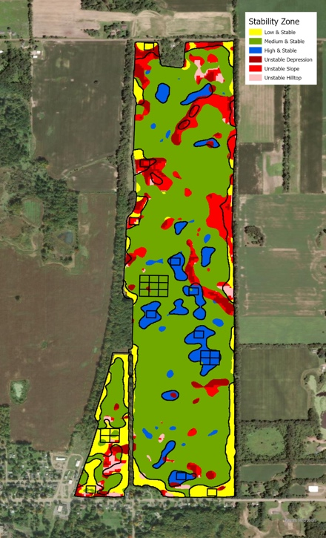 | 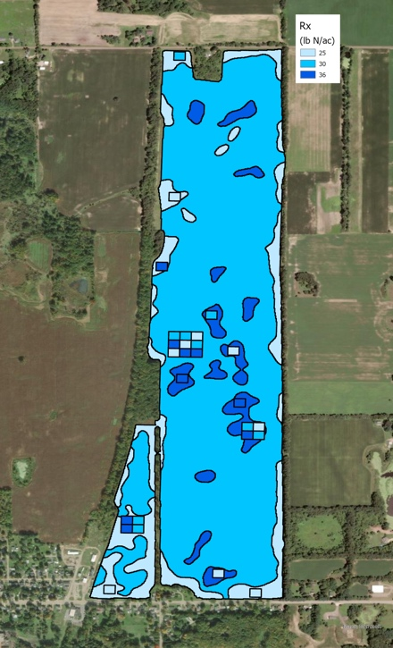 | 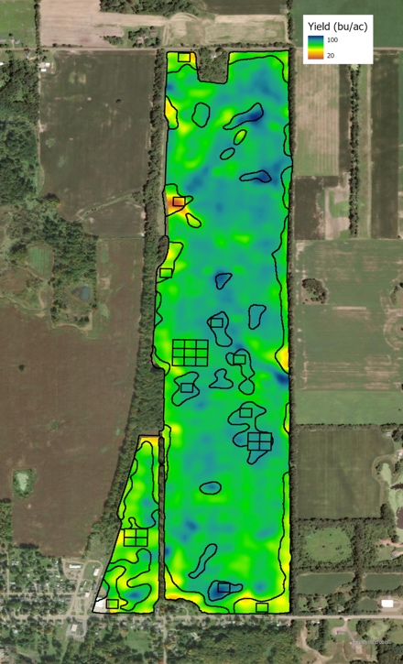
Figure 1. Yield stability map, variable rate nitrogen prescription (Rx) in wheat, and 2024 yield map.
Further analysis of wheat yields at 3 nitrogen rates (low, medium, high) indicates a trend of increasing yields across each yield stability zone (low-stable, medium-stable, high-stable) (Figure 2). The highest wheat yields were in the high and stable yield zones.

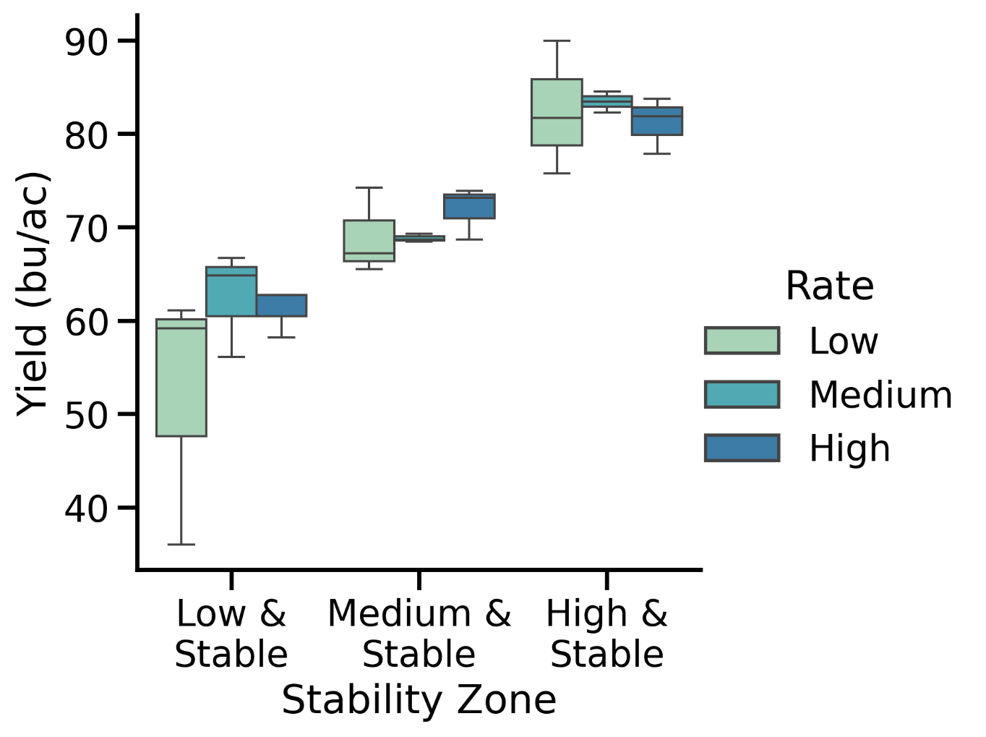
Figure 2. Boxplots of wheat yields at 3 nitrogen rates across 3 yield stability zones in 2024.

