Strategic and Tactical N Management Using Drone Images and Crop Modeling To Increase Protein Content and Grain Quality In Wheat

Dr. Bruno Basso
Dept. Earth and Environmental Sciences
Michigan State University

Rationale

Wheat grain protein content is a critical component of wheat quality. Nitrogen is a fundamental component of amino acids, which are the building blocks of grain protein. To achieve higher protein the quantity and timing of N application is extremely important. The early application of N allows to set yield levels, whilst late applications are more advisable to increase protein content. Grain protein with optimum N for yield in wheat is between 11 and 12 % protein but it needs extra nitrogen to achieve protein content greater 13%. Sulphur is also a major component of proteins and is therefore important in protein quantity and quality.
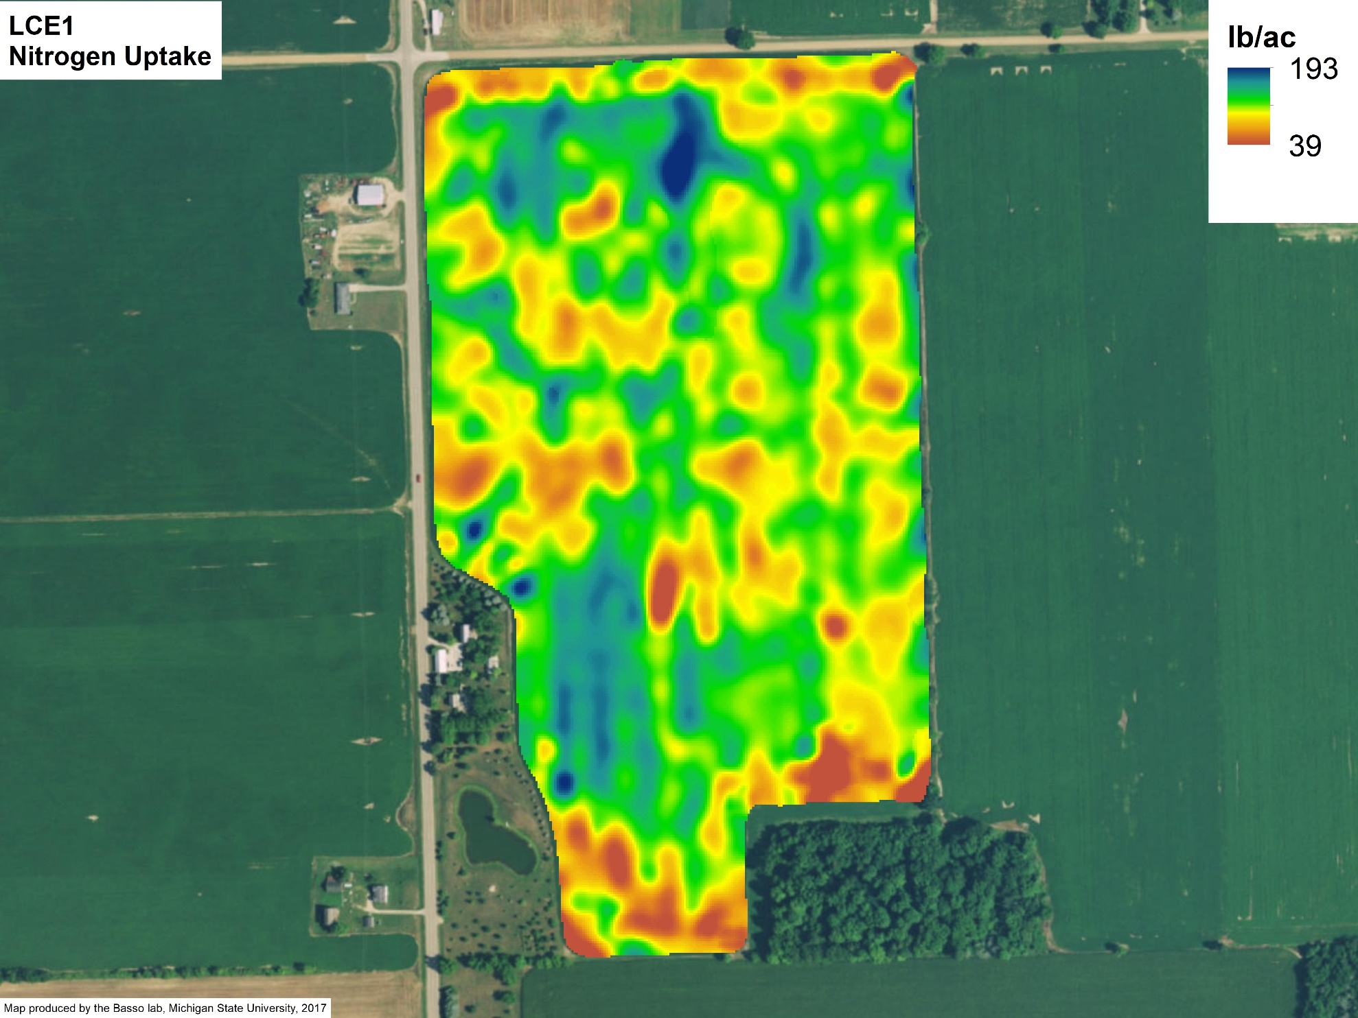
Wheat proteins vary spatially due to the inherent variability of soil properties and position in the landscape (Fig 1). The Basso Lab has been looking at N management over space and time with the support of the Michigan Wheat Program for the last three years now. During these years, results have shown that wheat yields are spatially variable and the variability associated with wheat yield causes N uptake to different within the same field, making a spatially uniform application of N fertilizers excessive in some areas and limited in others. Several studies have looked at N dynamics in wheat systems, but no studies hitherto have accounted for spatial and temporal variation using remote sensing technologies (satellite, airborne, drone) and dynamics crop modeling linked to the current weather during the study period to tactical management beside the initial work of Basso et al., 2011 and Dumont et al., 2016. With the advancements in remote sensing technologies, we can achieve a better understanding of field variability in real-time and apply this knowledge to make smarter N management decisions to increase yield where possible or grain quality.
Figure 1. Spatial variability of N uptake in wheat. To obtain grain protein we need to multiply the N% in the grain by 5.8.

Objectives

The focus of this year’s project is to develop a protocol that can be adopted by any farm that uses Precision Agriculture technologies to increase protein content, reduce N loss and were possible increase grain yield.
The protocol consists in first understanding yield variability by creating stability maps from yield monitor data available at the farm. The stability map separates the areas of the field that yield constantly higher than others from areas that are constantly low or from areas that fluctuate from high to low or vice versa. The stability maps are very useful because they show the consistency of spatial patterns over time and using plants as indicator is better approach than soils maps, which often do not correlate with yield maps. Our specific goal is to monitor the change of wheat crops at field level with different remote sensing technologies to better capture the interaction between soil, plant, management and position in the landscape in order to match the N supply with N demand in a strategic and tactical approach to tailor N amounts to avoid N loss, increase net revenue and increase grain quality.
Methodology
The methodology of this project is strongly characterized by integration of approaches spanning from field observation and data collection, geospatial analysis of historical information, remote sensing images analysis and interpretation, and dynamic process based crop simulation modeling and forecast of crop grain quantity and quality.
Task 1. Historical Yield Analysis
The selected fields will be analyzed using methods developed by the Basso Lab to determine yield stability zones. The procedure consists in developing stability maps of fields using yield maps and other layers of data.
Task 2. Image Analysis of Spatial and Temporal Change
Remote sensing images of the selected fields will be analyzed to understand temporal variability from images within the same growing season and spatial variability from how each zone relates to one another in the same field.
Task 3. In-season Crop Modeling
Input of the current management practices assist the model in simulating the actual growth and development of the wheat crop to provide a snapshot of the variability in the growing season to an exact date. Negative or positive yield potential can be noted early enough to make an informed N application decision in order to achieve a higher Nitrogen Use Efficiency (NUE).
Task 4. Variable Rate N Experiment
Knowledge from the previous 3 tasks is combined with the farmer’s best management practices to create comparable treatments in the field.

Task 5. Field Observation
Soil samples – Fall soil samples will be taken from the field before wheat is planted to understand a baseline of current N supply in the field. Push probe samples taken before top-dress will also be taken.
Plant samples – Vegetative samples will be taken just before top-dress and ground to determine total C and total N. Samples taken just before harvest will be measured for total C and total N in both the stover and grain to understand plant N uptake.
Yield Monitoring
Combine yield monitors along with samples taken in the field using 0.25m2 clip plots.
Hand samples of grain yield will be collected across the field to measure protein content, gluten, ash, and other wheat quality parameters.
Remote sensing
Satellite, airplane, and UAVs will all be utilized in gathering imagery in different wavelengths to create vegetation indices from optical and thermal imagery.
Crop Modelling
Another tool used by the Basso lab is the use of extremely robust crop model, Systems Approach to Land Use Sustainability (SALUS) developed by Basso during the last 10 years. SALUS continues to evolve and improve. In addition to our remote sensing methods, the model can accurately be calibrated to simulate crop yields, N dynamics, water use, etc. This allows us to monitor the growth of the crop in the field and predict with high certainty the expected yield under different alternative management scenarios.
In summary, we will delineate a protocol to strategically apply the UAV sensors (thermal, laser, and multispectral) to fully exploit the advantages of the most sophisticated and reliable systems to monitor growth of wheat crops throughout the growing season over space and time. The Basso lab has recently purchased a new drone and two new sensors to expand the ability to collect more precise information on plant reflectance and temperature. The drone images will be stitched, processed and analyzed by member of the Basso Lab under Prof. Basso direct supervision.
Expected Outcomes
Improve N management to increase protein content by better matching N supply (driven by soil, and weather conditions) with N demand (assessed by drone image interpretation)

Develop a system for applying precision agriculture technologies through the integration of UAVs, crop modeling and yield mapping analysis for sustaining agricultural productivity
Quarterly Milestones
 | Q1 | Q2 | Q3 | Q4
Fly bare soil images before wheat is planted to detect soil variability and  correlate it with yield | X
Collect remote sensing and ground truth data |  | X | X
Compare Vegetation indices, algorithms to better detect N stress across the field |  | X | X
Develop and apply a predictive model linked to remotely sensed data to improve N management for higher yield and grain quality |  | X | X | X

Budget Justification
We request a total of $18,000 per year for the next three years for field technician (2.5 months/yr) and for data analyst to process and analyze the images (2.5 months/yr)
Field Technician $12,000
Data analyst $ 8,000
In-kind contribution from Basso’s lab instrumentation $100,000
Total $20,000

