Final Report for: Title: Identifying and managing Fusarium species responsible for head scab
MWP Tracking Number: 17-08-03-CS
MSU Number (optional): PD40245
Researchers: Martin Chilvers (PI), Mikaela Breunig (PhD student), Adam Byrne (technician), John Boyse (technician), Janette Jacobs (technician)
Date: December 31, 2020

Project goals and value for Michigan Wheat Growers [from original proposal]:
The goal of this project is to characterize the fungi causing head blight of wheat in Michigan. Which species and subspecies are present, which mycotoxins are they producing and what is their sensitivity to fungicides. It is important to address these questions so that we can implement the best management practices, guide research, such as using correct strains to screen for resistant breeding material, and be prepared to address shifts in the fungal populations causing disease, such as fungicide resistance or species composition changes. These shifts could result in changes on growers’ fields such as reduced fungicide efficacy or increased toxin production. Within this project we also conduct fungicide efficacy trials, trial new chemistries, and have examined the effect of agronomics on disease management.

Results of Project: 1-4 pages of text with a discussion of work completed and results obtained. Please use as many graphics as necessary to support text. Graphs, charts, pictures are not counted towards the 4 pages.

A survey was conducted to collect and determine which Fusarium species were causing wheat head scab and corn ear mold from across Michigan. The map below (Figure 1) demonstrates the approximate location of where samples were collected.

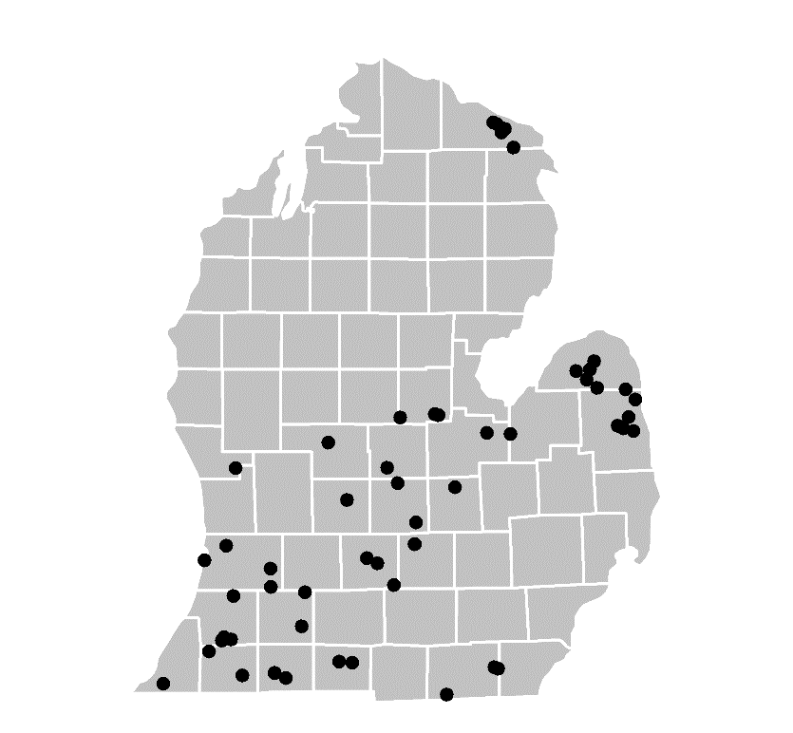
Figure 1. Map of Michigan with dots indicating approximate locations of commercial fields where isolates of F. graminearum in this study were collected.

Using colony morphology and DNA sequencing the Fusarium isolates were identified as follows (Figure 2). In contrast to the corn samples, the majority of isolates collected from Michigan wheat were Fusarium graminearum. However, there were a small portion of other species identified including F. poae, members of the Fusarium tricinctum species complex, and F. sporotrichioides. Understanding which species are present on wheat is critical to efforts of breeding wheat for FHB resistance, and understanding fungicide efficacy of FHB management.
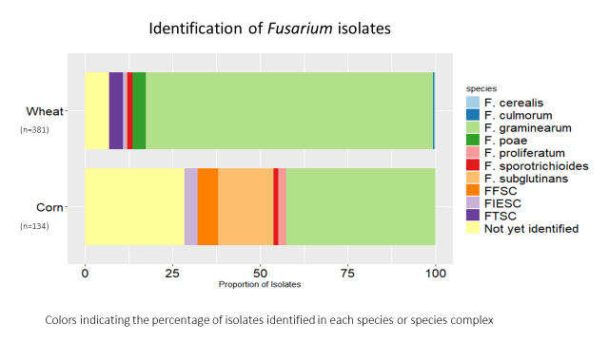
Figure 2. Fusarium species composition of isolates collected from wheat head scab (381 isolates) and corn ear mold (134 isolates).

Triazole (DMI) fungicides have been the only fungicide tool for head scab management. Michigan wheat growers can often be frustrated by the apparent lack FHB control from a fungicide application. Fungicides typically do not eliminate disease, but can be an effective tool in reducing FHB and subsequent DON accumulation. To determine if there are any fungicide resistance issues with the current triazole fungicides a lab assay was used to determine their efficacy.

All Fusarium isolates collected were screened against the three major triazole chemistries, prothioconaolze (Prosaro), tebuconazole (Tilt), and metconazole (Caramba). Initially assays were performed to determine the EC50 of 50 isolates of F. graminearum. We found that most of those 50 isolates had EC50s lower than 1ppm which means they are still very sensitive to the products. However, one isolate had an EC50 of 4ppm for tebuconazole which could be concerning. Next, we screened the rest of the 500 isolates (Figure 3). A majority of those isolates were still very sensitive to the products. There was a trend of tebuconazole being the least effective compared to prothioconazole and metconazole. Out of the 500 isolates screened, 97 had grown greater than 50% on 1ppm media. This means they could have higher EC50s and current work is investigating those further. In summary, the triazole fungicides appear to have good efficacy in reducing fungal growth in the assay, and there are no indications of widespread triazole fungicide resistance.
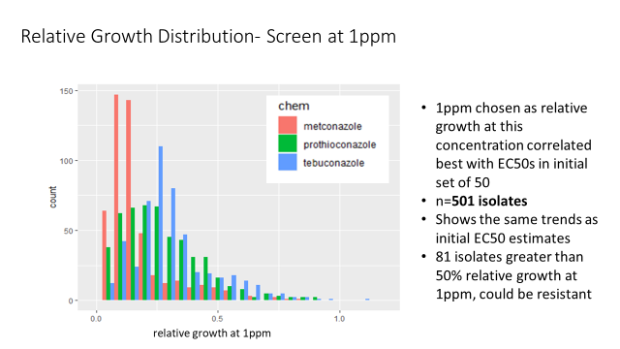
Figure 3. Fungicide sensitivity of Fusarium species collected from Michigan wheat and corn. All isolates demonstrated sensitivity to the three triazole (DMI) fungicide products tested, indicating that resistance to fungicides does not appear to be a significant concern at this time.

Syngenta recently released a new fungicide product for head scab management, Miravis Ace. The fungicide includes tebuconazole, which has been used previously for FHB management, but also a new product and chemistry class pydiflumetofen. Prior FHB management has relied on the triazole (DMI) class of fungicides. Having an additional chemistry class for FHB management may be especially important if fungicide resistance is to develop to the DMI class of fungicides.

Using the isolates collected in the above-mentioned survey a panel of 94 isolates of F. graminearum was screened for sensitivity to pydiflumetofen. All isolates appeared to be sensitive to pydiflumetofen (Figure 4), and a manuscript was published describing this study. This study represents the first such published study of F. graminearum sensitivity to this new fungicide product, and will serve as a baseline which allows for future screening for fungicide resistance development.
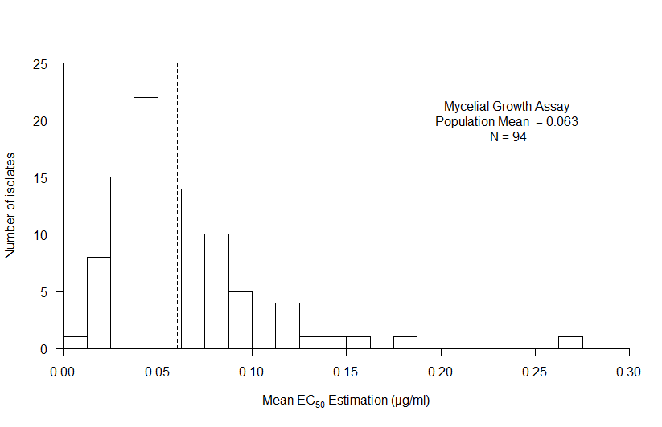
Figure 4. Distribution of mean EC₅₀ values to the novel fungicide pydiflumetofen (component of Miravis Ace) for 94 isolates of F. graminearum as determined by mycelial growth assay, with dashed line indicating the mean.

One Paragraph Summary of Project: One paragraph that details what was learned and its benefit to Michigan wheat growers. This paragraph should contain no business sensitive or confidential information and will be used to publicly describe research through our communications including our website, annual report and press releases.
The project has enabled us to determine exactly which species of Fusarium are responsible for wheat head scab and corn ear mold. This is critical to improve disease management. We found no evidence of widespread fungicide resistance for the older triazole fungicide products that we have been using for FHB management. In addition, we found no evidence of fungicide resistance to Syngenta’s new product pydiflumetofen.

Recommendations from Project: One to three paragraphs that detail what you would recommend based on this research. If you were in the field talking with a Michigan wheat grower, what would you tell them to do based on this research. Please include economic work about the economics of this project, as it is possible to increase yield and become too costly to make the bottom line work for the grower. This paragraph(s) should contain no business sensitive or confidential information and will be used to publicly describe research through our communications including our website, annual report and press releases. This information will also be used to update grower publications and to provide recommendations.
The project has enabled us to determine exactly which species of Fusarium are responsible for wheat head scab and corn ear mold. This is critical to improve disease management. We found no evidence of widespread fungicide resistance for the older triazole fungicide products that we have been using for FHB management. In addition, we found no evidence of fungicide resistance to Syngenta’s new product pydiflumetofen.

Future work: Up to 1 page of discussion of next steps. If project is experiencing delays, please describe cause of delay and approach to achieve project goals. If you are requesting funding from MWP for next steps please state an approximate amount and briefly what would be achieved with additional funding.
N/A

Project Changes: Please list any changes that impacted the project (e.g. publications, I.P., change of personnel, additional funding). [Note this reporting is in addition to any reporting and timing thereof as required through the Master Agreement.]
No changes

Budget narrative: Please describe any overage or shortfall for spending to date. If project is on target for spending projections, please state “On target.”
On target

Intellectual property: Please describe any intellectual property that was developed during project. Explain approach and timing to secure intellectual property. [Note this reporting does not supersede any reporting and timing as required by the Master Agreement.]
None to report

Approach to Disseminate Research: Please briefly describe strategy to disseminate research to interested parties including growers and the scientific community.
Due to Covid19 field meetings were not possible in 2020, however results were and will be disseminated at virtual summer and winter extension meetings, conferences, publications, extension articles and social media including Twitter and YouTube. The Chilvers lab provides head scab articles every year during critical decision making periods, and again at winter meetings. Articles are published at MSUE News for Ag site and through the MWP newsletter.

Please Indicate which Month is appropriate and that you are able to provide an article with photos, graphs, charts other graphics for publication in the Michigan Wheat e-newsletter and for release through wheat and other media channels. What is your timeline and source for getting information to growers.
An article on fungicide application timing could be provided in May
An article on grain quality could be provided in July
An article summarizing aspects of Mikaela’s project could be put together anywhere from January to December.

