Foliar disease and head scab management in wheat
Marty Chilvers, MSU Field Crops Pathologist chilvers@msu.edu
Wheat disease management starts with variety selection. Understanding potential weaknesses of the varieties that you’ve chosen is critical to making the most informed management decisions. For example, some varieties may have good head scab resistance, but may be susceptible to stripe rust or vice versa. In addition to information from your seed dealers and seed catalogues, MSU’s Wheat Performance Trial Report provides information on tested varieties susceptibility to head scab (www.varietytrials.msu.edu/wheat).
Cultural practices can influence disease development. Planting wheat after corn or another small grain increases the chance of head scab development. This is particularly true for corn as the head scab pathogen, Fusarium graminearum survives quite well on corn stalks and crowns. Short rotations will also favor buildup of soil borne pests and diseases. Volunteer wheat can create a “green bridge” in neighboring fields that can harbor viruses such as wheat streak mosaic virus which is spread by the wheat curl mite. High rates of nitrogen fertilizer can lead to overly dense, lush stands that tend to encourage leaf diseases.
The next key step is scouting! Be aware of what is going on in your fields and in the region. If you experience a potential disease issue, but are not sure of the cause, send a sample to the MSU diagnostic clinic. It is imperative to understand what disease you are trying to control. For example, a fungicide product will not have efficacy against a bacterial or viral disease.
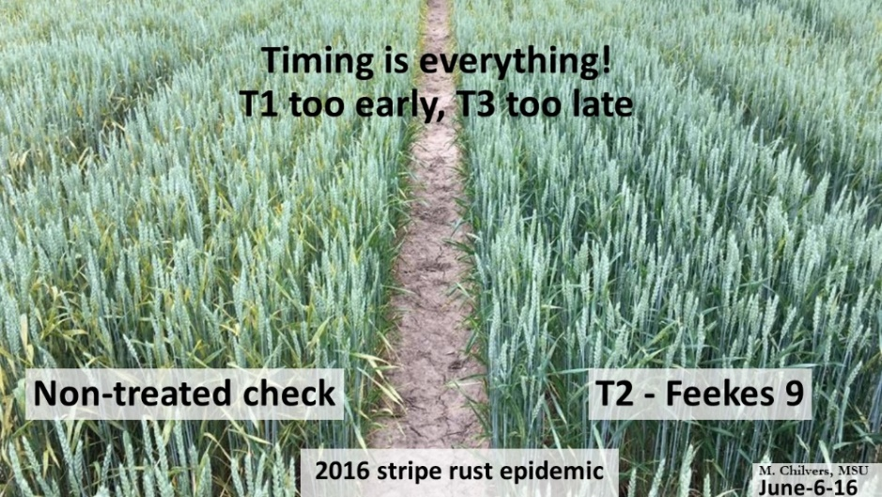
Fungicides! In general, we have seen some yield protection from a fungicide at early vegetative growth stages (Feekes 4-6), particularly if conditions favor diseases such as powdery mildew, but the benefit tends to be minimal. In contrast, protecting the flag leaf with an application from flag leaf emergence (Feekes 8-9) or at flowering (Feekes 10.5.1) tends to be more beneficial. Strategically, there can be an advantage to waiting until flowering, as this can be an effective fungicide timing that targets both leaf diseases and Fusarium head scab. However, an exception to using a single fungicide application to manage head scab and leaf diseases is when a disease such as stripe rust has been detected early in the season. This fast-moving disease may require a fungicide application prior to flowering to protect the flag leaf. Waiting until flowering may see disease levels explode and yield lost as seen in the stripe rust epidemic of 2016.
Figure 1: In the stripe rust epidemic of 2016 the ideal timing to suppress the disease was at flag leaf (T2 or Feekes 9), fungicides applied at early vegetative growth stages (T1 or Feekes 4-6) were too early to provide sufficient protection, and those applied at the head scab timing (T3 or Feekes 10.5.1) were too late.
In general fungicide applications are often cost effective where: 1) the variety is susceptible to the disease(s); 2) the disease is found at a relatively high level; 3) a damp weather pattern is predicted; and 4) the crop has a high yield potential. A complete wheat fungicide efficacy table which is updated annually can be found at the Crop Protection Network: https://cropprotectionnetwork.org/publications/fungicide-efficacy-for-control-of-wheat-diseases
Head scab also known as Fusarium head blight is one of the most significant issues in wheat production. Although head scab can result in a reduction of wheat yields, the greater threat comes from the production of mycotoxins in infected kernels such as deoxynivalenol (also known as DON or vomitoxin). No variety is completely immune to head scab, but varieties can vary widely in their susceptibility. Weather is one of the greatest influences on head scab development with warm and damp conditions being ideal for the Fusarium pathogen to produce spores and infect the wheat head particularly during flowering. The Fusarium risk tool (https://www.wheatscab.psu.edu/) can aid in predicting conditions that favor risk of head scab development. Both soft red and soft white classes of wheat are comparable in their susceptibility. However, soft white is often docked at 1ppm, whereas discounts for soft red often begin at 2 ppm.
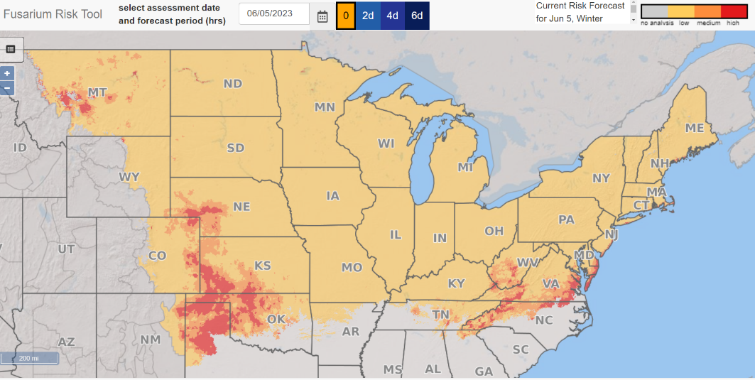
Figure 2: Screenshot of the Fusarium Risk Tool which can be used to examine risk of head scab as influenced by weather conditions. Yellow areas of the map have a low probability of disease, while areas of orange and red have a moderate and high probability of severe disease, respectively.
Fungicides such as those listed below can be used to reduce the severity of head scab by 50 to 60 percent and associated DON levels for 30 to 50 percent. The best application timing for head scab management is from the beginning of flowering (Feekes 10.5.1) until about a week after the beginning of flowering. The application method of fungicides for head scab should aim to cover the front and back of the wheat head. Use dual flat fan nozzles configured both forward and backward, and 30 degrees down from horizontal. A single, forward directed spray may be sufficient at higher ground speeds. Do not use strobilurin (group 11) fungicides during flowering as these may lead to elevated DON levels.
Recently there has been the introduction of new fungicide formulations for head scab management, including Miravis Ace, Prosaro Pro and Sphaerex. Our testing data has demonstrated these products to have good efficacy of head scab and foliar disease suppression.

Table 1: Recommended fungicide products and their efficacy for suppression of head scab of wheat
Product | Active ingredient % | FRAC Group -Mode of Action* | Rate (fl oz/A)** | Efficacy***
Folicur & (generics) | Tebuconazole 38.7% | 3 | 4.0 | Fair
Tilt & (generics) | Propiconazole 41.8% | 3 | 4.0 | Poor
Prosaro | Prothioconazole 19.0%  Tebuconazole 19.0% | 3  3 | 6.5-8.2 | Good
Caramba | Metconazole 8.6% | 3 | 13.5-17 | Good
Miravis Ace | Propiconazole 11.4%  Pydiflumetofen 13.7% | 3  7 | 13.7 | Good
Prosaro Pro | Prothioconazole 17.4%  Tebuconazole 8.7%  Fluopyram 8.7% | 3  3  7 | 10.3-13.6 | Good
Sphaerex | Metconazole 10.9%  Prothioconazole 18.2% | 3  3 | 7.3 | Good
*Fungicide resistance mode of action group
**Head scab rate
***North Central Regional Committee on Management of Small Grain Diseases (NCERA184)

