Final Report for Wheat Projects 2022-2023: Michigan Wheat Program
Prepared by: Elisabeth Darling, Marisol Quintanilla and Razieh Yazdani
Objective 1: To determine the plant-parasitic nematode abundance and frequency of occurrence in Michigan wheat fields.
To assess the current distribution and prevalence of Pratylenchus spp. in wheat fields, we conducted a state-wide field survey. We sampled a total of 30 wheat fields (Fig 1A) using a W-fashion approach around each field during their respective harvest times (Fig1B).
In each field, we sampled five times in a W-shaped pattern. At each of the five points within the field, we collected ten 5cm soil cores from a 2-meter perimeter near the base of the plants. These ten cores were combined into one sample and homogenized. This process was repeated four times within each field, resulting in five samples from different areas of the field. Each replicated sample was GPS-coordinated using an eTrex 10 (Garmin) and assigned a unique waypoint for potential revisits.

Fig 1: A. GPS Locations of 30 Wheat Fields Sampled in Michigan. B. Sampling from Wheat Fields with W-Shaped pattern.
We isolated nematodes from soil samples using the sugar-centrifugal flotation method (Jenkins, 1964) and processed each sample within three days to maintain sample freshness (Fig 2). Additionally, we collected one gram of roots from the plants for nematode extraction via root shaking (Moore et al., 1992) (Fig3). All samples were stored under refrigerated conditions (4°C) until further processing.
Subsequently, we examined the samples under an inverted light microscope (Nikon TMS), grouping and counting nematodes by feeding group (herbivorous, bacterial, fungal, predatory, and omnivorous). Plant-feeding nematodes were identified to the genus level for each field (Fig 2 and 3). Finally, we employed regression analyses to uncover any relationships between Pratylenchus populations, yield, field history/crop rotation, soil type (Fig 4 and 5), nematicide history, tillage, and yield.
For the duration of this project, all soil and root samples will undergo processing following the described procedures.
The soil sample results revealed that populations of Root Lesion Nematode (Pratylenchus spp.) did not exceed the threshold of 200 individuals per 100 cm³ of soil. They were found in 90% of the surveyed fields (Fig 2).
Root lesion nematodes (Pratylenchus spp.) were predominantly recovered from sandy and loamy fields compared to those with loam and clay soil types where wheat was planted. This trend persisted consistently across both soil (Fig 4) and root (Fig 5) sample densities, indicating a preference of Pratylenchus spp. for sand and loam environments over loam and clay soils when wheat is cultivated.

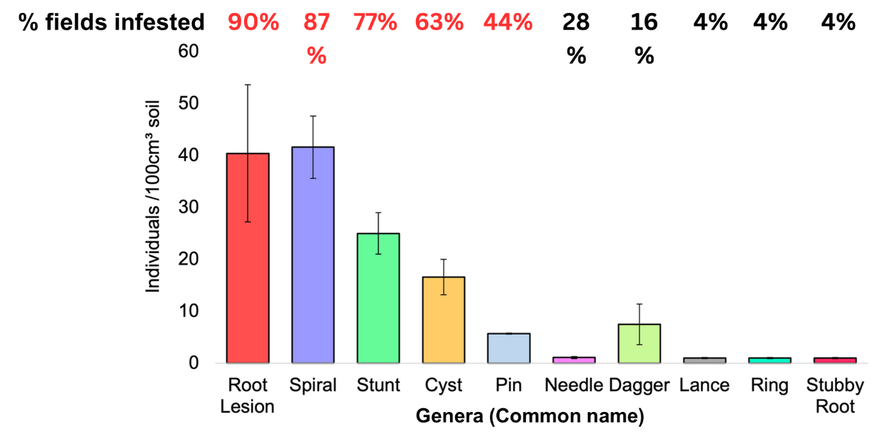
Fig 2: Average populations of plant-parasitic nematodes recovered from Michigan wheat field soil.
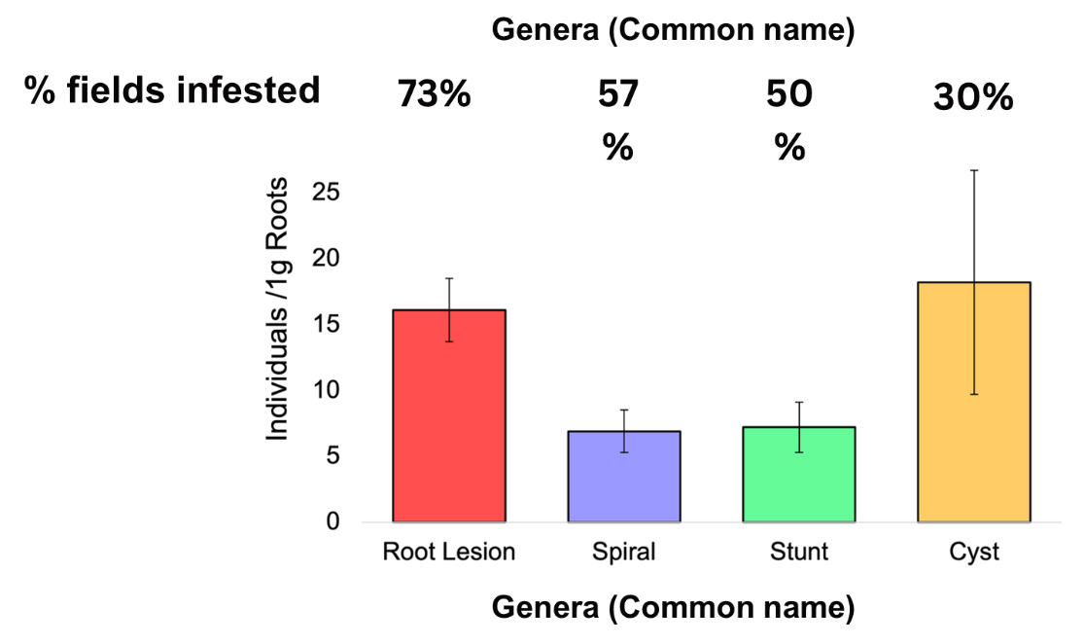
Fig 3: Average populations of plant-parasitic nematodes recovered from Michigan wheat field roots.
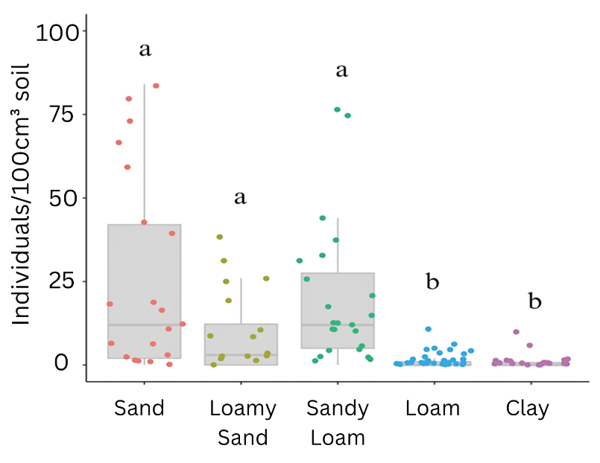
Fig 4: Distribution of Pratylenchus spp. in different wheat soil types extracted from soil samples.
Fig 4: Distribution of Pratylenchus spp. in different wheat soil types extracted from soil samples.
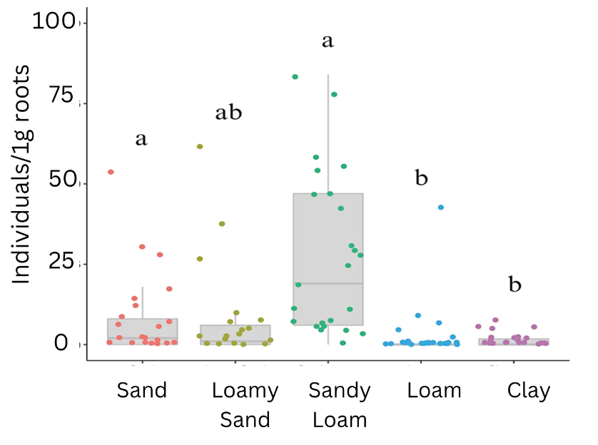
Fig 5: Distribution of Pratylenchus spp. in different wheat soil types extracted from root samples.
Objective 2: To identify root lesion nematodes (Pratylenchus) to species in Michigan wheat fields.
To confirm the species identification, we manually selected five adult female Pratylenchus specimens from each field sample included in the survey. Each individual was photographed using an inverted light microscope (Nikon, TMS) at 100x magnification, assigned a unique code, and stored in 100μl tubes (Eppendorf) under freezer conditions (-18°C) until DNA extraction.
Once all samples were collected and stored, we added 10μl NaOH (0.05 M) and 1μl Tween 20 to each sample tube and incubated the samples at 95°C for 15 minutes. Universal primers D2A (ACA AGT ACC GTG AGG GAA AGT TG) and D3B (TCG GAA GGA ACC AGC TAC TA) targeting the 28S rDNA, as well as VRAIN2F (GTG ATT CCA TTC ACC AHC TAC CTG) and VRAIN 2R (TTC GCA CTA ATT ATC GCA GTT GG) from the internal transcribed spacer (ITS) region of the 5.8S gene, were used for PCR extraction following established protocols associated with these primers (Subbotin et al., 2008; Vrain et al., 1992).
After gel electrophoresis, DNA was eluted using the ZymoClean Gel DNA Recovery kit, respective primers were added, and samples were submitted to the MSU Research Technology Support Facility for sequencing. Upon receiving the results, sequences were matched using the NCBI-Basic Local Alignment Search Tool (BLAST) for species identification.
Our results indicate that 40% of wheat fields in Michigan are infected with P. crenatus, 42% with P. penetrans, 16% with P. neglectus, and 2% with P. scribneri. Additionally, our findings reveal that 50% of the fields exhibit mixed populations of two or more species (Fig 6).

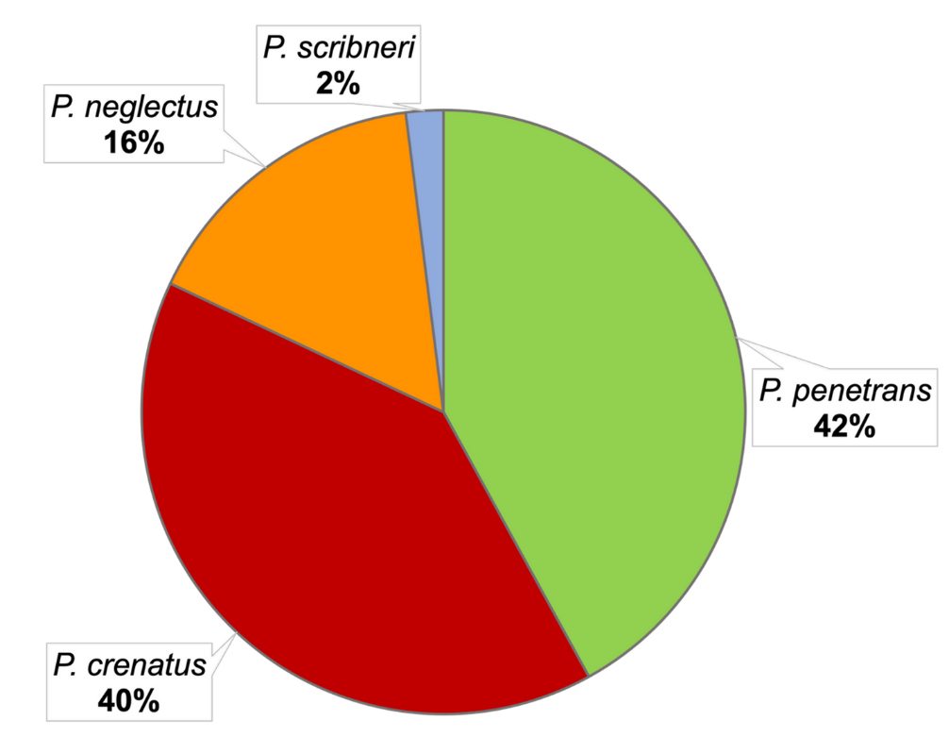

Fig 6: Distribution of Pratylenchus spp. in Michigan wheat fields
Conclusion:
- Root lesion nematodes (Pratylenchus spp.) emerge as the predominant plant-parasitic nematodes (PPN) in Michigan's winter wheat production.
- Soil type analysis suggests a preference of root lesion nematodes for soils with higher sand content, as documented by Kable and Mei (1968).
- The prevalent root lesion nematode species in Michigan's winter wheat fields include P. penetrans, P. crenatus, and P. neglectus.

