Title: Using Physiological and Hormone Indicators to Develop a Novel Winter Preparatory Management Strategy for Winter Wheat

Authors and Affiliation including contact information:
Dr. Emily (Merewitz) Holm, Dr. Eric Olson and Dennis Pennington
Michigan State University
1066 Bogue St
East Lansing, MI 48824
merewitz@msu.edu
517-355-0203

_X_ new project

Project goals and value for Michigan Wheat Growers:
Growing winter wheat has several advantages and disadvantages for farmers compared to growing spring wheat. Advantages include reduced spring weeds, protected soil, reduced Fusarium Head Blight (Fusarium graminearum), whose mycotoxins are hazardous to human and animal health, and advanced plant establishment in spring. Reluctance of farmers to plant winter wheat is related to a few issues but a primary one is the effects of harsh winter conditions on crop productivity. Severe winter conditions can limit the use of various winter wheat varieties in northern areas, can kill large areas of fields, reduce yield potentials, and can increase grower costs associated with reseeding winterkilled areas. Additionally, winter wheat germplasm/varieties are not as strong as spring wheat as there has been fewer breeding programs dedicated to winter wheat stress tolerance. Thus, the project goals are to increase our understanding of germplasm variability in ice encasement and freeze/thaw sensitivity and physiological traits related to tolerance to these stresses. The value of the research lies in the potential for the proposed work to readily result in knowledge to enhance winter wheat breeding programs and high management winter preparatory methods to improve winter wheat survival of severe winter conditions. Through extension efforts, growers will be informed of new management strategies. Thus, the long-term outcomes of this research will be enhancing winter wheat sustainability and reducing risks associated with winter wheat farming. This work will use prior knowledge of winter wheat germplasm winter survival documented by the MSU wheat breeding program in 2019.

Requested Budget: $Money for the year being requested and estimation for future years including how many years

Are there matching funds and from whom: A related and larger version of this proposal has been submitted to USDA NIFA AFRI- Physiology of Agricultural Plants A1152 entitled “Genetic and Physiological Mechanisms Associated with Ice Encasement and De-acclimation Tolerance of Winter Wheat”.

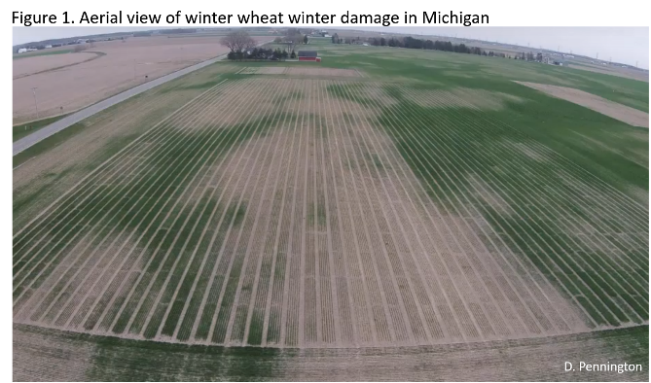
Recent research on winter issues of wheat has primarily focused on low temperature and freezing stress issues; however, two different winter stresses that are highly detrimental to winter wheat are premature cold de-acclimation and ice encasement. Improving the tolerance of winter wheat during these winter stresses will allow the wheat market to remain strong and grow throughout the U.S. Comparing planted and harvested acres as reported by USDA NASS is a useful estimate of the amount of winterkill (Table 1). Poor stands in the spring are the key reason why farmers decide not to harvest a field. There are several things that could cause poor stands including late planting, disease, excess/deficient water and winterkill. Most farmers relate poor stands with winterkill.
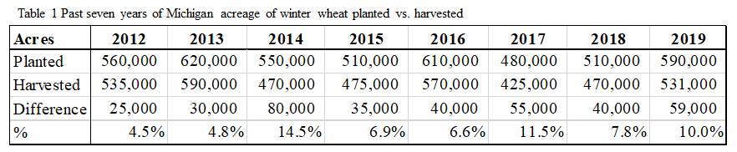
The occurrence of warming periods during winter or early spring can potentially trigger losses of freezing tolerance, known as cold de-acclimation. In general, there is significantly less known about cold de-acclimation compared to cold acclimation. The degree to which plants lose freezing tolerance depends on the magnitude of the temperature increase and duration of exposure (Kalberer et al., 2006). Consequently, the ability of plants to resist de-acclimation and maintain maximum freezing tolerance is considered an integral component of winter survival and may account for variations in freezing tolerance among plant species. Ice encasement is a unique and complex winter stress that cannot be understood or interpreted solely based on literature from freeze tolerance or general winter stress field studies (Andrews and Gudleifsson, 1983). While ice encasement may not damage the structural integrity of cells directly, prolonged ice encasement can cause plants to endure hypoxia or anoxia and buildup of toxic metabolic gases such as CO₂, butyrate gases, and various others during potential low temperature stress (Pomeroy and Andrews, 1978). Due to this extreme stress pressure, some cereal grasses can be killed in less than 1 week and exposure to ice encasement can highly limit subsequent freeze tolerance and spring recovery (Andrews, 1996).
There is background literature available on various metabolic differences in ice encasement tolerant and sensitive wheat types (Andrews 1996, 1997) but little management strategies for farmers have resulted from this basic knowledge and there is still little understanding of hormone responses. Here, we propose to determine basic physiological pathways in order to reveal readily useable novel winter preparatory strategies to promote tolerance of ice encasement and de-acclimation. How hormone changes during acclimation are used to regulate important ice encasement or de-acclimation tolerance pathways are not well understood. There is a clear lack of information on how hormones are used to signal ice encasement and de-acclimation responses and how they could be used in applied strategies to improve tolerance to these stresses.
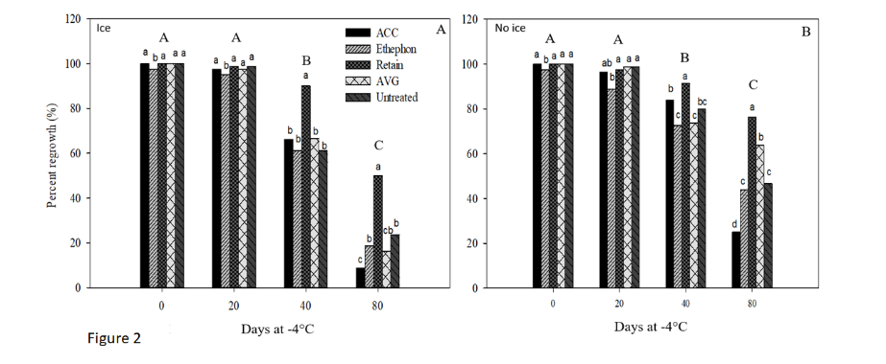
Preliminary research in the (Merewitz) Holm lab has been on a grass species related to wheat known as annual bluegrass. Much like wheat, annual bluegrass is prone to spring necrosis following prolonged ice encasement periods. Annual bluegrass, which survives 40 to 70 d of ice encasement, tends to produce much higher ethylene during fall acclimation compared to a more ice encasement tolerant grass species, creeping bentgrass, which survives 120 days of ice encasement (Laskowski et al., 2018). Applying ethephon, which is akin to applying ethylene, decreased winter tolerance of annual bluegrass whereas inhibiting ethylene (with Retain, a product used on tree crops containing aminoethoxyvinylglycine, AVG) highly promoted ice encasement tolerance imparted under controlled conditions (Figure 2; Laskowski et al., 2019a). Regulation of grass ethylene evolution may be a potential management strategy for promoting winter survival and testing on winter wheat under controlled and field conditions is needed.
An important question to consider is whether these fall treatments would have any impact on yields. Plant growth regulators (PGRs) are commonly applied to wheat during the spring to reduce lodging (Tripathi et al., 2004). Ethylene treatment effects on yield of soft red winter wheat were not significant (Van Sanford et al., 1989) but in an arid field study ethephon treatment increased the yield, supposedly through modified carbon partitioning (Turk and Tawaha, 2002). Ethephon treatment does promote maturation of grain whereas ethylene inhibition slows maturation (Beltrano et al., 1994). The effects of ethylene inhibition on wheat responses have not been investigated as thoroughly as ethylene treatment and there is little to no information about using PGRs in the fall to influence winter survival. Based on minimal documented effects of ethylene on wheat yield if applied in the spring, we expect that regulating ethylene in the fall with PGRs would not have negative effects on yield but may improve yield through enhanced winter survival and could potentially improve yield quality.
Fall applications of PGRs would effectively be altering wheat’s natural acclimation processes and physiological indicators of tolerance such as carbohydrate content of crowns and other parameters need to be assessed. Hormone changes during acclimation and cold tolerance of wheat types differing in frost tolerance have been reported (Kosova et al., 2012) but the roles of ethylene and other major hormone in effecting major pathways important in ice encasement and de-acclimation tolerance are not known. It is important to look at both stresses because fall PGR applications could affect spring release from dormancy. The mechanisms revealed here could be used in breeding winter tolerant wheat germplasm.
Objectives
- Perform simulated acclimation studies to determine hormone and physiological responses during acclimation and relate acclimation characteristics to tolerance or sensitivity to ice encasement and de-acclimation.
- Investigate fall plant growth regulatory treatments as a novel method to promote tolerance to winter stresses under controlled and field conditions.
- Identify and gauge stakeholder interests in new management strategies and germplasm by surveying key metrics, communicate research results to stakeholders, and broadly disseminate research findings.

Methods
Plant Material. Data collected from the Winter to Spring 2019 have revealed that significant variation in winter tolerance exists in germplasm resources available within the MSU wheat breeding program for field winter survival (Table 1). Table 1 shows a subset of the available data. In order to understand germplasm responses to specific winter stresses 5 each of the top and bottom performing lines in table 1 will be utilized for ice encasement and freeze/thaw simulation studies.
Objective 1 Experiment. Plants will be acclimated and vernalized under natural conditions at MSU in conetainers (6 cm by 35 cm) buried in a fallow field. This conetainer-in-field system will allow for natural acclimation and vernalization and provide a facilitated system for removing plants from the field with minimal crown and roots disturbance into controlled conditions in mid-December. The deep containers should allow for optimal root and shoot development. Field planting of conetainers will prevent total rootzone freezing and simulate natural field conditions. A set of 320 plants will be planted in conetainers to allow for the following controlled conditions studies to be performed twice in one year. A set of 160 plants to account for 10 plant lines replicated 4 times and exposed to 4 different stresses (ice, no ice, freeze/thaw, and gradual thaw) will be used. Ethylene evolution and hormone changes during acclimation will be measured as in (Krishnan and Merewitz, 2014 and Mir et al., 2001). Ice encasement studies will be performed by Dr (Merewitz) Holm at MSU using a low temperature growth chamber and misting method as in Laskowski et al (2018). De-acclimation and freeze tests will be performed as in Hoffman et al. (2013). Following ice encasement treatments, plant tissue will be analyzed for physiological parameters (hormone profiles, fatty acid, carbohydrate content, and antioxidant status) and regrowth and yield potential under greenhouse conditions. Following de-acclimation studies, plants will be analyzed for survival (LT₅₀ analysis) and assessed for physiological analysis the same as for the ice studies.
Objective 2 Experiments. Similar methods to experiment 1 will be used, except that only 2 plant lines will be used (one tolerant and one sensitive to each stress). Plant chemical treatments will include plant growth regulatory treatments aimed to increase or decrease ethylene evolution or other relevant hormones such as abscisic acid during acclimation at 2 different rates (based on results from objective 1). Plant abiotic stress treatments will be the same as in objective 1. We expect that approximately 10 chemical treatments would be used so a total of 320 plants would be used (10 chemical treatments x 2 plant lines x 4 replications x 4 stresses). Objective 2 studies will be repeated and will be conducted in year 2.
Plans to Share Information with Growers:
Our team, led by Pennington, will leverage existing, impactful programs to share results with stakeholders. We will share results annually or more frequently to scientific, grower and stakeholder audiences through both oral and written format, using peer-reviewed and extension outlets. Social media such as professional, departmental and foundational twitter and facebook accounts will be utilized throughout the project duration to stimulate interest in the research process and goals. Pennington is highly successful with a large professional twitter following with metrics in the range of 200 to 28,000 impressions on twitter. For agricultural stakeholders and farmers, extension articles will be written such as freely available MSU factsheets and popular extension websites such as Morning AgClips. Oral presentations will be given at AgExpo at MSU, the annual meeting of the MI Wheat Program (over 300 attendees), field day (approximately 200 attendees, co-sponsored by MSUE, MI Wheat and Michigan Crop Improvement Association) and Great Lakes Crop Summit (over 1200 attendees, held in late January each year at Soaring Eagle Casino in Mt. Pleasant) to disseminate results to growers where relevant. Additionally, AgBioResearch of MSU is an integrated and instrumental resource for helping MSU researchers disseminate research topics and highlights. Research results will be communicated to the academic community at the joint international meetings of the American Society for Agronomy, Crop Science Society of America, and the Soil Science Society of America in 2018, 2019 and 2020. Articles will be written when relevant or when requested for the Michigan Wheat Program’s Monthly e-newsletter.
Budget Narrative:
Funds from the USDA AFRI have been requested. Dr. Holm has not previously received any funds for wheat research but she is eager to help the wheat industry. Future years of research would be needing for field testing and other analyses using knowledge gained from this project. Budget justification –
Olson’s technician, Amanda Noble, will be responsible for germplasm maintenance, propagation and assistance with care. A graduate student in Holm’s lab will conduct the research. Undergraduate assistance is needed for routine laboratory and plant care help. Travel is for presenting research results. Materials and supplies are laboratory consumables and other lab expenses.
Literature Cited
Andrews CJ. 1996. How do plants survive ice? Annals of Bot. 78:529-536.
Andrews CJ. 1997. A comparison of glycolytic activity in winter wheat and two forage grasses in relation to their tolerance to ice encasement Annals of Botany, 79: 87–91.
Beltrano J, Carbone A, Montaldi ER,and JJ Guiamet.1994. Ethylene as promoter of wheat grain maturation and ear senescence. Plant Growth Regulation. 15:107–112.
Hoffman, L., M. DaCosta, and J.S. Ebdon. 2013. Examination of cold deacclimation sensitivity of annual bluegrass and creeping bentgrass. Crop Sci. 54:413-420.
Kalberer SR, Wisniewski M, Arora R. 2006. Deacclimation and reacclimation of cold-hardy plants: current understanding and emerging concepts. Plant Sci. 171:3-16.
Kosova K, Prášil T, Vítámvása P, Dobrev P, Motyka V, Floková K, Novák O, Turečková V, Rolčik J, Pešek B, Trávničková A, Gaudinová A, Galiba G, Janda T, Vlasáková E, Prášilová P, Vanková R. 2012. Complex phytohormone responses during the cold acclimation of two wheat cultivars differing in cold tolerance, winter Samanta and spring Sandra. J Plant Physiol. 169:567-576.
Krishnan, S. and Merewitz, E. 2014. Drought stress and trinexapac-ethyl modify phytohormone content within kentucky bluegrass leaves. J. Plant Growth Regul. DOI: 10.1007/s00344-014-9434-0
Laskowski K, Frank K, and Merewitz E. 2018. Chemical plant protectant and plant growth regulator effects on annual bluegrass survival of ice cover. Journal of Agronomy and Crop Science. 00:1–11. https://doi.org/10.1111/jac.12309
Laskowski, K and Merewitz, E. 2019a. Influence of Ice and Ethylene Regulation on Cellular Protection Mechanisms in Annual Bluegrass. J of Plant Growth Regul. Under Review.
Mir, N.A., N. Curell, N. Khan, M. Whitaker, and R.M. Beaudry. 2001. Harvest maturity, storage temperature, and 1-mcp application frequency alter firmness retention and chlorophyll fluorescence of red chief delicious' apples. J. Amer. Soc. Hort. Sci. 126: 618-624.
Pomeroy KM, Andrews CJ. 1978. Ultrastructural changes in shoot apex cells of winter wheat seedlings during ice encasement. Canadian J of Bot. 56:786-794.
Tripathi SC, Sayre K D, Kaul JN, and RS Narang. 2004. Lodging Behavior and Yield Potential of Spring Wheat (Triticum aestivum, L.): Effects of Ethephon and Genotypes. Field Crop Res., 87: 207-220.
Turk MA and Tawaha AM. 2002. Response of Winter Wheat to Applied N with or without Ethrel Spray under Irrigation Planted in Semi-arid Environments. Asian J. Plant Sci. 4: 464-466.
Van Sanford, DA, Grove JH, Grabau LJ, and CT MacKown. 1989. Ethephon and Nitrogen Use in Winter Wheat Agron. J. 81:951-954.

