Wheat information resources

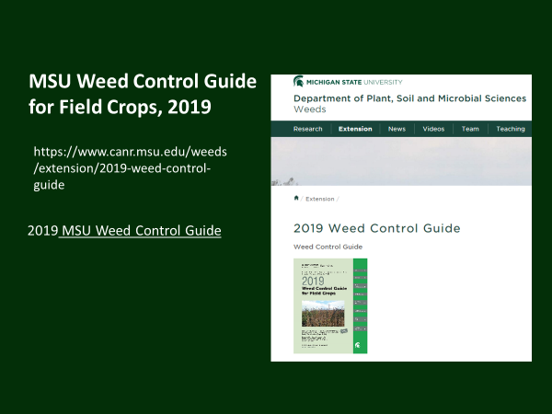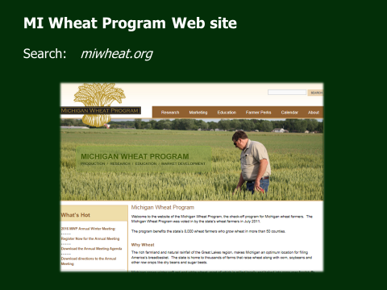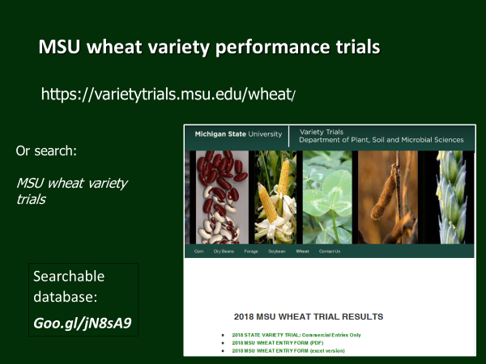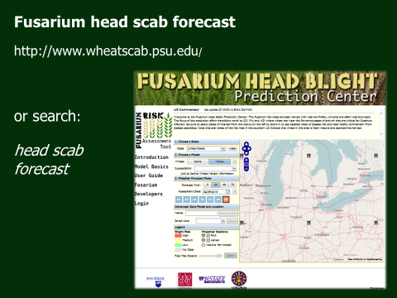MI Wheat Annual Meeting, March, 2019