Optimizing planting practices in winter wheat: role of precision planting, row spacing, seeding rate, and varietal canopy

MWP Tracking Number: 23-08-04-BS

Researchers:
Wallas Mendes da Silva, Graduate student, wmendes@msu.edu
Maninder Singh, MSU Cropping Systems Agronomist, msingh@msu.edu, 517-353-0226
Collaborators: Brook Wilke, Eric Olson, Dennis Pennington

Date: January 28, 2026

Project goals and value for Michigan Wheat Growers:

To maximize wheat yields, crop canopy architecture should be designed to optimize light capture and its use efficiency. This can be achieved by optimizing planting decisions such as precise seed placement, narrow row spacing, erect varietal canopy architecture, and optimized seeding rates. Recently concluded and ongoing work in Michigan has tested some of these practices along with their yield benefits but was conducted using non-ideal precision planting equipment and did not combine these practices for testing their synergistic benefits. The ongoing proposed project is using a planter with capacity to plant in 5” rows at plot and field scale, recently custom-built with funding from MSU AgBioResearch and the Long-Term Agroecosystem Research (LTAR) program. The overall goal of this research is to evaluate planting practices that can help develop an ideal wheat canopy, maximizing interception and use efficiency of solar radiation, leading to sustainable yield and profit improvements for growers in Michigan and across the Great Lakes Region. Growers will continue to learn about the implications of precision planting technology that is scalable to their farms and can be used for multiple crops. If successful, this approach could lead to improved yield and profitability for wheat growers by matching row spacing with ideal seed placement, seeding rate, and varietal canopy.

Progress Report:
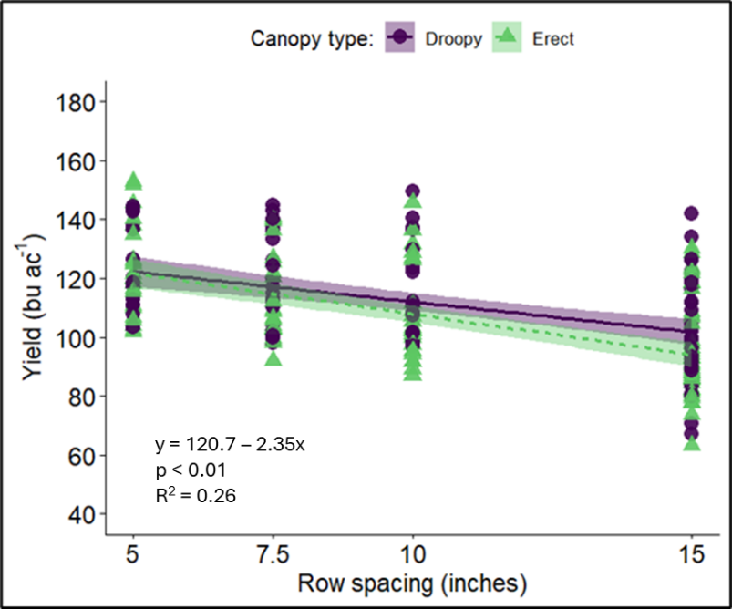
The overall goal of this research is to evaluate planting practices that can help develop an ideal wheat canopy, maximizing interception and use efficiency of solar radiation, leading to sustainable yield and profit improvements for growers in Michigan and across the Great Lakes Region. We categorized this study into three sub-objectives: 1) Evaluate the impact of row spacing across varieties of differing canopy architecture, 2) Compare the optimal seeding rate in winter wheat planted using a precision planter and a conventional drill, and 3) evaluate field and system-scale performance of winter wheat planted using equipment with differing seed placement accuracy, row spacing, and varietal canopy types. Only a subset of data are presented here for brevity, rest are available upon request.
Fig. 1. Wheat yield (at 13.5% moisture) for two canopy types (Erectophile and Planophile) across different row spacings (5-, 7.5-, 10-, and 15-inch).

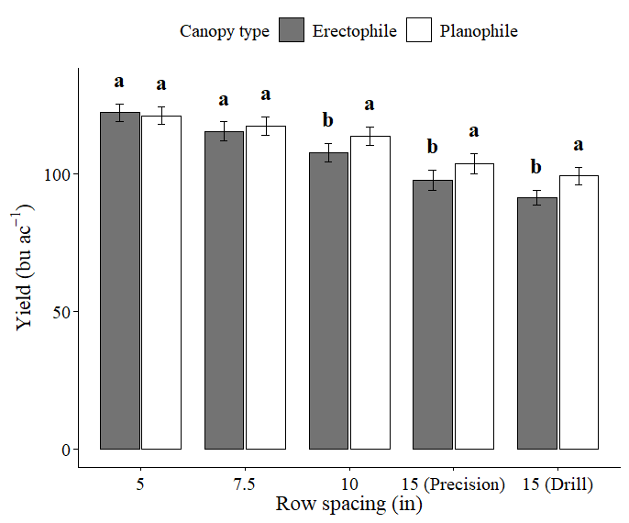
Winter wheat varieties differed in their canopy architecture. This difference was visually observed in the field and was quantified by estimating tiller angle using the width between tillers at 30cm from the soil level. Planophile varieties showed greater tiller angle (21.0˚) compared to Erectophile (15.1˚) varieties. An increasing trend in wheat yield with narrower row spacings was observed (Fig. 1, p < 0.01), with the greatest yield observed in 5-in spacing (121 bu ac⁻¹). No statistical difference in yield was found under narrow rows between planophile and erectophile canopy types (Fig. 2). However, under wider rows, yields differed between the two canopy types, with planophile canopies achieving greater yields compared to erectophile. These data showed the potential of combining canopy types with row spacing systems and precision planting equipment for improving yield potential in winter wheat.
Fig. 2. Wheat yield comparison across the two canopy types in different row spacings (5-, 10-, and 15-inch with planter; 7.5- and 15-inch with drill).

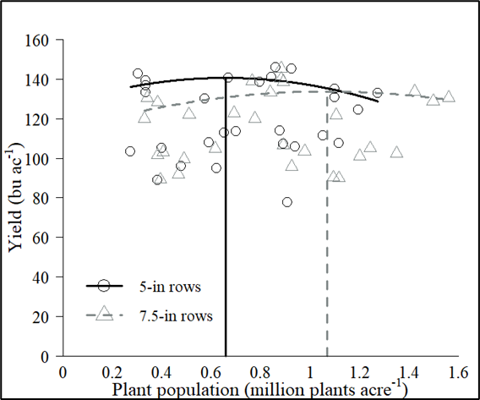
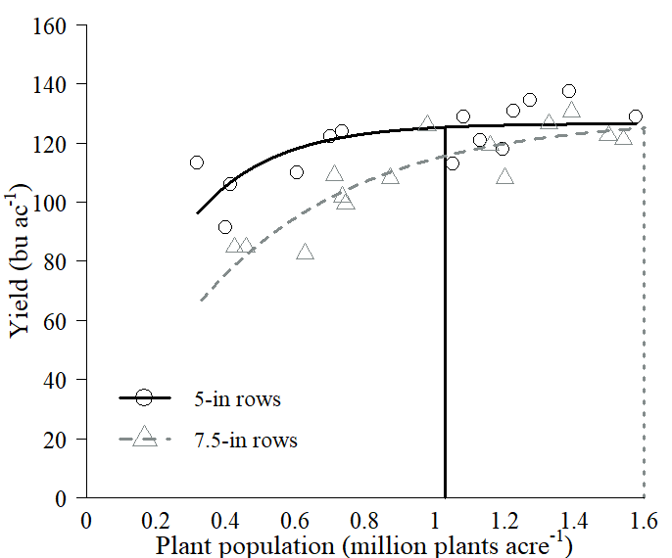
For the second objective, we compared different seeding rates using both planting methods, a precision planter (5” row spacing) and a conventional seed drill (7.5” row spacing). All seeding rates expressed in final plant population were regressed against yield, and the best regression model was fitted to the data (asymptotic through the origin). Plant population for maximum yield was lower for the precision planter (in 5-inch rows) with 1.03 million plants acre⁻¹ compared to 1.6 million plants acre⁻¹ (the highest rate in our trials) for the conventional drill (7.5-inch rows). Similar results were found in the second season of the study, with 0.65 million plants acre⁻¹ for the precision planter compared to 1.1 million plants acre⁻¹ for the drill (Fig. 3). Lower optimal population (and seeding rate) with precision planting equipment indicates potential for cost savings by reducing seeding rate without any yield penalty.
Fig. 3. Yield response to plant population for precision planter (5-inch rows) and drill (7.5-inch rows). Vertical line shows the optimal plant population for each row spacing.

Canopy coverage pictures were taken in different growth stages throughout the season and pictures were analyzed using Canopeo App. Narrow row spacing closed canopy faster than other rows spacings across varietal canopy types, with 15” rows never reaching canopy closure during the growing season. Planophile varieties achieved greater canopy coverage in 15” rows compared to erectophile varieties, indicating potential benefit of such varieties under wider row spacings (and other environments where light interception can be a limiting factor, e.g., later plantings). There was a difference in light interception when comparing planophile vs. erectophile varieties due to the differences in their canopy architecture (Fig. 4).

Planophile varieties showed greater light interception in all layers of wheat canopy compared to erectophile varieties across row spacings. Planophile canopies tend to intercept more light because they reach canopy closure quickly and capture a larger amount of seasonal radiation compared to erectophile canopies. Greater differences were noticed in middle layers of the canopy. In narrow rows, erect varieties allowed greater light penetration through the canopy compared to their planophile counterparts. No difference in light intercepted at the bottom of the canopy were observed in 5” rows. However, in 7.5” rows, a significant difference was found at the bottom of the canopy (Fig. 4 B). This result suggests that radiation use efficiency can be improved in these dense canopies and suggests that erect varieties can be ideal for high yielding environments (e.g., narrow rows, early planting).

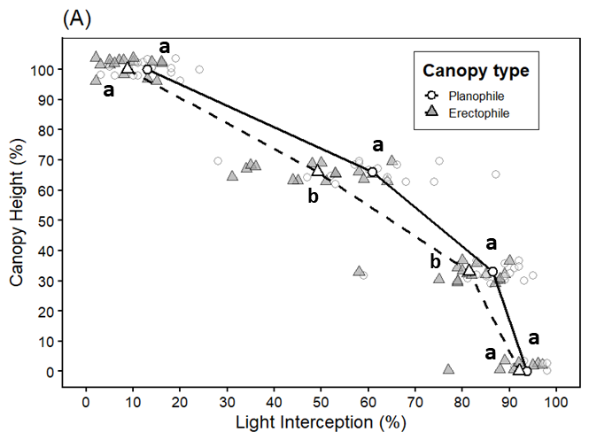
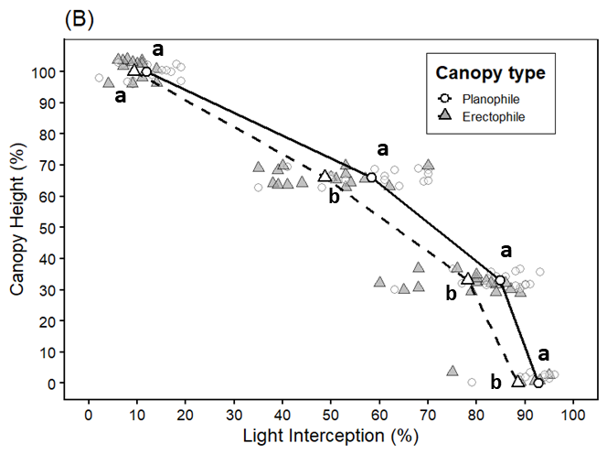
Fig. 4. Intercepted Photosynthetic Active Radiation (PAR) measured in four layers within wheat canopy (0% = soil surface; 0-33% = lower layer; 33-66% = middle layer; 100% = top layer of the canopy) for two row spacing (A: 5”, B: 7.5”) and two canopy types.
Project Changes
No changes were made for this year (2025-2026). Two new varieties added last year were kept in this year (3rd and last year of the study). Similar to 2025 (2nd year of trials), a second location for the study was planted in addition to KBS Farm, located at the MSU Mason Farm.

Budget Narrative. As described in the proposal.

Intellectual Property. None.

Approach to Disseminate Research
Project findings were shared with growers at multiple field events and extension meetings organized by MWP and MSUE. Data from this project were presented at the American Society of Agronomy’s 2025 CANVAS annual meeting in Salt Lake City and won a first-place award in the Applied Wheat Research community. Research results from previous seasons of this study were published as an extension article on the MSU Extension webpage and can be accessed with this link: Optimizing row spacing and seed placement for high yield potential in winter wheat - Wheat. This article was also shared for publication in MWP’s eNewsletter. Results will continue to be posted on the MSU Agronomy webpage (https://www.canr.msu.edu/agronomy/Extension/Small_Grains), as well as presented at winter grower meetings and field days.

