*Fusarium head blight, commonly called scab, is the single most important disease of wheat. Risk of the disease cannot be avoided, but knowledge of the disease, and use of improved varieties and fungicides can substantially reduce the risk of financial losses*

Fusarium head blight (FHB) can lead to a reduction in wheat yields. However, the greatest financial threat is when infected kernels produce a mycotoxin called deoxynivalenol (DON or vomitoxin) as a byproduct. Symptom of the disease include bleached spikelets. Within these discolored awns, the kernels may be shriveled, lightweight and, sometimes, chalky-white or pink in color. It should be noted, however, that kernels might exhibit little or no visual symptoms of FHB and yet contain the pathogen and a significant DON level.

***Weather*** has the greatest influence on disease development. Damp conditions and moderately warm temperatures at the time of flowering are most advantageous to the pathogen. It is also favored to an extent by wet weather several days prior to flowering (encourages spore production and dissemination) and to damp weather during grain fill (favors both disease development and the production of DON. A [FHB Risk Assessment Tool](http://www.wheatscab.psu.edu/), based on a FHB forecast model, is available to help assess local risk to the disease.

***Varieties*** nowvary significantly in theirsusceptibility to scab due to plant breeding efforts. In some cases, simply selecting a more FHB resistant variety could potentially reduce a particular field’s level of FHB by half. The table on the back page provides susceptibility rating for some commonly grown varieties in Michigan. Scab and DON ratings are also available at Michigan State University’s annual [variety performance report](https://varietytrials.msu.edu/wheat) and in a [searchable data base](http://web2.canr.msu.edu/varietytrials/wheat/wheatsearch.cfm). These sources also include ratings for foliar diseases.

***Soft white and soft red wheat***, as sub-classes, are generally comparable in their susceptibility to FHB.

March, 2019

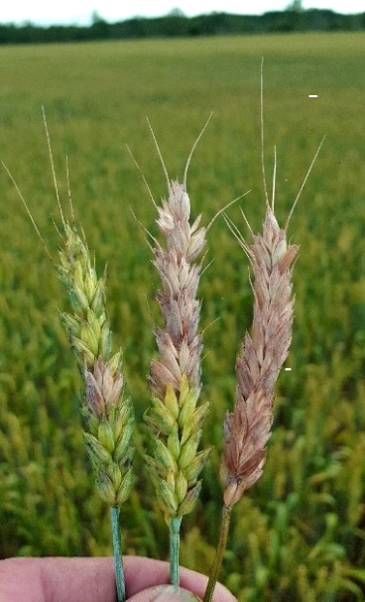However, soft white has a disadvantage in that the market is more sensitive to DON levels due to end-use requirements. While market discounts for DON vary, soft white wheat value is often docked when levels exceed 1 ppm, whereas discounts for soft red grain often begin at 2 ppm.

***Crop rotations*** matter, as residues from the previously infected crop can harbor the Fusarium fungus and, thereby, increase the chance for infection. The greatest risk is associated with residue from corn and, to a lesser extent, wheat, barley and some hay crops. Using tillage to completely incorporate the residue from these crops will reduce the amount of inoculum generated within the field, although the risk of Fusarium spores from outside the immediate field remains.

FHB symptoms include a bleaching of a single floret or entire head

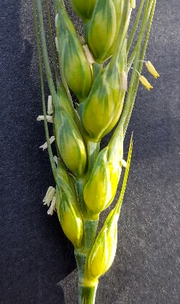***Fungicides*** such as Caramba, Miravis Ace and Prosaro, often reduce the severity of FHB by 50 to 60 percent and DON levels by 30 to 50 percent, although the actual reductions are highly variable. Conversely, the use of strobilurin fungicides (e.g. Quadris, Headline, and Aproach), when used during heading stages, may lead to elevated DON levels. Using fungicides against FHB offers the additional benefit of boosting yields by 4 to 10 percent due to their activity against the many foliar diseases (e.g. leaf rust and leaf spots).

*Flowering stage indicated by anthers protruding from florets.*

Successful fungicide applications against FHB depend on the use of:

1. recommended fungicides (see table below). The most effective products are Prosaro, Caramba, Miravis Ace and Proline. Tebuconazole (sold under various product names) is less effective on FHB but, because of lower product cost, might be considered where the risk of FHB is relatively low and yet foliar diseases are present.
2. proper application timing. For best results, apply fungicides for scab within 5 to 6 days following early flowering (early flower is when 50 percent of the heads first exhibit anthers).

1. application adjustments (see [Ground Application of Fungicide](http://www.ag.ndsu.edu/pubs/ageng/machine/ae1314.pdf) sheet):
   1. adjust boom height to target the wheat heads (generally 8 to 10 inches above heads);
   2. use dual flat fan nozzles configured both forward and backward, and 30 degrees down from horizontal, are preferred [a single, forward directed spray may be sufficient at higher ground speeds, but dual nozzles may help insure leaf coverage for foliar diseases];
   3. select flat fan nozzles that provide a droplet size between a large fine to small medium (300 to 350 microns); and
   4. calibrate sprayer to deliver 10 to 15 gallons of volume per acre.

|  |  |  |  |  |  |  |  |  |  |
| --- | --- | --- | --- | --- | --- | --- | --- | --- | --- |
| **Fungicide products for Fusarium head blight and selected leaf diseases on wheat1** | | | | | | | | | |
| **Active ingredient** | **Product** | **Rate/A** | **Powdery mildew** | **Stag. leaf spot** | **Septoria leaf spot** | **Stripe rust** | **Leaf rust** | **Head scab** | **Harvest Restriction** |
| **(fl. oz)** |
| **metconazole 8.6%** | **Caramba 0.75 SL** | **10.0 - 17.0** | **VG** | **VG** | **--** | **E** | **E** | **G** | **30 days** |
| **tebuconazole 38.7%** | ***various2*** | **4** | **NL** | **NL** | **NL** | **E** | **E** | **F** | **30 days** |
| **pydiflumetofen 13.7%** | ***Miravis Ace*** | **13.7** | **G** | **VG** | **VG** | **VG** | **VG** | **G** | **full flower Feekes 10.54** |
| **propicaonazole 11.4%** |
| **prothioconazole 41%** | **Proline 480 SC** | **5.0 - 5.7** | **--** | **VG** | **VG** | **VG** | **VG** | **G** | **30 days** |
| **prothioconazole 19%** | **Prosaro 421 SC** | **6.5 - 8.2** | **G** | **VG** | **VG** | **E** | **E** | **G** | **30 days** |
| **tebuconazole 19%** |
| 1 Efficacy categories: NL=Not labeled; P=Poor; F=Fair; G=Good; VG=Very Good; E=Excellent. | | | | | | | |  |  |
| 2 Multiple generic products be labeled, eg: Folicur,Embrace, Monsoon, Muscle, Onset, Orius, Tebucon F, Tebustar, Tebuzol, Tegrol, and Toledo | | | | | | | | | |

*Martin Nagelkirk, MSU Extension*

*Martin Chilvers, Dept. of Plant, Soil and Microbes, MSU*

*MSU is an affirmative-action, equal-opportunity employer. Michigan State University Extension programs and materials are open to all without regard to race, color, national origin, gender, gender identity, religion, age, height, weight, disability, political beliefs, sexual orientation, marital status, family status or veteran status.*