Exploring Host Suitability and Trap Crop Potential for Nematode Management in Winter Wheat (23-08-03-AS)- 2023-2024

Marisol Quintanilla, Razieh Yazdani
Applied Nematology Lab
Michigan State University

Evaluate the impact of various wheat cultivars on SCN populations in greenhouse
Two wheat trials were established on November 15, 2023, and March 11, 2024, at the MSU greenhouses. The cover crop treatments included AgriMAXY 498 wheat, Whitetail wheat, MCIA Wharf wheat, DG 9172 wheat, DF119R wheat, and susceptible soybean. In the first experiment, the treatments were planted in 2 kg soil plots (Fig 1A), while in the second experiment, they were planted in cone containers (Fig 1B), with each treatment replicated five times. Each pot was inoculated with approximately 2,000 soybean cyst nematode eggs in the first trial and 800 eggs in the second.
B
A
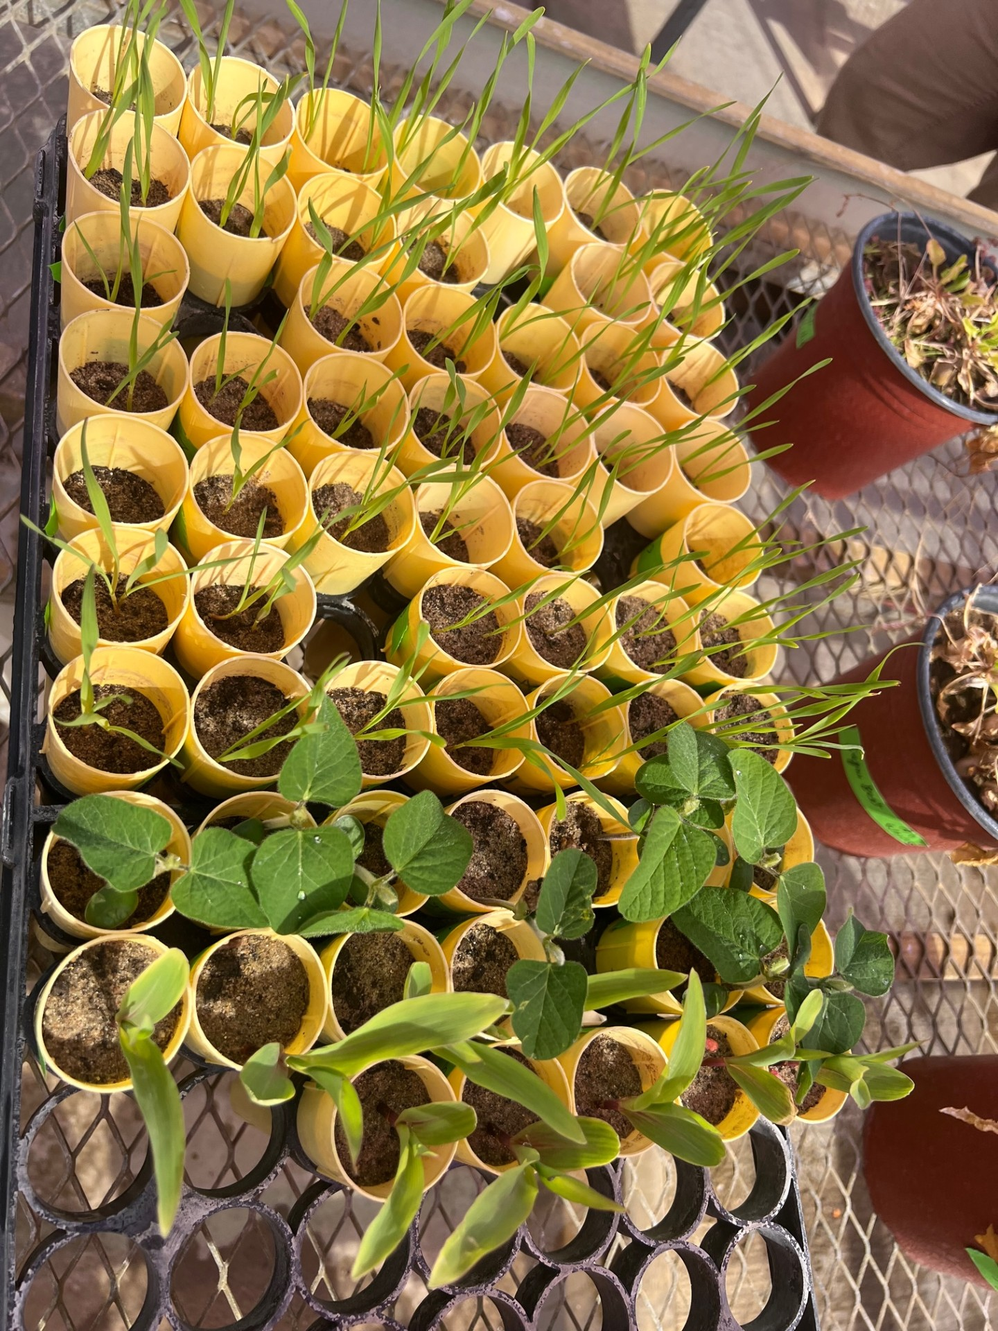
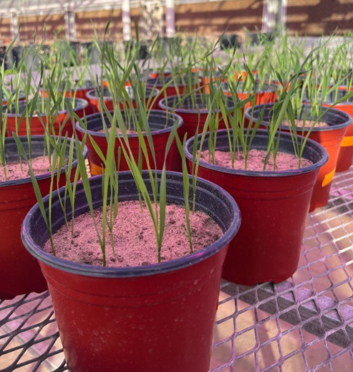

Fig. 1. First (A) and second (B) experiments of wheat trials at MSU greenhouses.

Plants terminated 2 months after inoculation and roots samples have been stained following this protocol. We washed and dried the roots, then weighed 5 g of cut roots in a petri dish. The roots were submerged in a 10% bleach solution, rinsed, and soaked in tap water to remove residual bleach (Fig. 2A). Acid fuchsin stain was added to the roots in tap water, boiled for 1 minute, cooled, rinsed, and transferred to acidified glycerin (Fig. 2B). The roots were heated in glycerin until boiling for destaining, cooled to room temperature, and placed in a petri dish containing glycerin. Finally, the roots were examined under a microscope (Fig. 2C).
A
C
B
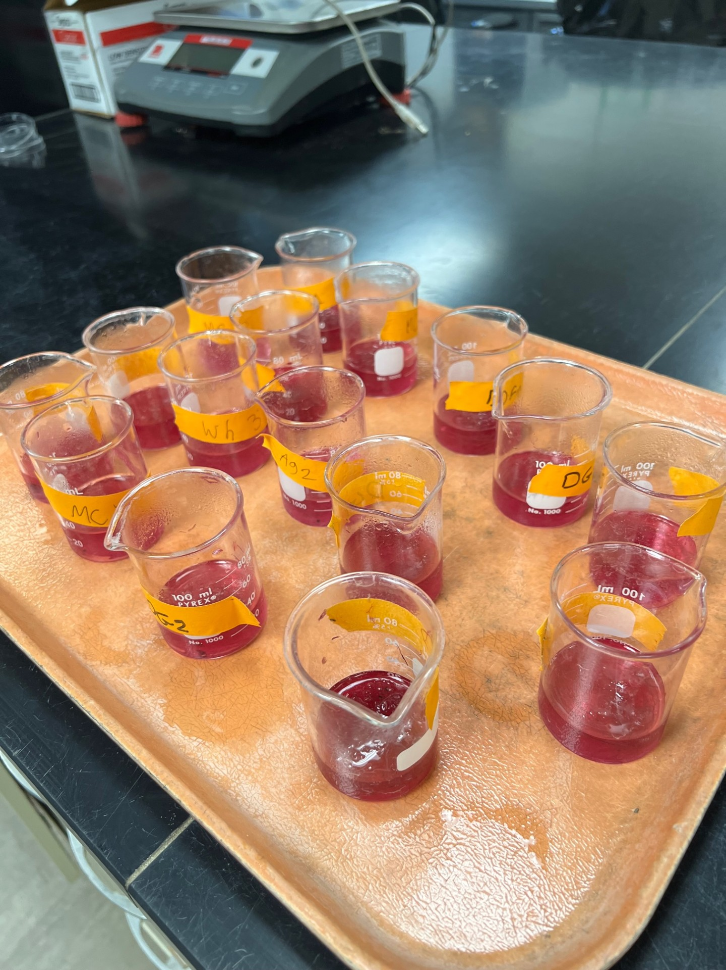
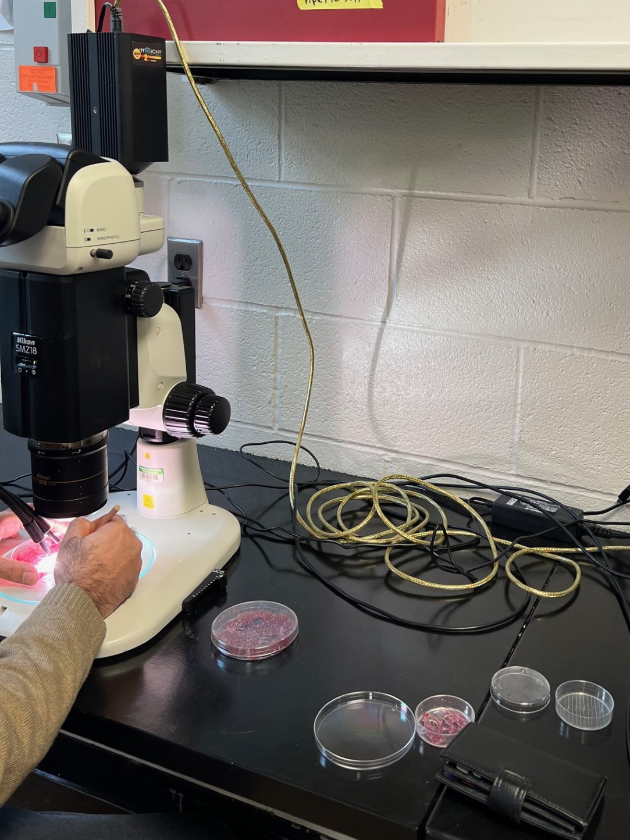
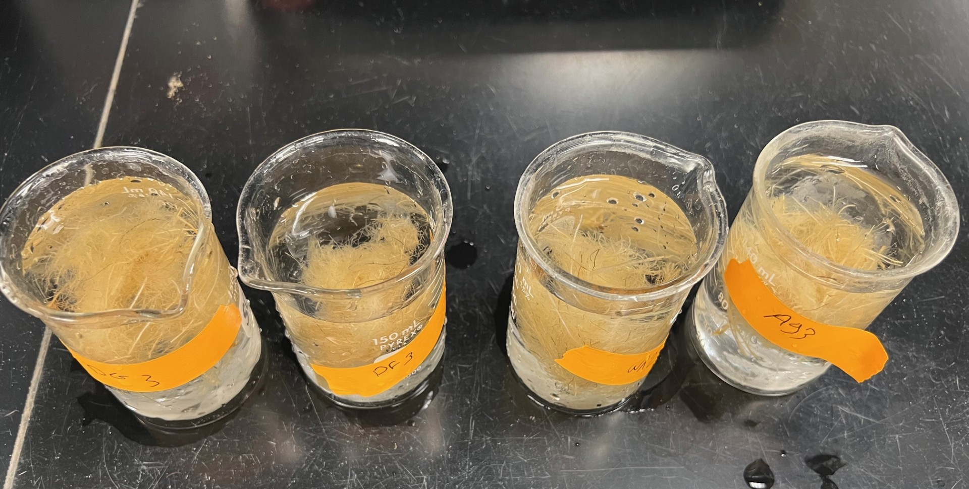

Fig. 2. Root staining process: (A) roots washed, bleached, and rinsed, (B) roots stained with acid fuchsin and transferred to acidified glycerin, and (C) roots examined under a microscope.

First experiment: The wheat varieties used in the study were sourced from the Michigan Wheat Program and represent the most commonly planted varieties in Michigan. The results in the first experiment showed that no soybean cyst nematodes (SCN) were detected in the roots of any of the wheat varieties tested. In contrast, SCN was successfully detected in the roots of soybean plants, which served as the control (Fig 3).
Fig. 3. J2 of soybean cyst nematode inside a soybean root at harvest, stained with acid fuchsin (arrow indicates J2).
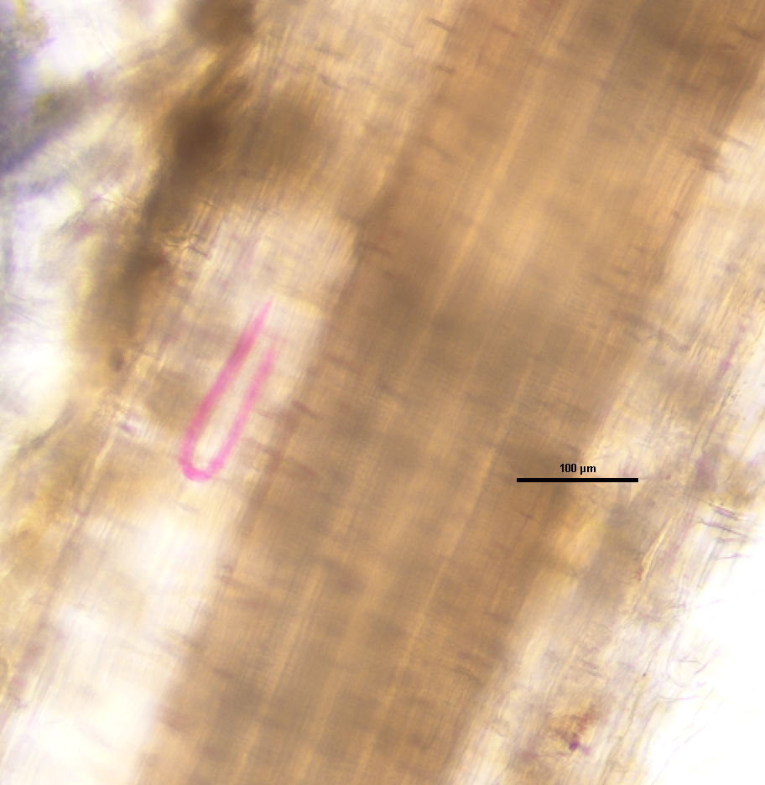

Second experiment: The wheat-plant experiment was initiated on March 11, 2024, with inoculation conducted on March 8, 2024, introducing 800 soybean cyst nematode (SCN) eggs per small pot. The first harvest took place 9 days after planting to monitor SCN J2. The second harvest occurred 18 days after planting to observe SCN J3 and J4, and the third harvest was conducted 28 days after planting to examine the formation of cysts.

Root staining was expected to reveal that wheat could function as a trap plant, with SCN J2 detected in its roots following harvest. However, our results showed the absence of SCN at all stages in wheat, confirming it as a non-host plant. In contrast, the presence of all SCN life stages in soybean roots confirmed soybean as a host plant for the nematode (Fig 4). Overall, the experiment validated soybean as a host for all stages of SCN, while wheat was identified as a non-host plant.
A
B
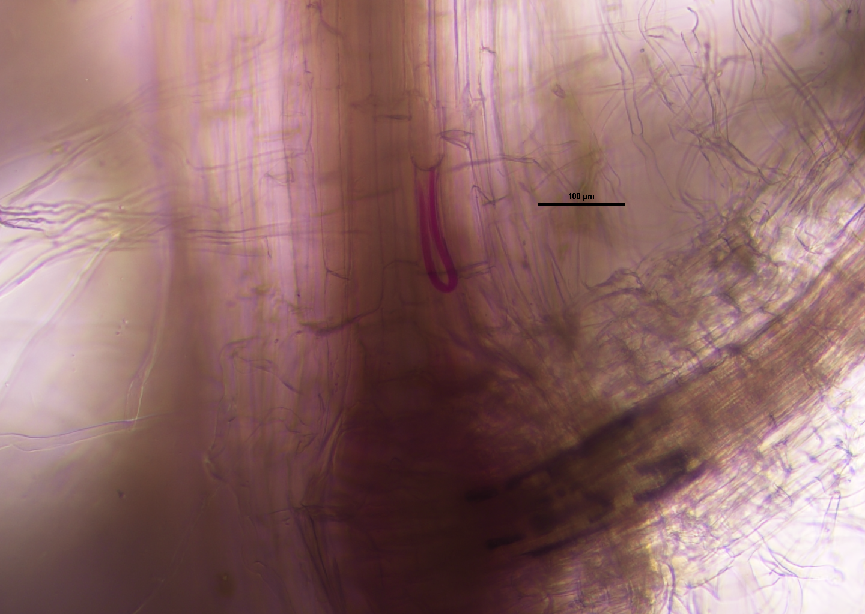
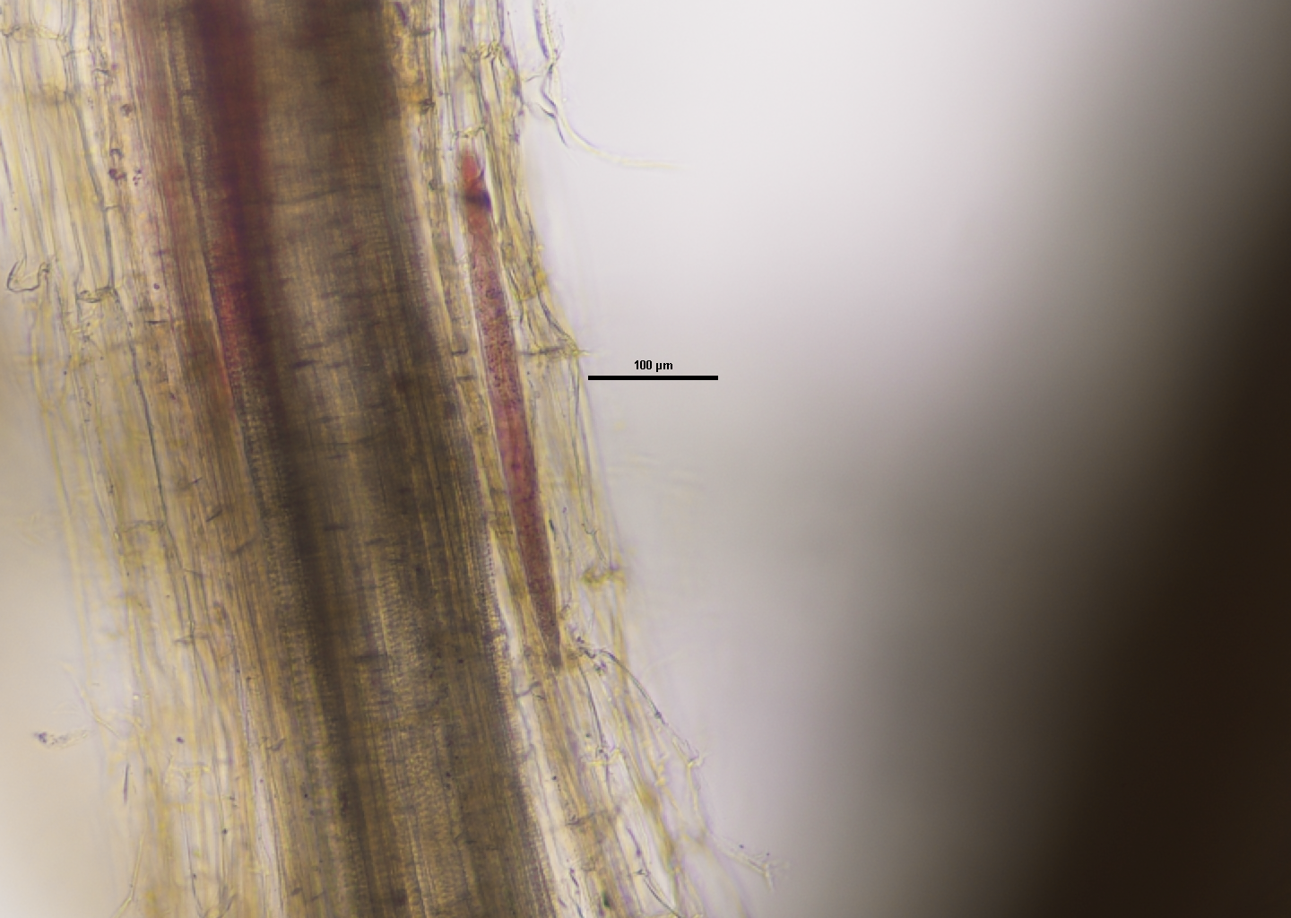

Fig. 4. Development of SCN in soybean roots (Bar = 100 μm). (A) SCN J2 in the soybean root system; (B) SCN J3 in the soybean root system.

