Evaluating Soybean Cyst Nematode Interactions with Wheat: Host Status and Management Potential- 2024-2025 (project # 24-08-05-AS)

Marisol Quintanilla, Razieh Yazdani
Applied Nematology Lab
Michigan State University

Objective 1: Survey of wheat fields and root analysis using staining techniques
Sampling was conducted on October 22, 2024, from Michigan wheat fields that had previously been reported as potential hosts for soybean cyst nematode (SCN), where second-stage juveniles (J2) were observed within root tissues. Samples were subsequently transported to the laboratory for further analysis (Fig. 1).

B
A

Fig. 1. (A) Wheat sampling from Michigan fields and (B) samples transported to the laboratory.

Root samples were processed following a standard staining protocol. Briefly, roots were thoroughly washed, air-dried, and 5 g of chopped root material was weighed and placed in a Petri dish. The roots were submerged in a 10% bleach solution to clear tissues, then rinsed thoroughly and soaked in tap water to remove any residual bleach (Fig. 2A)
An acid fuchsin staining solution was added to the roots in tap water, and the samples were heated to boiling for approximately 1 minute. After cooling, the roots were rinsed and transferred into acidified glycerin (Fig. 2B). The samples were then reheated in glycerin until boiling to facilitate destaining and improve visualization. After cooling to room temperature, the roots were placed in a Petri dish containing glycerin and examined under a microscope for the presence of nematodes (Fig. 2C).

A
C
B
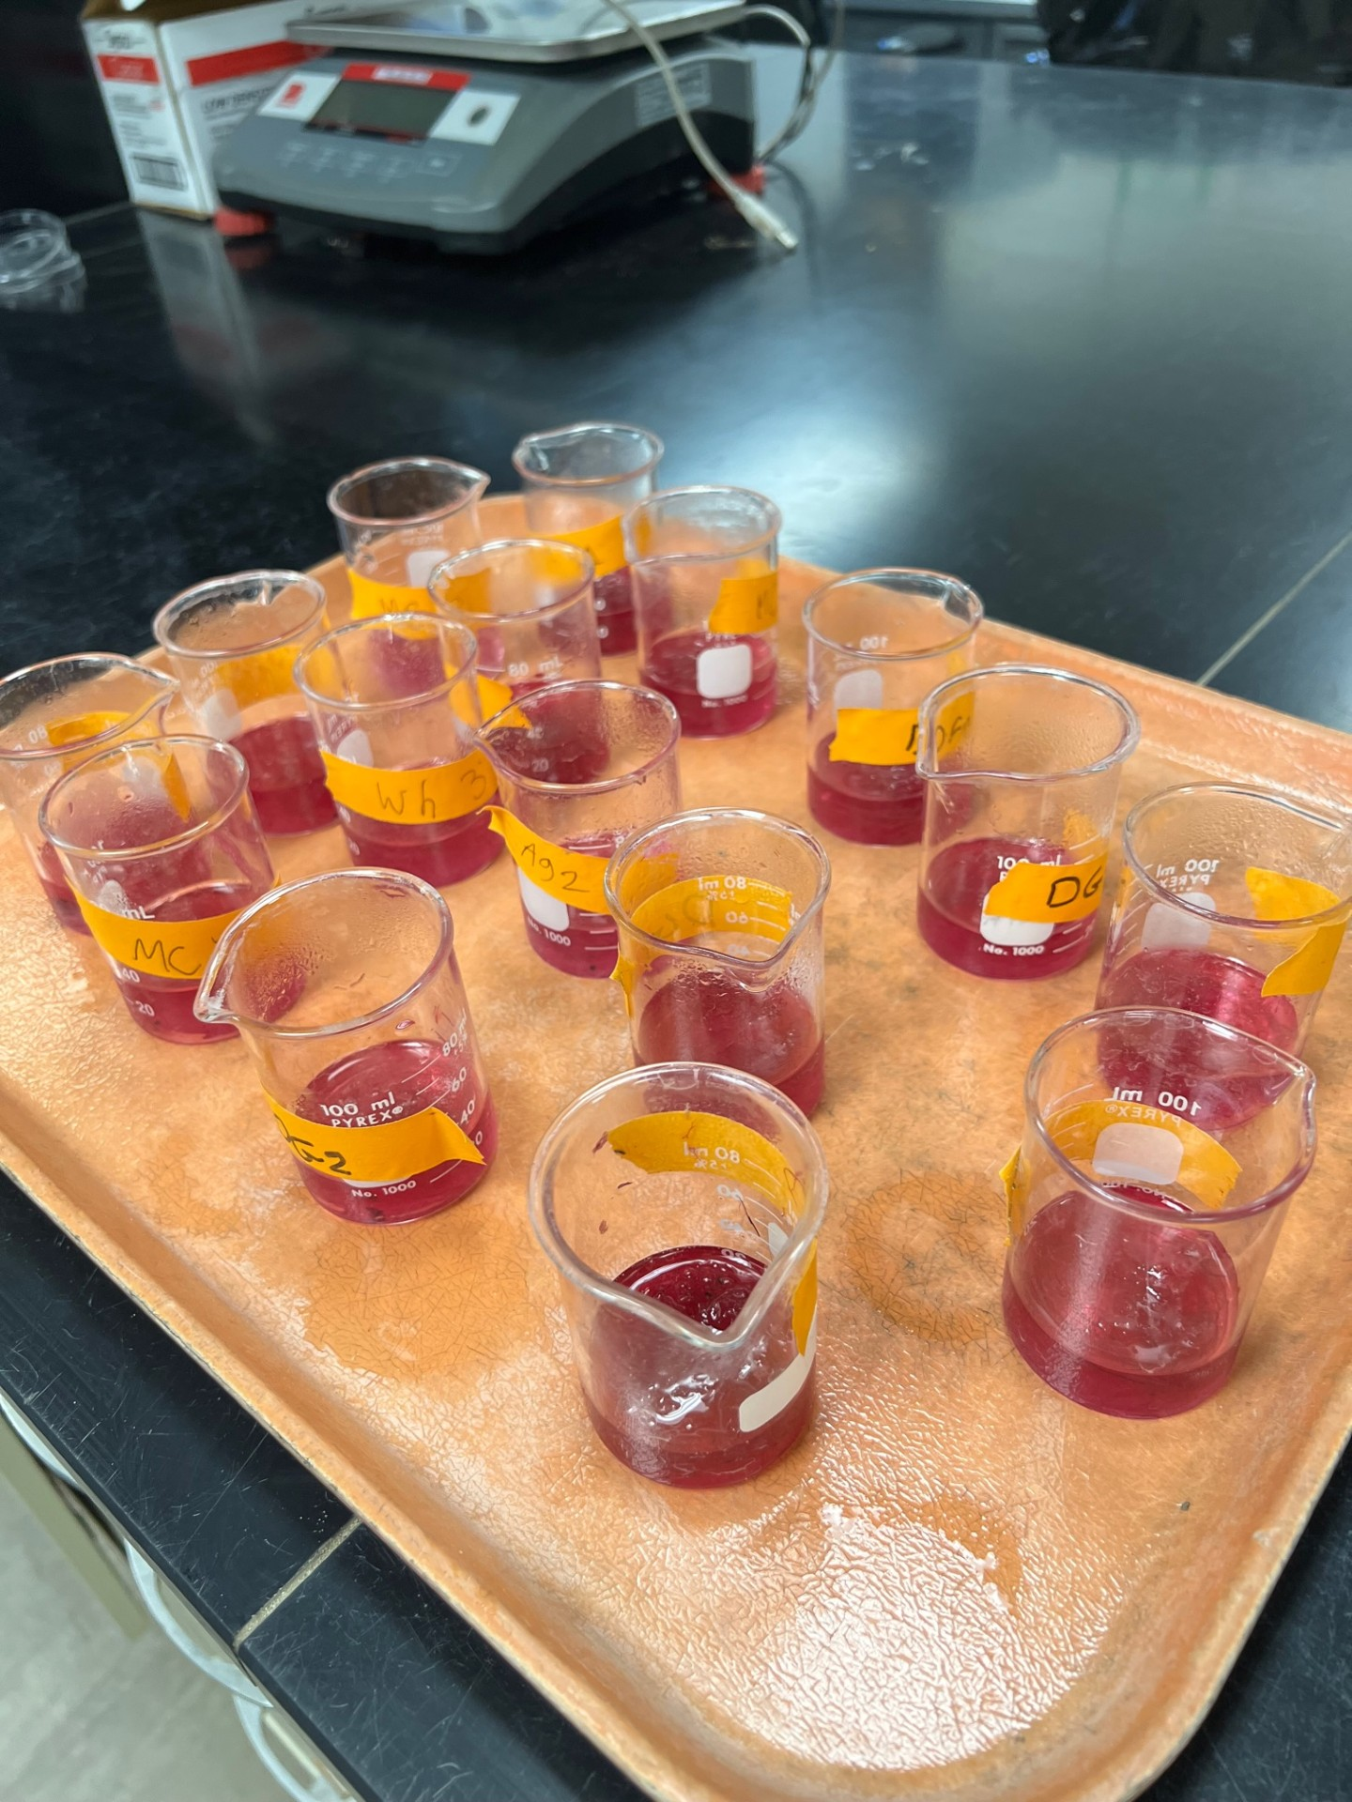
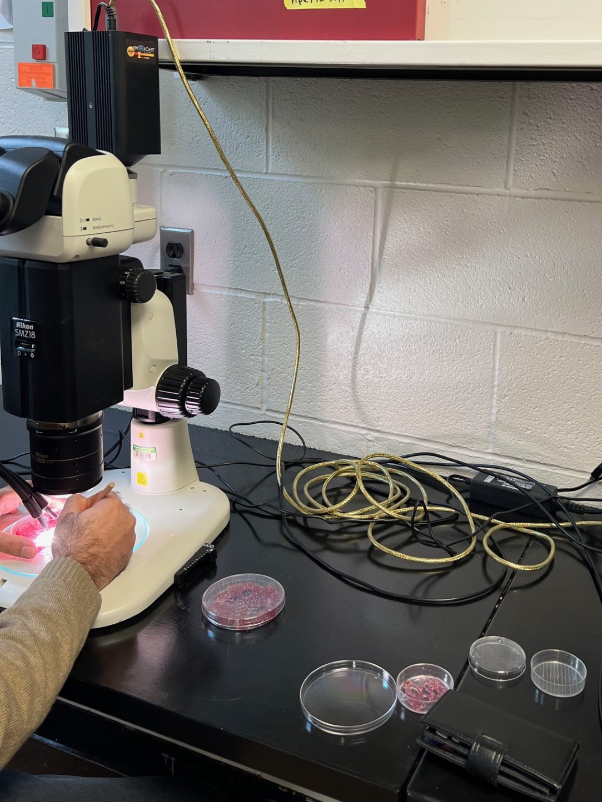
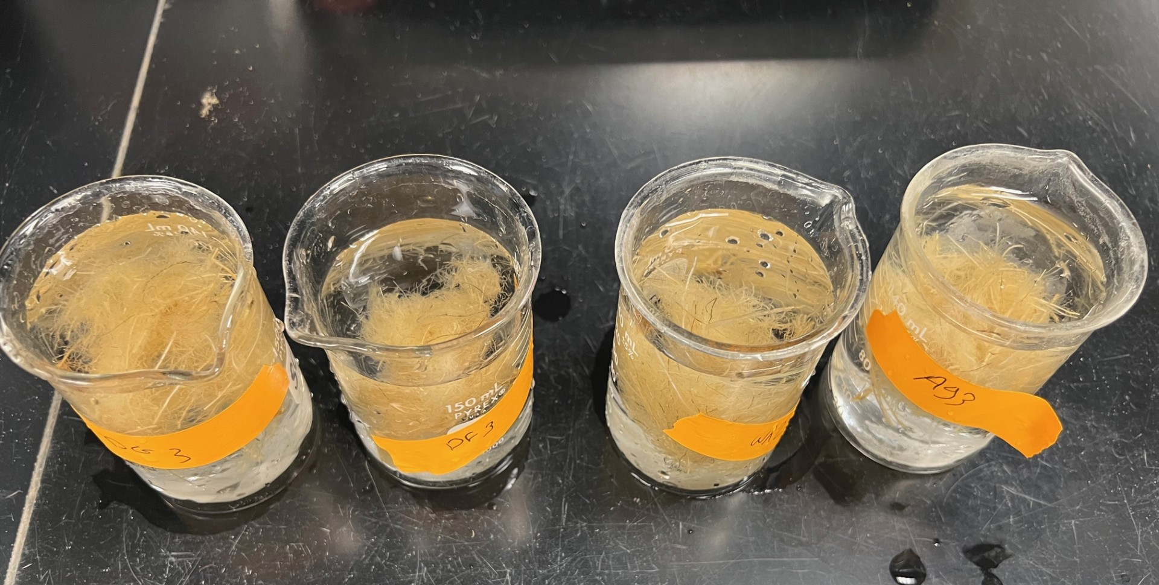

Fig. 2. Root staining process: (A) roots washed, bleached, and rinsed, (B) roots stained with acid fuchsin and transferred to acidified glycerin, and (C) roots examined under a microscope.

Results and Discussion:

The wheat root samples were analyzed using the staining technique; however, no nematodes were observed in the stained root tissues. This suggests that, under the conditions of this study, wheat roots were not colonized by nematodes at detectable levels.

In contrast, soil samples showed evidence of contamination, indicating the presence of soybean cyst nematode (SCN). This discrepancy between root and soil results suggests that the detected nematodes were likely present in the soil but did not infect or reproduce within the wheat roots.

These findings suggest that previous reports identifying wheat as a host for SCN may have been influenced by soil contamination rather than true root infection. Therefore, distinguishing between nematode presence in soil and actual root colonization is essential when evaluating host status. Overall, the results indicate that wheat is unlikely to be a suitable host for SCN.

Objective 2: Evaluating Soybean Cyst Nematode Interactions with Wheat: Host Status and Management Potential
This study investigated the interactions between soybean cyst nematode (SCN) and selected crop species, including wheat, cereal rye, barley, oat, oilseed radish (OSR), and soybean cultivars in Michigan. Host status evaluations were conducted under both greenhouse and microplot conditions to assess the potential of these crops as cover or trap crops for SCN management.
The experiment was arranged in a randomized complete block design with five replications. The cover crop trial was established on October 18, 2024, and harvested on December 3, 2024, at the Michigan State University Entomology Farm in East Lansing, MI (Fig. 3).
The treatments evaluated in this study included:
- Wheat
- Oat
- Oilseed radish (Ecotill)
- Cereal rye
- Fallow (no crop control)
- Wild-type soybean
Soil samples were collected and processed for nematode analysis. Nematodes were extracted from soil subsamples using the sugar centrifugal flotation method (Jenkins, 1964). Extracted cysts and eggs were identified and enumerated under an inverted microscope (Nikon TMS).

B

A

Fig. 3. (A) Microplots at MSU Entomology Farm and (B) microplot cell.

The cover crop treatment trial showed significant differences in SCN reproduction (Table 1). Soybean and cereal rye supported the highest nematode reproduction (means 4.78 and 4.29, respectively; group “A”), confirming their high susceptibility and potential to maintain SCN populations. Oat and oilseed radish (OSR) supported SCN reproduction with means of 2.14 and 1.40, respectively; however, these values were not significantly different from the fallow control, indicating that these crops did not increase SCN populations and can be considered poor hosts under the conditions tested. Wheat exhibited low SCN reproduction (mean 0.67; group “B”), significantly lower than soybean and cereal rye. Compared to the fallow control, wheat effectively limited SCN reproduction, demonstrating its potential as a poor- or non-host and the most suitable crop for SCN management in Michigan soybean systems, highlighting its value for sustainable nematode control and crop rotation planning.

B
A

Fig. 4. Soybean cyst nematode (SCN) reproduction factor (RF) in the microplot cover crop trial. (A) RF based on cyst counts and (B) RF based on egg counts for each cover crop treatment: soybean, cereal rye, oat, oilseed radish (OSR), wheat, and fallow (no cover crop). Error bars represent standard error (S.E.), and letters indicate significant differences among treatments (P < 0.05).

