Michigan Wheat Program Final Report

Title: Strategies to Manage Horseweed (Marestail) in Winter Wheat - Year 1
MWP Project #: 20-08-07-AS
MSU PD#: 46811
Researcher: Christy Sprague, Professor and Extension Specialist
Plant, Soil and Microbial Sciences, Michigan State University,
517/353-0224, sprague1@msu.edu
Date: January 31, 2022

Project goals and values for Michigan Wheat Growers: This research has and will continue to be used to develop recommendations for the most effective horseweed (marestail) management strategies in wheat and after winter wheat harvest. Proper management of horseweed will improve wheat yields where horseweed is present, ultimately increasing economic returns and wheat quality. This project fits with the Michigan Wheat Program’s priorities to:
- evaluate the efficacy of fungicides, herbicides, and insecticides
- evaluate the interaction of pesticides and agronomic practices
- develop management strategies to mitigate losses due to pests

RESULTS OF PROJECT:
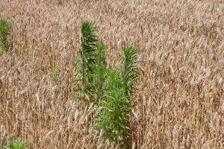
Struggles with horseweed (marestail) management continue to plague Michigan farmers. Typically, these struggles have been more of a problem in low growing spring planted no-till crops (i.e., soybean). However, more recently horseweed management challenges have occurred in tilled fields and in more crops, including winter wheat (Figure 1).
Figure 1. Horseweed not controlled in a winter wheat field in Michigan.
Additionally, one of the longer-term challenges with horseweed management is after wheat harvest (Figure 2). Once wheat is harvested and the crop canopy is removed horseweed often flourishes and it is important to manage it to reduce seed input into that field and surrounding fields. Typically, glyphosate would be the herbicide of choice to clean up these fields, however due to widespread glyphosate-resistance issues in Michigan, growers need other options.
This past year with funding from the Michigan Wheat Program we started a two-year project to answer the following questions:
Figure 2. Horseweed issue after winter wheat harvest.
- What effect does fall herbicide treatments have on horseweed control in winter wheat?
- Which commonly used broadleaf herbicides in winter wheat provide the best horseweed control?
- What effect does horseweed competition have on winter wheat yield?
- What are the best management strategies for horseweed control after winter wheat harvest?

A field experiment was established in the fall of 2020 at the MSU Mason Farm on a field where horseweed (marestail) was present in soybean during the 2020 growing season. The experiment was set up as a split-block design with tillage as the main plot and herbicide treatments as the subplot factors. All plots were replicated four times. After soybean harvest, part of the study area was shallowly tilled with a soil-finisher and the remainder of the study was no-till. ‘Whale’ soft red winter wheat was drilled on October 20 at a population of 1.8 million seeds per. The no-till wheat area had an additional split with a fall application of Sharpen at 1 fl oz/A + Roundup PowerMax at 32 fl oz/A + MSO (Table 1).

Table 1. Tillage and fall herbicide application main plots.
 | Tillage treatments | Herbicide treatments
1 | Conventional tillage | Spring herbicide treatments in Table 2
2 | No-tillage | No fall applications fb. Spring treatments in Table 2
3 |  | Sharpen at 1 fl oz¹ (Fall) fb. Spring treatments in Table 2
4 |  | Sharpen at 2 fl oz¹ (Fall) fb. no spring treatment
¹ Roundup PowerMax (32 fl oz) + MSO + AMS was included with all Sharpen treatments.

In the spring, wheat was sprayed on May 5 when wheat was at Feekes stage 5 and 13-inches tall with five different herbicide treatments within each tillage and fall herbicide block, including untreated controls for a total of 19 treatments (Table 2). Wheat injury and horseweed control were assessed several times throughout the growing season. Wheat was also harvested for yield.

Table 2. Spring herbicide treatments applied in each tillage and fall herbicide block.
 | Herbicide treatment | SOA² Group # | Rate | Additives
1 | Huskie | 6 + 27 | 15 fl oz/A | NIS + AMS
2 | Talinor | 6 + 27 | 18.2 fl oz/A | CoAct+
3 | Quelex | 2 + 4 | 0.75 oz/A | COC
4 | Curtail | 4 + 4 | 2 pt/A
5 | MCPA | 4 | 0.38 pt/A
6 | Untreated
² Herbicide site of action group numbers.

Due to early dry conditions in the spring, wheat effectively competed with horseweed and other weeds, so there were very few weeds to evaluate. However, we were able to evaluate both wheat injury and yield to examine effects on winter wheat on different treatments that may work for horseweed control. Overall, wheat injury both 7 and 14 d after treatment (DAT) were negligible and wheat growth and maturity was similar for all treatments. At the end of the season, there were very minor effects of herbicides on wheat yield. However, averaged across the herbicide treatments wheat yielded highest in the conventional tillage plots (84.2 bu/A) and was significantly greater than the no-tillage plots that did not have a fall burndown (78.9%). The application of a fall burndown of Sharpen at 1 or 2 fl oz/A + Roundup PowerMax 32 fl oz/A + MSO + AMS just prior to no-tilling winter wheat was not different than the conventionally tilled treatments (Figure 3).

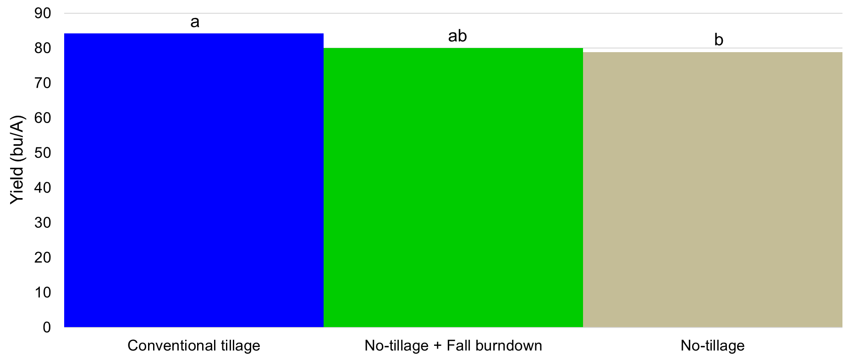
Figure 3. Main effect of tillage on winter wheat yield. Yield is averages over five different spring applied herbicides.

A second experiment was conducted to investigate horseweed control after winter wheat harvest. This experiment was set up as a randomized complete block design with four replications. Three weeks after wheat harvest on August 9, 15 different herbicide treatments were applied and compared with an untreated control. The core treatments examined are listed in Table 3. Additional treatments included combinations of some of these key treatments with Roundup PowerMax and Liberty. These treatments were evaluated 7, 14, and 28 DAT.

Table 3. Herbicide treatments to be applied after winter wheat harvest to evaluate horseweed control.
 | Herbicide treatment | SOA³ Group # | Rate | Additives
1 | Liberty | 10 | 32 and 43 fl oz/A | AMS
2 | Gramoxone | 22 | 2.67 pt/A | NIS
3 | Enlist One (2,4-D)⁴ | 4 | 1 pt/A & 1 qt/A
4 | XtendiMax (dicamba)⁴ | 4 | 22 fl oz/A | Vapor Grip + Intact
5 | Sharpen⁴ | 14 | 1 & 2 fl oz/A | MSO
6 | 2,4-D ester + atrazine⁴ | 4 + 5 | 1 pt/A + 1 qt/A | COC
7 | Roundup PowerMax | 9 | 32 fl oz | AMS
8 | Untreated
³ Herbicide site of action group numbers.
⁴ Roundup PowerMax (32 fl oz/A) + AMS was included.

Horseweed control was greatest (>95%) with Liberty at 43 fl oz/A, Sharpen at 2 fl oz/A + Roundup PowerMax + MSO, and 2,4-D + atrazine + Roundup PowerMax, 14 DAT (Figure 4). Liberty at 32 fl oz/A and Gramoxone provided slightly less control (88%). All other treatments that were not tank-mixed with Liberty provided between 65-80% control, with the exception of Roundup PowerMax that provided no horseweed control, since the population was resistant to glyphosate.
When Liberty at 32 fl oz/A was added to Enlist One, XtendiMax, or Sharpen at 1 fl oz/A horseweed control was similar to Liberty at 43 fl oz/A (Figure 5). Common ragweed control was greater than >92% when Enlist One, XtendiMax, or Sharpen at either rate was applied with Roundup PowerMax (Figure 6). The addition of Liberty to XtendiMax improved common ragweed control. However, adding Liberty to Sharpen reduced common ragweed control compared with either herbicide tank-mixed with Roundup PowerMax.
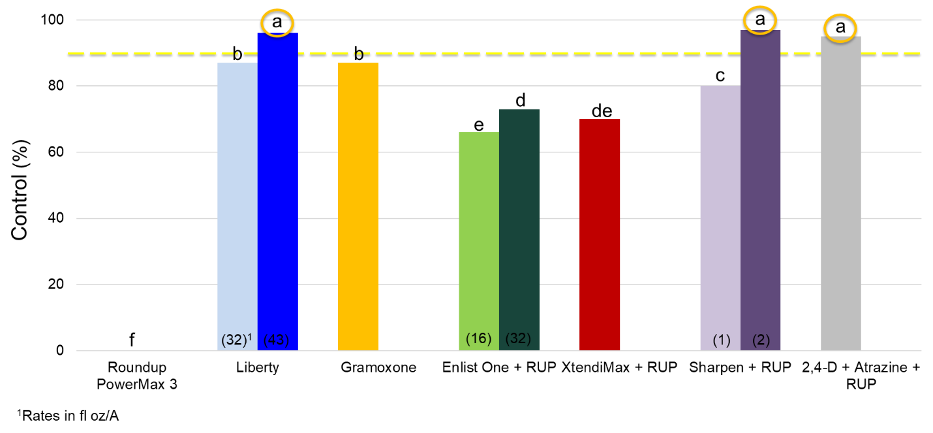
Figure 4. Horseweed control with POST-harvest treatments, 14 DAT, with various herbicides alone and tank-mixed with Roundup PowerMax (glyphosate).

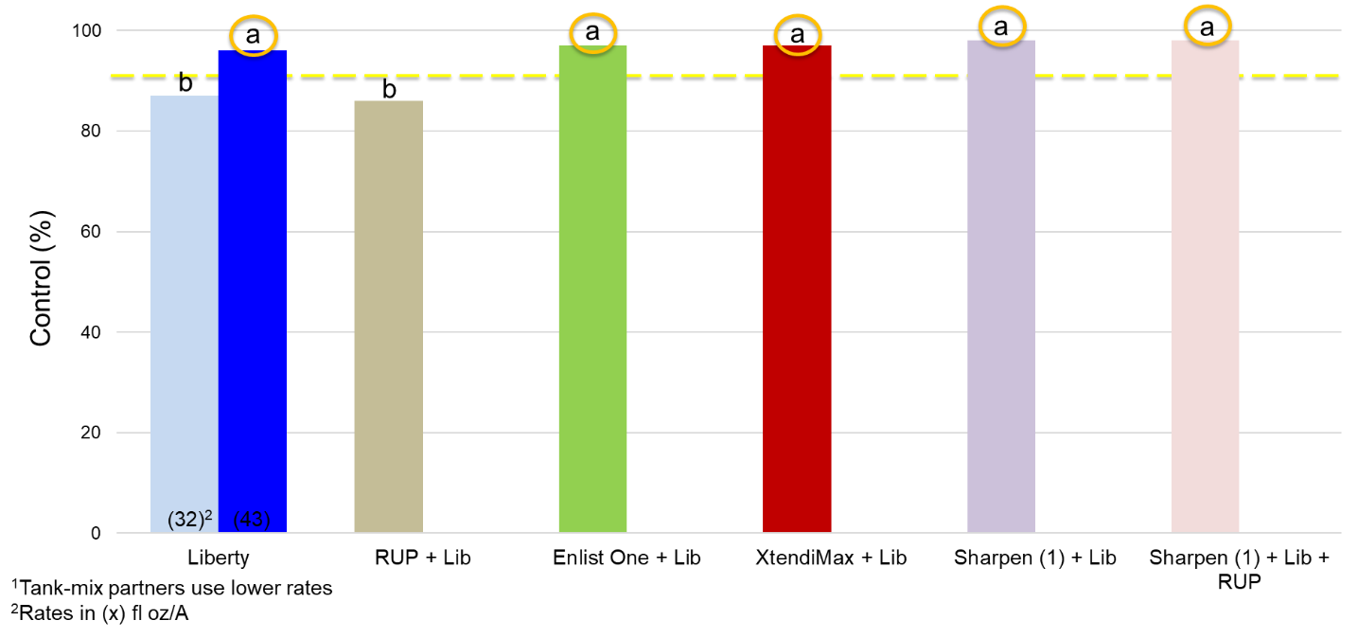
Figure 5. Horseweed control with POST-harvest treatments, 14 DAT, with various herbicide tank-mixed with Liberty at 32 fl oz/A.

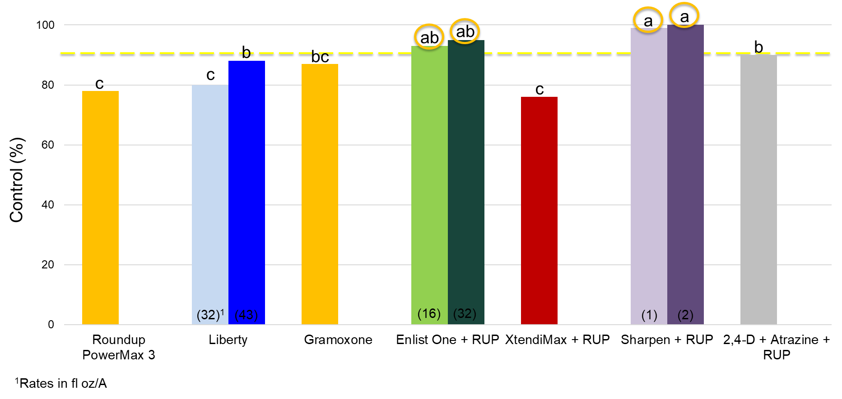
Figure 6. Common ragweed control with POST-harvest treatments, 14 DAT, with various herbicide tank-mixed with Liberty at 32 fl oz/A.

SUMMARY OF PROJECT:
Horseweed (marestail) continues to be a significant weed problem for Michigan farmers in all facets of their rotation, including winter wheat. Prolonged emergence, prolific seed production, capabilities of long-distance seed dispersal, and herbicide-resistance issues have all contributed to challenges with horseweed management. In addition, horseweed management after wheat harvest is another area that contributes to the overall horseweed problem that we have in the state. The dry conditions experienced in the spring of 2021 led wheat being able to out-compete horseweed and other weeds, so horseweed control was not able to be evaluated. However, we were able to compare the effects of different tillage systems on winter wheat yield and found that yield was highest when wheat was planted into conventionally tilled soils compared with a no-tillage practice without a fall burndown. Yet if a fall burndown application of Sharpen + Roundup PowerMax was made prior to planting wheat no-till yield was similar to the conventionally-tilled wheat. Additionally, we found that there are several options for POST harvest control of both horseweed and common ragweed, with the most effective generally involving applications of Liberty and/or Sharpen. We will continue to examine some of these management strategies to develop recommendations on the most effective horseweed management strategies in wheat and after wheat harvest. Proper management of this weed will improve wheat yields where this weed is present, ultimately increasing economic returns and wheat quality. Results from this research will be added to the MSU Weed Control Guide for Field Crops (E-434), continue to be presented at extension meetings, and posted on www.MSUweeds.com.

FUTURE WORK:
We plan to repeat both of these experiments in 2022 with some minor adjustments. This information will be used for future extension meetings and recommendations that will be included in the MSU Weed Control Guide for Field Crops.

PROJECT CHANGES:
None requested.

BUDGET NARRATIVE:
On track.

INTELLECTUAL PROPERTY:
None developed.

APPROACH TO DISSEMINATE RESEARCH:
This research has been and will be used to develop recommendations on the most effective horseweed management strategies in wheat and after wheat harvest. Proper management of horseweed will improve wheat yields where this weed is present, ultimately increasing economic returns and wheat quality. This information will be shared with Michigan wheat growers and will be included in the Michigan Weed Control Guide for Field Crops (E0434). Research data and resulting recommendations will be presented at extension meetings, MWP summer field day, in newsletter articles (i.e., Wheat Wisdom), included in a factsheet on horseweed management in wheat and after wheat harvest, and on the web at www.msuweeds.com. Additionally, when the research is completed, we will write a peer-reviewed manuscript for Weed Technology to communicate with the Weed Science discipline.

