Michigan Wheat Program Final Report

Title: Strategies to Manage Horseweed (Marestail) in Winter Wheat
MWP Project #: 20-08-07-BS
MSU PD#: 53316
Researcher: Christy Sprague, Professor and Extension Specialist
Plant, Soil and Microbial Sciences, Michigan State University,
517/353-0224, sprague1@msu.edu
Date: March 1, 2023

Project goals and values for Michigan Wheat Growers: This research has been used to develop recommendations for the most effective horseweed (marestail) management strategies in wheat and after winter wheat harvest. Proper management of horseweed will improve wheat yields where horseweed is present, ultimately increasing economic returns and wheat quality. This project fits with the Michigan Wheat Program’s priorities to:
- evaluate the efficacy of fungicides, herbicides, and insecticides
- evaluate the interaction of pesticides and agronomic practices
- develop management strategies to mitigate losses due to pests

RESULTS OF PROJECT:
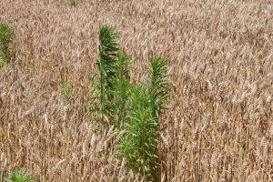
Struggles with horseweed (marestail) management continue to plague Michigan farmers. Typically, these struggles have been more of a problem in low growing spring planted no-till crops (i.e., soybean). However, more recently horseweed management challenges have occurred in tilled fields and in more crops, including winter wheat (Figure 1).
Figure 1. Horseweed not controlled in a winter wheat field in Michigan.
Additionally, one of the longer-term challenges with horseweed management is after wheat harvest (Figure 2). Once wheat is harvested and the crop canopy is removed horseweed often flourishes and it is important to manage it to reduce seed input into that field and surrounding fields. Typically, glyphosate would be the herbicide of choice to clean up these fields, however due to widespread glyphosate-resistance issues in Michigan, growers need other options.
The past two seasons with funding from the Michigan Wheat Program we have strived to answer the following questions:
Figure 2. Horseweed issue after winter wheat harvest.
- What effect does fall herbicide treatments have on horseweed control in winter wheat?
- Which commonly used broadleaf herbicides in winter wheat provide the best horseweed control?
- What effect does horseweed competition have on winter wheat yield?
- What are the best management strategies for horseweed control after winter wheat harvest?

Field experiments were established in the fall of 2020 and 2021 at the MSU Mason and Agronomy Farms, respectively, on fields where horseweed (marestail) was present the previous growing season. In the first year, the experiment was set up as a split-block design with tillage as the main plot and herbicide treatments as the subplot factors. The tillage factor was dropped from the 2nd year and additional fall herbicide applications were included (Table 2). All plots were replicated four times. ‘Whale’ and ‘Wharf’ soft red winter wheat was drilled in late-October at population of 1.8-1.9 million seeds per acre in 2020 and 2021, respectively. The no-till wheat in both years had an additional split with a fall application of Sharpen at 1 fl oz/A + Roundup PowerMax at 32 fl oz/A + MSO (Tables 1 and 2).

Table 1. Tillage and fall herbicide application main plots (Year 1).
 | Tillage treatments | Herbicide treatments
1 | Conventional tillage (year 1 only) | Spring herbicide treatments in Table 3
2 | No-tillage | No fall applications fb. Spring treatments in Table 3
3 |  | Sharpen at 1 fl oz¹ (Fall) fb. Spring treatments in Table 3
4 |  | Sharpen at 2 fl oz¹ (Fall) fb. no spring treatment
¹ Roundup PowerMax (32 fl oz) + MSO + AMS was included with all Sharpen treatments.

Table 2. Fall herbicide applications immediately after winter wheat planting (Year 2).
 | Herbicide treatments
1 | Roundup PowerMax 32 fl oz/A + AMS (Fall)
2 | Liberty 32 fl oz/A + AMS (Fall)
3 | Sharpen at 1 fl oz + Roundup + MSO + AMS (Fall)
4 | Sharpen at 2 fl oz + Roundup + MSO + AMS (Fall)
5 | Sharpen at 1 fl oz¹ (Fall) fb. Spring treatments in Table 3
6 | No fall applications fb. Spring treatments in Table 3
¹ Roundup PowerMax (32 fl oz) + MSO + AMS was included with all Sharpen treatments.

In the spring, wheat was sprayed on May 5, 2021 and May 10, 2022 in 2021 and 2022 when wheat was at Feekes stage 5 and 13- and 10-inches tall, respectively, with five different herbicide treatments within each tillage (Year 1) and fall herbicide block (Years 1 and 2), including untreated controls (Table 3). Wheat injury and horseweed control were assessed several times throughout the growing season. Wheat was also harvested for yield.

Table 3. Spring herbicide treatments applied in each tillage and fall herbicide block.
 | Herbicide treatment | SOA² Group # | Rate | Additives
1 | Huskie | 6 + 27 | 15 fl oz/A | NIS + AMS
2 | Talinor | 6 + 27 | 18.2 fl oz/A | CoAct+
3 | Quelex | 2 + 4 | 0.75 oz/A | COC
4 | Curtail | 4 + 4 | 2 pt/A
5 | MCPA | 4 | 0.38 pt/A
6 | Untreated
² Herbicide site of action group numbers.

In 2021, early dry conditions in the spring led to wheat effectively competing with horseweed and other weeds, so there were very few weeds to evaluate. However, we were able to evaluate both wheat injury and yield to examine effects on winter wheat on different treatments that may work for horseweed control. Overall, wheat injury both 7 and 14 d after treatment (DAT) were negligible and wheat growth and maturity was similar for all treatments. At the end of the season, there were very minor effects of herbicides on wheat yield. However, averaged across the herbicide treatments wheat yielded highest in the conventional tillage plots (84.2 bu/A) and was significantly greater than the no-tillage plots that did not have a fall burndown (78.9%). The application of a fall burndown of Sharpen at 1 or 2 fl oz/A + Roundup PowerMax 32 fl oz/A + MSO + AMS just prior to no-tilling winter wheat was not different than the conventionally tilled treatments (Figure 3).

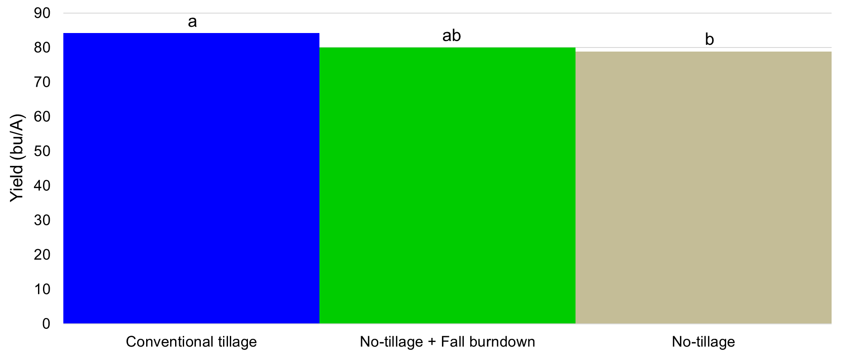
Figure 3. Main effect of tillage on winter wheat yield. Yield is averages over five different spring applied herbicides.

Similar to 2022, there was no injury to winter wheat from any of the herbicide treatments. Winter wheat establishment in growth was excellent helped suppress new weed emergence. However, weed control was application timing, herbicide selection, and weed species dependent. The greatest difference in control was for common chickweed. Common chickweed control was excellent when a fall burndown application of Sharpen (1 fl oz) + Roundup PowerMax + MSO + AMS were made and followed up with any of the spring herbicide treatments (Figure 4). If only a fall burndown treatment was applied common chickweed control was 79-92% and herbicide selection was important for common chickweed control for spring only herbicide applications. Common chickweed control was greater with Huskie, Talinor, or Quelex than Curtail and MCPA. However, none of these treatments were equivalent to a fall burndown followed by spring POST herbicide application.
Unlike common chickweed, horseweed control was excellent 14 d after the spring application and at winter wheat harvest with all treatments, with the exception of a fall burndown application of Roundup PowerMax or a MCPA spring only application. There was no control with Roundup PowerMax, due to the horseweed population being glyphosate-resistant and horseweed control was only 75% when MCPA was applied in the spring.
Common ragweed control was also evaluated at wheat harvest. All spring applied herbicide treatments provided greater than 98% common ragweed control. None of the fall herbicide applications provided common ragweed control at wheat harvest. Winter wheat yield ranged from 97-112 bu/A and the only difference in yield was between the highest and lowest yielding treatments.
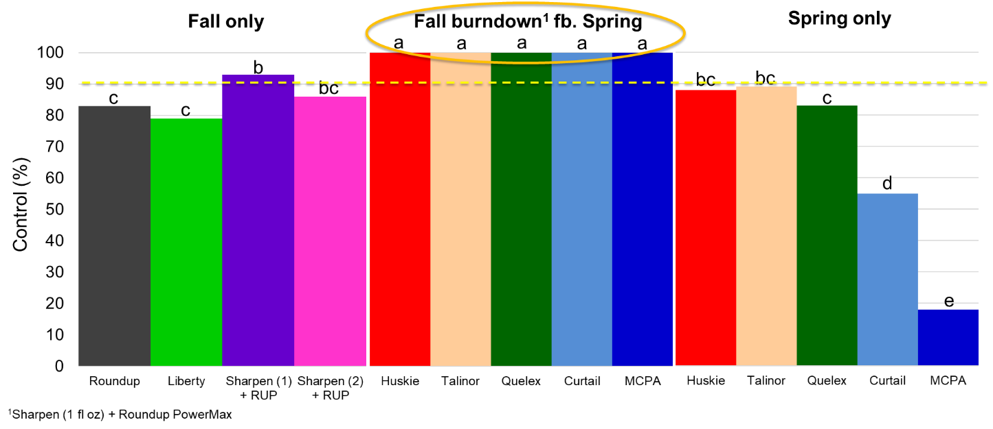
Figure 4. Common chickweed control, 14 d after spring herbicide application, from fall burndown only, fall burndown followed by spring POST, and spring POST only treatments. Yield is averages over five different spring applied herbicides.

A second experiment was conducted to investigate glyphosate-resistant horseweed control after winter wheat harvest. This experiment was set up as a randomized complete block design with four replications. Approximately, three weeks after wheat harvest in early August of 2021 and 2022, 15 different herbicide treatments were applied to 15- 1-inch tall horseweed and compared with an untreated control. The core treatments examined are listed in Table 4. Additional treatments included combinations of some of these key treatments with Roundup PowerMax and Liberty. These treatments were evaluated 7, 14, and 28 DAT.

Table 4. Herbicide treatments to be applied after winter wheat harvest to evaluate horseweed control.
 | Herbicide treatment | SOA³ Group # | Rate | Additives
1 | Liberty | 10 | 32 and 43 fl oz/A | AMS
2 | Gramoxone | 22 | 2.67 pt/A | NIS
3 | Enlist One (2,4-D)⁴ | 4 | 1 pt/A & 1 qt/A
4 | XtendiMax (dicamba)⁴ | 4 | 22 fl oz/A | Vapor Grip + Intact
5 | Sharpen⁴ | 14 | 1 & 2 fl oz/A | MSO
6 | 2,4-D ester + atrazine⁴ | 4 + 5 | 1 pt/A + 1 qt/A | COC
7 | Roundup PowerMax | 9 | 32 fl oz | AMS
8 | Untreated
³ Herbicide site of action group numbers.
⁴ Roundup PowerMax (32 fl oz/A) + AMS was included.

In both years, horseweed control was greater than 95% with Liberty at 43 fl oz/A, Sharpen at 2 fl oz/A + Roundup PowerMax + MSO, and 2,4-D + atrazine + Roundup PowerMax, 14 DAT (Figures 5 and 6). Additionally in 2022, Liberty at 32 fl oz/A and Gramoxone provided slightly higher horseweed control than in 2021. All other treatments that were not tank-mixed with Liberty provided between 65-80% control, with the exception of Roundup PowerMax that provided no horseweed control, since the population was resistant to glyphosate.

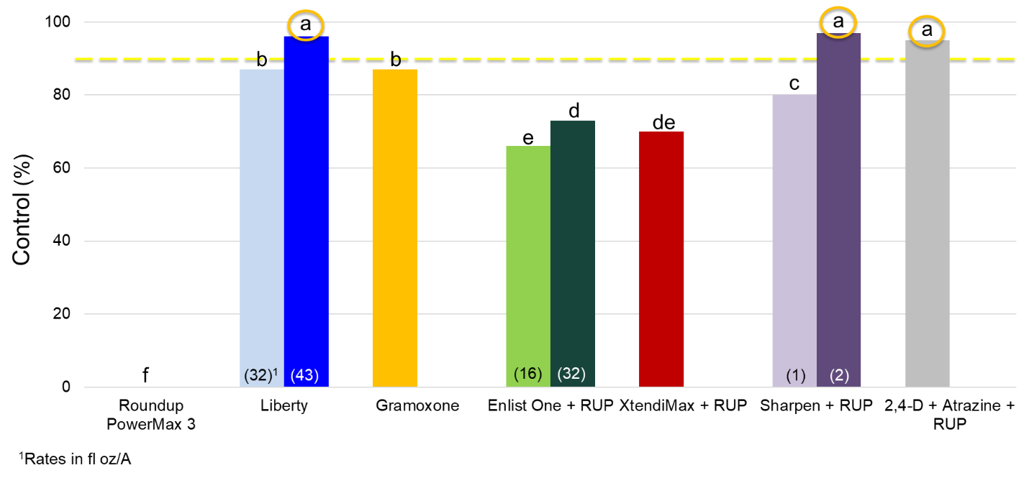
Figure 5. Horseweed control with POST-harvest treatments, 14 DAT, with various herbicides alone and tank-mixed with Roundup PowerMax (glyphosate), 2021.

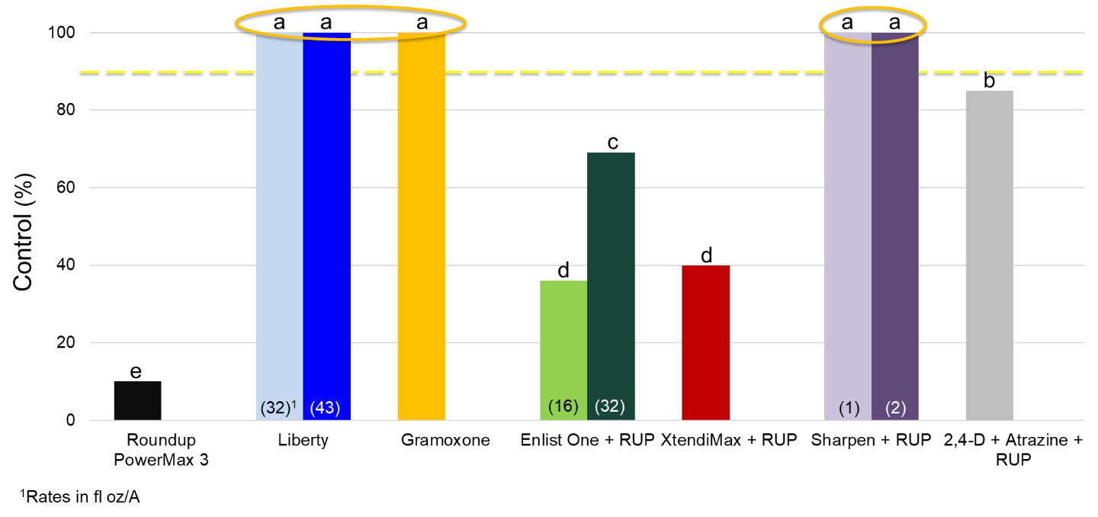
Figure 6. Horseweed control with POST-harvest treatments, 14 DAT, with various herbicides alone and tank-mixed with Roundup PowerMax (glyphosate), 2022.

When Liberty at 32 fl oz/A was added to Enlist One, XtendiMax, or Sharpen at 1 fl oz/A horseweed control was similar to Liberty at 43 fl oz/A in 2021 (Figure 7). Common ragweed control was greater than >92% when Enlist One, XtendiMax, or Sharpen at either rate was applied with Roundup PowerMax. The addition of Liberty to XtendiMax improved common ragweed control. However, adding Liberty to Sharpen reduced common ragweed control compared with either herbicide tank-mixed with Roundup PowerMax (Figure 8).

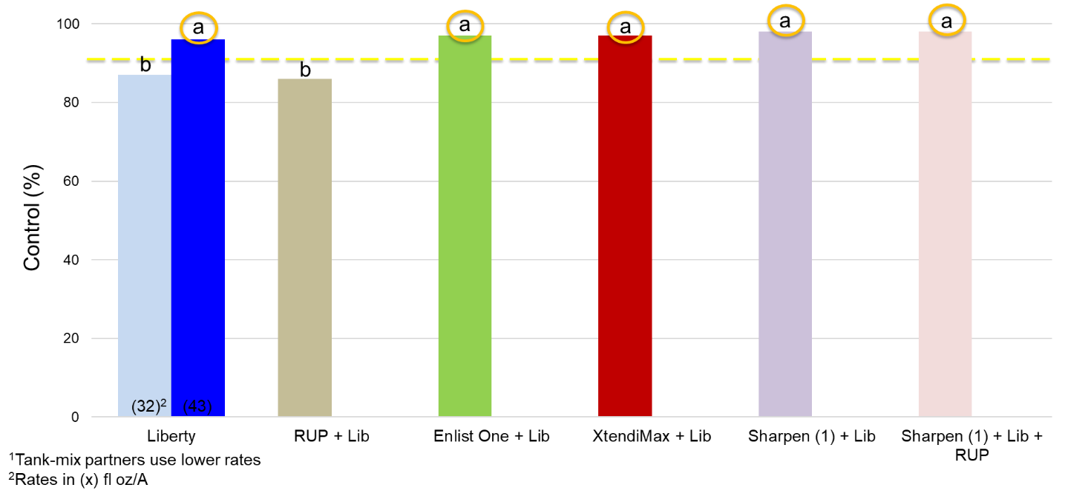
Figure 7. Horseweed control with POST-harvest treatments, 14 DAT, with various herbicide tank-mixed with Liberty at 32 fl oz/A, 2021.
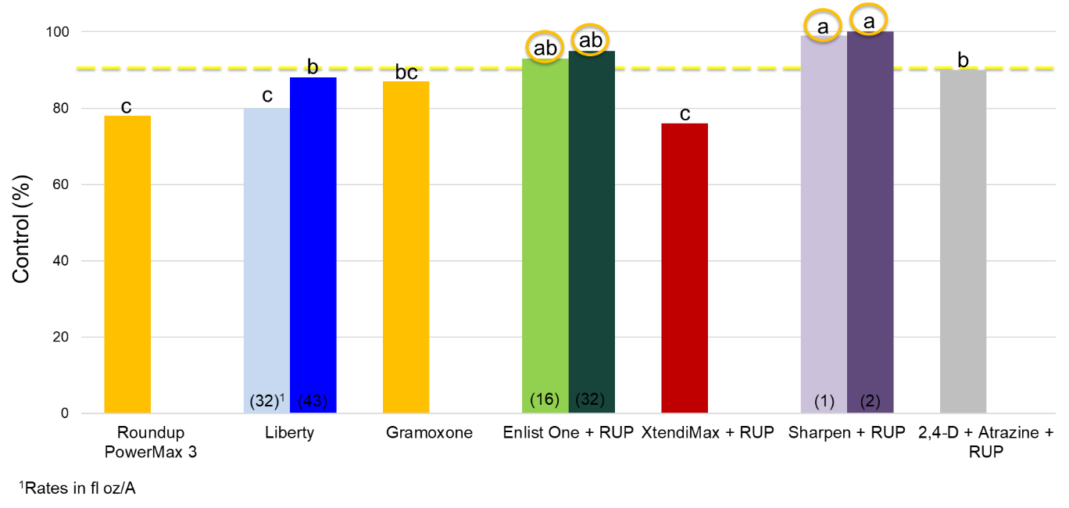

Figure 8. Common ragweed control with POST-harvest treatments, 14 DAT, with various herbicide tank-mixed with Liberty at 32 fl oz/A.

FUTURE WORK:
This project is completed, and the information generated has been used for recommendations on how to manage glyphosate-resistant horseweed and presented to Michigan Wheat growers through various formats.

PROJECT CHANGES:
None requested.

BUDGET NARRATIVE:
On track.

INTELLECTUAL PROPERTY:
None developed.

APPROACH TO DISSEMINATE RESEARCH:
This research has been and will continue to be used to develop recommendations on the most effective horseweed management strategies in wheat and after wheat harvest. Proper management of horseweed will improve wheat yields where this weed is present, ultimately increasing economic returns and wheat quality. This information has been shared with Michigan wheat growers and is included in the Michigan Weed Control Guide for Field Crops (E0434). Recommendations will continue to be presented at extension meetings, and in newsletter articles, and on the web at www.msuweeds.com.

