Michigan Wheat Program Final Report
Title: Weed control and crop tolerance in early- and late-planted winter wheat from fall herbicide applications - Year 3
MWP Project #: 22-08-05-CS
MSU PD#: 71616
Researcher: Christy Sprague, Professor and Extension Specialist
Plant, Soil and Microbial Sciences, Michigan State University,
517/353-0224, sprague1@msu.edu
Kaddi Gewirtz, M.S. Graduate Student, gewirtz3@msu.edu
Date: December 27, 2025
Project goals and value for Michigan Wheat Growers: Controlling weeds in the fall may help with overall wheat establishment and growth, leading to vigorous wheat stands that may outcompete spring emerging weeds, preventing the need for a spring herbicide application. However, little is known about the benefits of fall herbicide applications on early versus later planted wheat and what effect cold temperatures may have on fall herbicide applications. This research will be used to develop recommendations on fall versus spring herbicide applications on early- versus late-planted winter wheat. These recommendations will help ensure successful weed control, while maximizing wheat yields. This project fits with the Michigan Wheat Program’s priorities to:
- develop management strategies to mitigate losses due to pests.
- evaluate the efficacy of fungicides, herbicides, and insecticides.
- evaluate the interaction of pesticides, varieties, and agronomic practices.

RESULTS OF PROJECT – 3 YEARS:
Winter wheat planting in Michigan commences in mid-September after the Hessian fly free date and may continue over the following 4 to 6 weeks. Delays in harvest and rainy fall weather can push an ideal planting date of mid- to late-September into late-October or further. This range in planting dates could have an impact on how to best manage weeds. This window can affect both weed and winter wheat growth and where fall herbicide applications may best fit. As planting dates are pushed to later October, there are questions regarding the benefits of fall herbicide applications. The increased interest in fall POST herbicide applications stems from trying to improve control of winter annual broadleaf weeds and hard to control winter annual grasses. Also, with earlier planted wheat growers have asked: Will fall herbicide applications eliminate the need for a spring herbicide application? Fall herbicide applications may also become more important, as we have struggled over the past several years in finding the ideal time to apply wheat herbicides in the spring, due to colder weather. Therefore, the objectives of this research were two-fold: 1) evaluate weed control and crop tolerance from fall-applied herbicides for early- and late-planted wheat, and 2) determine if later fall herbicide applications, under cooler conditions, influence wheat tolerance to commonly used herbicides.

TRIAL INFORMATION:
This year was the third and final season of this experiment where we examined the effects of fall herbicide applications on crop tolerance and weed control in early and late planted wheat. Winter wheat was planted in mid- to late-September and in late-October (+4 weeks). Fall herbicide applications were made at two different times for the early planted wheat when winter wheat had 2- to 3-leaves (Feekes 1.2 to 1.3) and then approximately two weeks later (considerably more winter annual weed growth). Only one application was made to the later planted wheat, which usually occurred the first week of December. Herbicides examined included (Table 1): Huskie, Talinor, Affinity BroadSpec, and Quelex for broadleaf weed control and Osprey and PowerFlex for winter annual grass control. Tank-mixtures of Huskie + Osprey and Huskie + PowerFlex were also examined. These treatments were compared with spring applications of Huskie and Huskie + Osprey. This experiment was conducted over five site-years that included 2022-2023 at MSU (East Lansing), 2023-2024, and 2024-2025 at MSU and at the Saginaw Valley Research and Extension Center (SVREC) near Richville, MI. ‘Wharf’ soft red winter wheat was planted at MSU and ‘AM Mackinaw’ soft white winter wheat was planted at SVREC to coincide with what wheat types are planted in the two different areas of Michigan.

Table 1. Fall herbicide treatments applied to early- and late-planted wheat at application 1 and 2.
 | Herbicide treatment | SOA¹ Group # | Rate | Additives
1 | Huskie | 6 + 27 | 15 fl oz/A | NIS + AMS
2 | Talinor | 6 + 27 | 18.2 fl oz/A | CoAct+ + COC
3 | Affinity BroadSpec | 2 + 2 | 1 oz/A | NIS + AMS
4 | Quelex | 2 + 4 | 0.75 oz/A | COC
5 | Osprey | 2 | 4.75 oz/A | NIS + AMS
6 | PowerFlex HL | 2 | 2 oz/A | NIS + AMS
7 | Huskie + Osprey | 6 + 27 + 2 | 15 fl oz + 2 oz/A | NIS + AMS
8 | Huskie + PowerFlex | 6 + 27 + 2 | 15 fl oz + 4.75 oz/A | NIS + AMS
9 | Untreated
¹ Herbicide site of action group number.

CROP TOLERANCE:
Winter wheat injury from fall herbicide applications to 2 to 3leaf wheat was apparent in only three of the five site-years in this study. At the three MSU site-years, there was a significant planting date by herbicide treatment interaction for wheat injury 14 days after treatment (DAT). Osprey- and PowerFlex-containing treatments caused significant injury (9–12%) at 14 DAT when applied to wheat planted at the ideal time (Figure 1). Injury symptoms included foliar discoloration (yellowing) and general stunting.

In contrast, applications of Huskie, Talinor, Quelex, and Affinity BroadSpec did not cause significant injury and were not different from the untreated control. No injury from any fall herbicide treatment was observed 14 DAT when applied to the later-planted wheat. Differences between planting dates may be attributed to wheat growth after herbicide application. For the earlier planting date, fall temperatures allowed continued growth and biomass accumulation, which likely contributed to observable differences among herbicide treatments.

By mid-April, no wheat injury from fall herbicide treatments was apparent at two of the three MSU site-years. However, at MSU24, there was a significant planting date by herbicide treatment interaction for injury. Wheat planted at the ideal timing recovered from the fall injury caused by Osprey and PowerFlex, similar to MSU23 and MSU25 (Figure 2). In contrast, wheat planted later exhibited mid-April injury ranging from 15–19% following fall applications of PowerFlex alone, PowerFlex + Huskie, and Osprey + Huskie (Figure 3). Spring injury symptoms also included yellowing and stunting, although wheat eventually outgrew these symptoms within a couple of weeks.

At SVREC24 and SVREC25, none of the fall herbicide treatments caused injury to wheat planted at either timing. One potential explanation is the difference in winter wheat classes planted at these locations; soft white winter wheat was planted at SVREC.

Winter wheat injury from additional Huskie and Huskie + Osprey treatments, applied two weeks after the initial fall application for the ideal planting date, and in the spring for both planting dates, was compared with the fall applications of the same treatments across all site-years. Regardless of herbicide treatment, no injury occurred in the fall or early spring from the fall 2nd applications to wheat planted at the ideal timing.

Additionally, no injury was observed from these treatments applied in the spring (Feekes 4–5) in four of the five site-years. However, at SVREC25, there was a significant two-way interaction of planting date–application time by herbicide treatment 14 DAT. Spring-applied Huskie + Osprey caused 10% injury to the later-planted wheat, characterized by yellowing and stunting. Wheat soon quickly outgrew this injury.

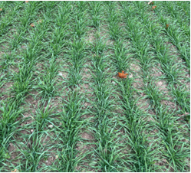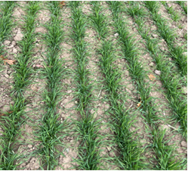

Figure 1. Wheat injury and weed control from the Oct.18 fall application of herbicides to early planted wheat,
14 DAT.

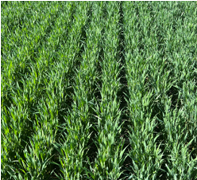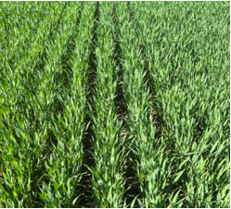

Figure 2. Winter wheat outgrew injury from fall applications in the spring for both planting dates. Pictures taken end of April.

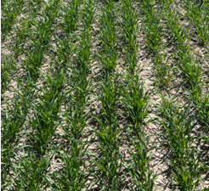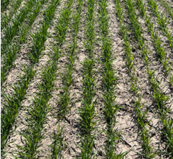

Figure 3. Winter wheat 14 DAT from Huskie + Osprey compared to the untreated control from the spring herbicide application to the later planted wheat at SVREC-25.

CANOPY DEVELOPEMENT:
Greater development of a crop canopy can help with weed suppression and many times can improve crop yield. The development of the winter wheat crop canopy was measured throughout the season for various treatments. While herbicide treatment had very little effect on canopy closure, the time of winter wheat planting and the time of herbicide application did affect canopy development. Early planted wheat regardless of fall herbicide applications provided quicker canopy closure (50 & 75%) across all site-years. However, spring applications delayed canopy development. Spring applications to the early and late planting date delayed wheat development, 24 and 22 d to 50% closure at SVREC-24 (Figure 4). Due to wheat growth and earlier canopy closure very few summers annual weeds emerged (Figure 5).


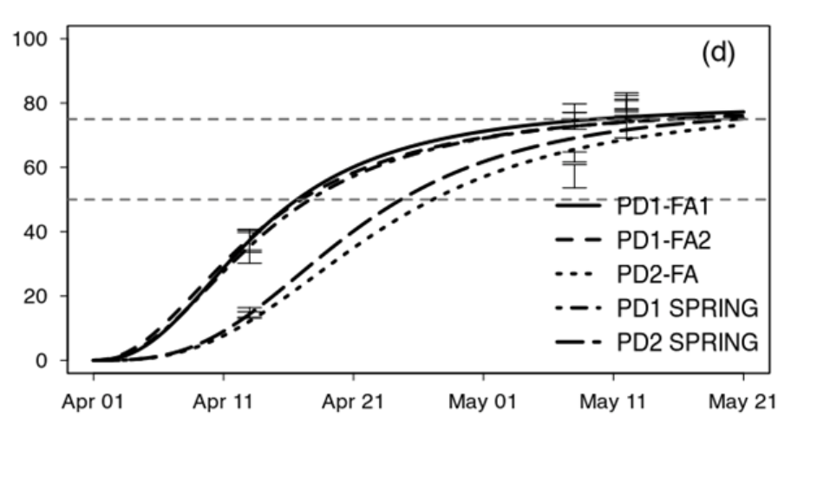
Figure 4. Wheat canopy closure at SVREC-25 for the five different application timings for Huskie + Osprey.

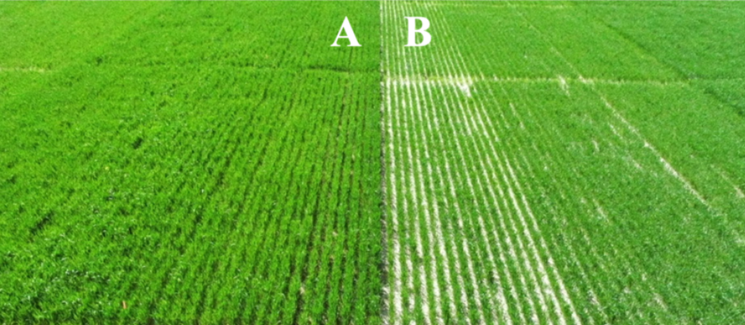

Figure 5. MSU. Canopy Closure May 2, 2024. (A) Early planted ~ 66% (B) Late planted ~ 52%

WEED CONTROL:
Weed biomass was harvested mid-season as a measurement of weed control from the different herbicide programs. At SVREC, weed numbers were low, so weed control and biomass were not evaluated. At campus 2023 and 2024, weed biomass was 121% higher in the first planting date compared with the later planting date. At campus 2025, the later planted wheat had 60% higher weed biomass when compared to the early planted date. One explanation is that there were dry conditions in the fall after wheat was plated at the ideal time that could have delayed germination and good wheat fall establishment. Additionally, the main effect of application timing did not affect weed biomass at the three site-years. However, the combination of Osprey with Huskie reduced weed biomass 29% (or 1.3 times) more than Huskie alone.

WHEAT YIELD:
Across the five site-years of the study, the effect of planting date on wheat yield was significant four out of five site-years. At campus 2023, SVREC 2024 and SVREC 2025, the early planted wheat outyielded late planted wheat by an average of 15%, regardless of application timing. There was no difference in wheat yields at MSU-24, regardless of planting date or application timing. This was likely due to the occurrence of stripe-rust that appeared in early May, likely negating any advantage to early planting even with a fungicide application. Different results occurred at MSU-25, the later planted wheat outyielded the early planted wheat at the FPOS1 application. This was likely due to the dry conditions that were experienced after the ideal planting. Herbicide selection did not affect yield in four out of five site-years. SVREC-25 had the highest yielding treatment of the later application to the early planted wheat. The later planting with the spring application of Huskie + Osprey reduced wheat yield by 15% compared to the untreated control.

SUMMARY OF PROJECT – 3 YEARS:
There has been an increased interest regarding fall herbicide applications for weed control in winter wheat. Controlling weeds in the fall for early (ideal) planted wheat was beneficial in overall wheat establishment leading vigorous wheat stands that helped outcompete the spring emerging weeds, preventing the need for a spring herbicide application. Overall, there was no difference in weed suppression based on herbicide treatment, however adding Osprey or PowerFlex to Huskie was needed for annual bluegrass control in the fall. Fall herbicide treatments that contain Osprey or PowerFlex caused some injury to wheat (yellowing and stunting), 14 days after application at East Lansing for the earlier planting early fall application. However, by spring this injury was not apparent. In one site-year, fall applications of treatments that contained Osprey or PowerFlex to later planted wheat showed some initial injury in the spring but quickly it outgrew this injury and ultimately did not affect yield. Overall, all other treatments had very little herbicide injury to wheat. Both spring herbicide applications provided good control of winter annual weeds, which contrasts with our 2023 research where fall herbicide applications provided greater weed control of winter annual weeds than applications made in the spring. Due to the excellent wheat growth very few summer annual weeds emerged at both locations. Fall herbicide applications, particularly for early planted wheat, may be the best option to control weeds as spring weather often impacts the time of herbicide application. Additionally, earlier canopy closure helped suppress summer annuals and maximized winter wheat yield. Overall, herbicide selection did not affect wheat yield from fall herbicide applications. Planting data had more of an effect on wheat yield with greater wheat yield from earlier planted wheat in three of five site-years.
This research has been used to develop recommendations to ensure successful weed management while maximizing wheat yield. The results from this research has been included in MSU Weed Control Guide for Field Crops (E-434), presented at extension meetings, presented MWP summer field day, and posted on www.MSUweeds.com.

FUTURE WORK:
This is the conclusion of the project.

