# Michigan Wheat Program Final Report

# Title: *Roughstalk bluegrass management in winter wheat* - Year 3

**MWP Project #:** 17-08-05-CS

**MSU#:** 443114

**Researcher:**  Christy Sprague, Professor and Extension Specialist

Plant, Soil and Microbial Sciences, Michigan State University,

517/353-0224, [sprague1@msu.edu](mailto:sprague1@msu.edu)

**Date:** August 19, 2019

**Project goals and values for Michigan Wheat Growers:** This research has been used to develop recommendations on the most effective roughstalk bluegrass management strategies in winter wheat. Proper management of this weed will improve wheat yields where this weed is present, ultimately increasing economic returns and wheat quality. This project fits with the Michigan Wheat Program’s priorities to:

* evaluate the efficacy of fungicides, herbicides, and insecticides
* develop management strategies to mitigate losses due to pests

**RESULTS OF PROJECT:**

 Grass weed problems have become more prevalent in Michigan wheat fields over the past several years. One grass weed that has become more apparent in many Michigan wheat fields is roughstalk bluegrass (*Poa trivialis*). Roughstalk bluegrass (RSBG) is a cool-season perennial grass weed that can survive year-to-year by creeping, above-ground stems, known as stolons. However, this grass can also reproduce and spread by seed and this appears to be the case in wheat. As roughstalk bluegrass grows it becomes 1 to 3 feet tall and often exceeds the wheat canopy once it flowers in May. However, roughstalk bluegrass really becomes apparent in winter wheat once the plants start to mature and turn a golden-brown color in June just prior to seed shed, while wheat is still green (Figure 1). While we have some general knowledge about the biology and growth of roughstalk bluegrass in turf, there is very little information available about how it grows in wheat.

Figure 1. Roughstalk bluegrass in a Michigan wheat field.

Over the last three years with funding from the Michigan Wheat Program we have conducted research to answer the following questions:

1. When does roughstalk bluegrass emerge in winter wheat in Michigan?
2. What herbicides and when is the best time to apply these herbicides to manage roughstalk bluegrass in winter wheat?

We have monitored roughstalk bluegrass emergence and growth over the past three winter wheat growing seasons. This has provided us with some baseline knowledge on this weed in Michigan winter wheat. Our results have shown us that a majority of roughstalk bluegrass emerges in the fall; however early spring emergence can happen up until the 2nd week of May. Depending on wheat planting date, fall emerged roughstalk bluegrass can be more problematic and more competitive with winter wheat. Once the spring season starts, roughstalk bluegrass can rapidly progress through its life cycle. Roughstalk bluegrass starts to head out between the 1st and 3rd weeks of May, reaches full-flower one to two weeks later, matures and turns a golden-brown color by the 1st or 2nd weeks of June. Knowing this information on the phenology of roughstalk bluegrass, including emergence and growth, will aid us in the timing of future management strategies, including herbicide applications.

In addition to examining the emergence and phenology of roughstalk bluegrass, our goal has been to conduct extensive studies examining different management strategies using several different herbicide options at different application timings, including fall, early spring, and late spring applications. The main herbicide active ingredients that we have examined for roughstalk bluegrass control include: mesosulfuron, pyroxsulam, and pinoxaden alone and most recently in a premixtures. These active ingredients are sold as ***Osprey*** (*mesosulfuron*) which is a Group 2 herbicide that can be applied to wheat from Feekes stage 1 to 6. The use rate is 4.75 oz/A and it should be applied with a NIS + AMS. The second herbicide is ***PowerFlex HL*** (*pyroxsulam*) which is also a Group 2 herbicide and can be applied to wheat between Feekes 1.3 and 6. The use rate is 2 oz/A and additives are NIS + AMS. The final herbicides are ***Axial XL*** (*pinoxaden*) and ***Axial Bold*** (*pinoxaden* + *fenoxaprop-p-ethyl*). These are Group 1 herbicides and are applied at 16.4 and 15 fl oz/A, respectively. In 2020, Axial Bold replaced Axial XL in the marketplace, and we examined Axial Bold in both 2019 and 2020. Both herbicides can be applied up to Feekes stage 8 (preboot). In 2020, we also examined a new premixture ***Osprey Xtra*** (*mesosulfuron + thiencarbazone*) that includes an additional Group 2 herbicide for broadleaf weed control. The use rate for Osprey Xtra is 4.75 oz/A and it should be applied with a NIS + AMS. We were able examine several different applications timings for these herbicides, including fall (wheat at Feekes 1.2-1.3), early spring (Feekes 4-5), and late spring (Feekes 6-7) applications, but due to delayed planting in the 2018-2019 season, fall applications could not be made.

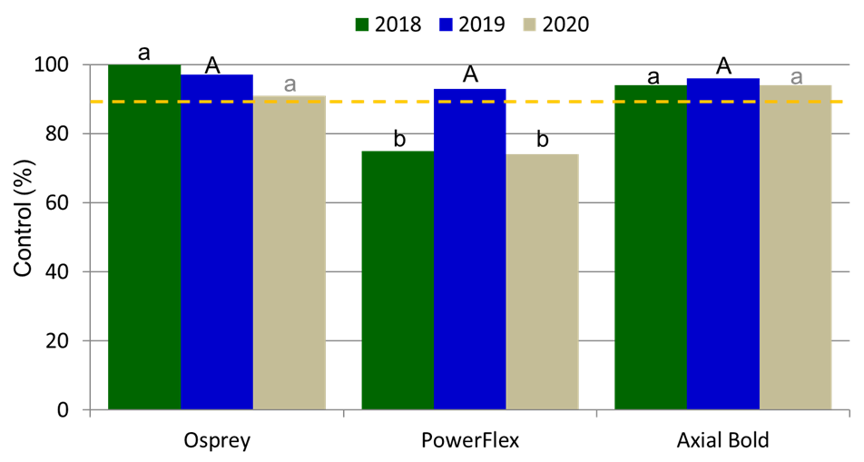We have found that the time of herbicide application influences roughstalk bluegrass control. While we have had acceptable control with fall herbicide applications of Osprey and Axial Bold, across all treatments roughstalk bluegrass control was greatest from early spring applications. Early POST applications, when wheat is at Feekes stage 5 or less and roughstalk bluegrass is 3-inches or less has provided the most consistent control. We have observed some differences in product performance over the three years (Figure 2), especially with PowerFlex. Early POST applications of Osprey have been the most consistent. Through the end of the season, it also appears that the addition of a tank-mix partner like Huskie or Talinor does not increase or decrease roughstalk bluegrass control with these herbicides. Additionally, broadleaf weed control was not affected. Over the years, one of the greatest things that we observed was that roughstalk bluegrass control was reduced dramatically when herbicide applications were made as roughstalk bluegrass started to head out, especially in 2019. However, in 2020 when the late POST applications were made slightly earlier, we had good control at harvest (Figure 3). We have also found that without extensive management 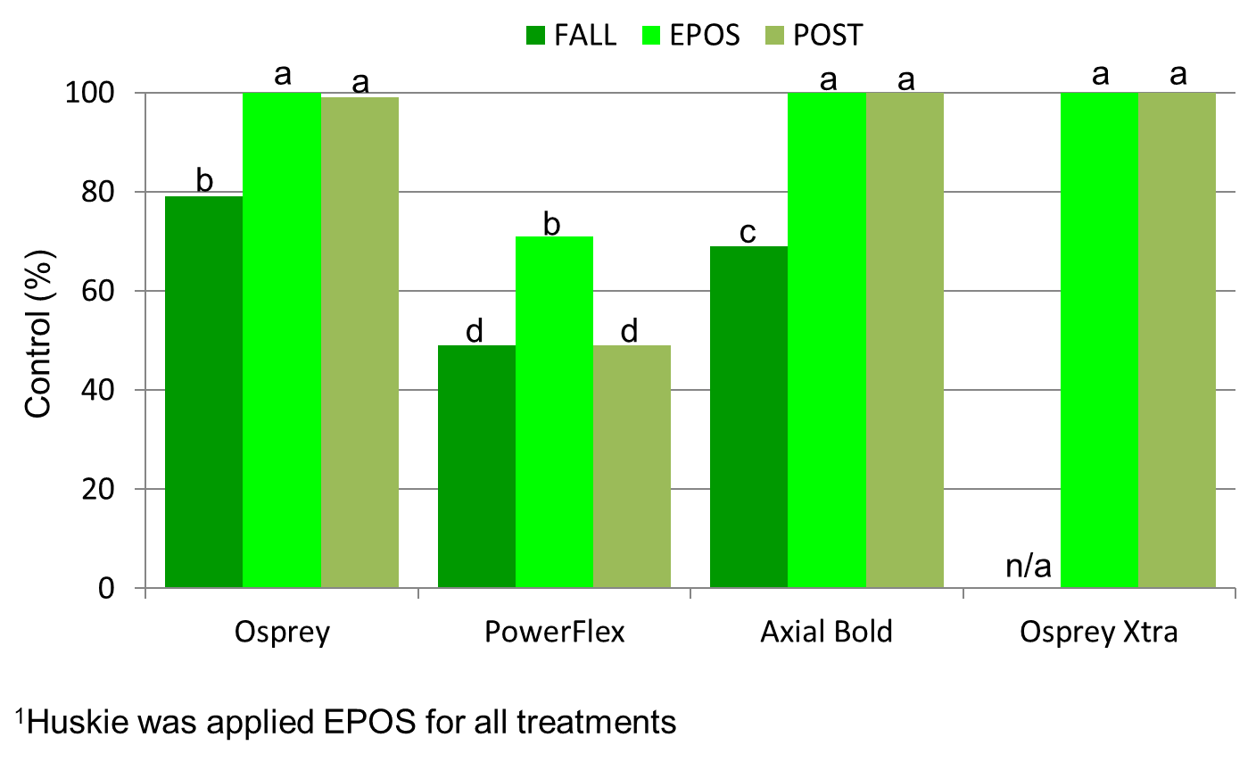roughstalk bluegrass can reduce winter wheat yield by as much as 54%. In 2018, our untreated control yield was 45 bu/A, but with effective management options wheat yield was as much as 96 bu/A. In 2020, we observed a 33% reduction in wheat yields if roughstalk bluegrass was not adequately controlled. Additionally, one of the key components of this research was to make Michigan wheat growers aware and educate them about this weed problem and to take proactive steps in managing this weed. We have been able to present this research at the Michigan Wheat Programs Annual Meeting in 2019, the MWP Summer Field Tours 2018-2020 (including the virtual field day), and I have also had the opportunity to do a short video on this research for the Michigan Farm Bureau’s Farm News Five in 2019 (<https://www.michfb.com/MI/farm-news/Dairy-Margin-Coverage-Sign-up-and-Scouting-for-Roughstalk-Bluegrass/>).

Figure 2. Roughstalk bluegrass control in 2018, 2019, and 2020 from early POST applications, 14 DAT.

Figure 3. Roughstalk bluegrass control at wheat harvest from fall, early POST and late POST applications in 2020.

**SUMMARY OF PROJECT:**

Michigan wheat growers should be on the lookout for roughstalk bluegrass in winter wheat. Roughstalk bluegrass can have a detrimental effect on wheat yields if not effectively controlled. If not adequately managed we have found anywhere from 33-54% reductions in wheat yields due to roughstalk bluegrass competition. Application timing and herbicide selection for roughstalk bluegrass control is critical. Currently, the addition of Osprey or Osprey Xtra to a herbicide program when roughstalk bluegrass is less than 3-inches tall has been one of the most effective strategies for roughstalk bluegrass control. Axial Bold has also been effective and allows for the use of frost-seeded clover. These herbicides can also be tank-mixed with broadleaf herbicides (i.e., Huskie) for an overall weed control program. This research has been used to develop weed control recommendations that are important to Michigan winter wheat growers. Results from this research will be added to the 2020 MSU Weed Control Guide for Field Crops (E-434), continue to be presented at extension meetings, and posted on [www.MSUweeds.com](http://www.MSUweeds.com).

**FUTURE WORK:**

We are currently finalizing a roughstalk bluegrass identification and management factsheet that will be included in the 2020 MSU Weed Control Guide for Field Crops.

**PROJECT CHANGES:**

None requested.

**BUDGET NARRATIVE:**

On track.

**INTELLECTUAL PROPERTY:**

None developed.

**APPROACH TO DISSEMINATE RESEARCH:**

This research has been used to develop recommendations on the most effective roughstalk bluegrass management strategies in wheat. This information has been and will continue to be shared with Michigan wheat growers and will be included in the Michigan Weed Control Guide for Field Crops (E0434). Research data and resulting recommendations have been presented at extension meetings, MWP summer field days, in newsletter articles, and will be included in a factsheet on roughstalk bluegrass identification and management, and on the web at [www.msuweeds.com](http://www.msuweeds.com). Additionally, we have also presented this research at the National Weed Science Annual Meeting and will ultimately write a peer-reviewed manuscript for Weed Technology to communicate with the Weed Science discipline.