Michigan Wheat Program Final Report

Title: Weed control and crop tolerance in early- and late-planted winter wheat from fall herbicide applications
MWP Project #: 22-08-05-BS
MSU PD#: 71616
Researcher: Christy Sprague, Professor and Extension Specialist
Plant, Soil and Microbial Sciences, Michigan State University,
517/353-0224, sprague1@msu.edu
Kaddi Gewirtz, M.S. Graduate Student, gewirtz3@msu.edu
Date: September 10, 2024

Project goals and value for Michigan Wheat Growers: Controlling weeds in the fall may help with overall wheat establishment and growth, leading to vigorous wheat stands that may outcompete spring emerging weeds, preventing the need for a spring herbicide application. However, little is known about the benefits of fall herbicide applications on early versus later planted wheat and what effect cold temperatures may have on fall herbicide applications. This research will be used to develop recommendations on fall versus spring herbicide applications on early- versus late-planted winter wheat. These recommendations will help ensure successful weed control, while maximizing wheat yields. This project fits with the Michigan Wheat Program’s priorities to:
- develop management strategies to mitigate losses due to pests.
- evaluate the efficacy of fungicides, herbicides, and insecticides.
- evaluate the interaction of pesticides, varieties, and agronomic practices.

RESULTS OF PROJECT – Year 2:
Winter wheat planting in Michigan commences in mid-September after the Hessian fly free date and may continue over the following 4 to 6 weeks. Delays in harvest and rainy fall weather can push an ideal planting date of mid- to late-September into late-October or further. This range in planting dates could have an impact on how to best manage weeds. This window can affect both weed and winter wheat growth and where fall herbicide applications may best fit. As planting dates are pushed to later October, there are questions regarding the benefits of fall herbicide applications. The increased interest in fall POST herbicide applications stems from trying to improve control of winter annual broadleaf weeds and hard to control winter annual grasses. Also, with earlier planted wheat growers have asked: Will fall herbicide applications eliminate the need for a spring herbicide application? Fall herbicide applications may also become more important, as we have struggled over the past several years in finding the ideal time to apply wheat herbicides in the spring, due to colder weather. Therefore, the objectives of this research were two-fold: 1) evaluate weed control and crop tolerance from fall-applied herbicides for early- and late-planted wheat, and 2) determine if later fall herbicide applications, under cooler conditions, influence wheat tolerance to commonly used herbicides.

TRIAL INFORMATION:
This year was the second season of this experiment where we examined the effects of fall herbicide applications on crop tolerance and weed control in early and late planted wheat. Winter wheat was planted in mid- to late-September and in late-October (+4 weeks). Fall herbicide applications were made at two different times for the early planted wheat when winter wheat had 2- to 3-leaves (Feekes 1.2 to 1.3) and then approximately two weeks later (considerably more winter annual weed growth). Only one application was made to the later planted wheat, which usually occurred the first week of December. Herbicides examined included (Table 1): Huskie, Talinor, Affinity BroadSpec, and Quelex for broadleaf weed control and Osprey and PowerFlex for winter annual grass control. Tank-mixtures of Huskie + Osprey and Huskie + PowerFlex were also examined. These treatments were compared with spring applications of Huskie, PerfectMatch (premixture of PowerFlex + Stinger + Starane Ultra), and Huskie + PowerFlex.

Table 1. Fall herbicide treatments applied to early- and late-planted wheat at application 1 and 2.
 | Herbicide treatment | SOA¹ Group # | Rate | Additives
1 | Huskie | 6 + 27 | 15 fl oz/A | NIS + AMS
2 | Talinor | 6 + 27 | 18.2 fl oz/A | CoAct+ + COC
3 | Affinity BroadSpec | 2 + 2 | 1 oz/A | NIS + AMS
4 | Quelex | 2 + 4 | 0.75 oz/A | COC
5 | Osprey | 2 | 4.75 oz/A | NIS + AMS
6 | PowerFlex HL | 2 | 2 oz/A | NIS + AMS
7 | Huskie + Osprey | 6 + 27 + 2 | 15 fl oz + 2 oz/A | NIS + AMS
8 | Huskie + PowerFlex | 6 + 27 + 2 | 15 fl oz + 4.75 oz/A | NIS + AMS
9 | Untreated
¹ Herbicide site of action group number.

At the MSU Plant Pathology farm, a ‘Warf’ soft red winter wheat was planted on Sept. 20 (early planting) and Oct. 24 (late planting) in 2023, at 1.6 million seeds/A in 7.5-inch row spacing with a John Deere 1560 Drill. Fall herbicide applications (Table 1) were made to the early planted wheat on Oct. 24 (Feekes 2) FPOS1 and on November 14 (Feekes 3) FPOS2. Fall herbicide applications to the later planted wheat occurred on Dec. 8 (Feekes 2) FPOS3. Spring herbicide applications were made on April 15, 2024 to both planting dates. At this time the early planted wheat was 8-10 inches tall and the later planted wheat was 5-6 inches tall (Feekes 4-5).
At the Saginaw Valley Research and Extension Center (SVREC), ‘AM Mackinaw’ soft white winter wheat was planted on October 14 and November 2, 2023, at 1.6 million seeds/A. Fall herbicide applications (Table 1) were made to the early planted wheat on November 3 (Feekes 1-2) and November 16 (Feekes 2). Fall herbicide applications to the later planted wheat occurred on December 8 (Feekes 1-2). Spring herbicide applications were made on April 22 to both planting dates. At this time the early planted wheat was 8-10 inches tall and the later planted wheat was 5-7 inches tall (Feekes 4-5).

CROP TOLERANCE:
Fall herbicide applications to both the early and late planted wheat at SVREC did not cause injury to winter wheat. However, fall herbicide treatments that contained Osprey or PowerFlex caused ~10% wheat injury (stunting and yellowing) 14 d after the FPOS1 application at E. Lansing (Figure 1). By spring Greenup, wheat injury from these applications were not apparent. These same herbicide applications resulted in injury to the later planted wheat from FPOS3 that was present in the spring, however what recovered from this injury by late-April (Figure 2). Wheat injury was low from all other herbicide treatments.

CANOPY DEVELOPEMENT:
Greater development of a crop canopy can help with weed suppression and many times can improve crop yield. The development of the winter wheat crop canopy was measured throughout the season for various treatments. While herbicide treatment had very little effect on canopy closure, the time of winter wheat planting did affect canopy development. There was over an 8 d difference between the early and later planted wheat in the time to reach 80% canopy closure at East Lansing. Due to wheat growth and canopy closure very few summers annual weeds emerged (Figure 3).

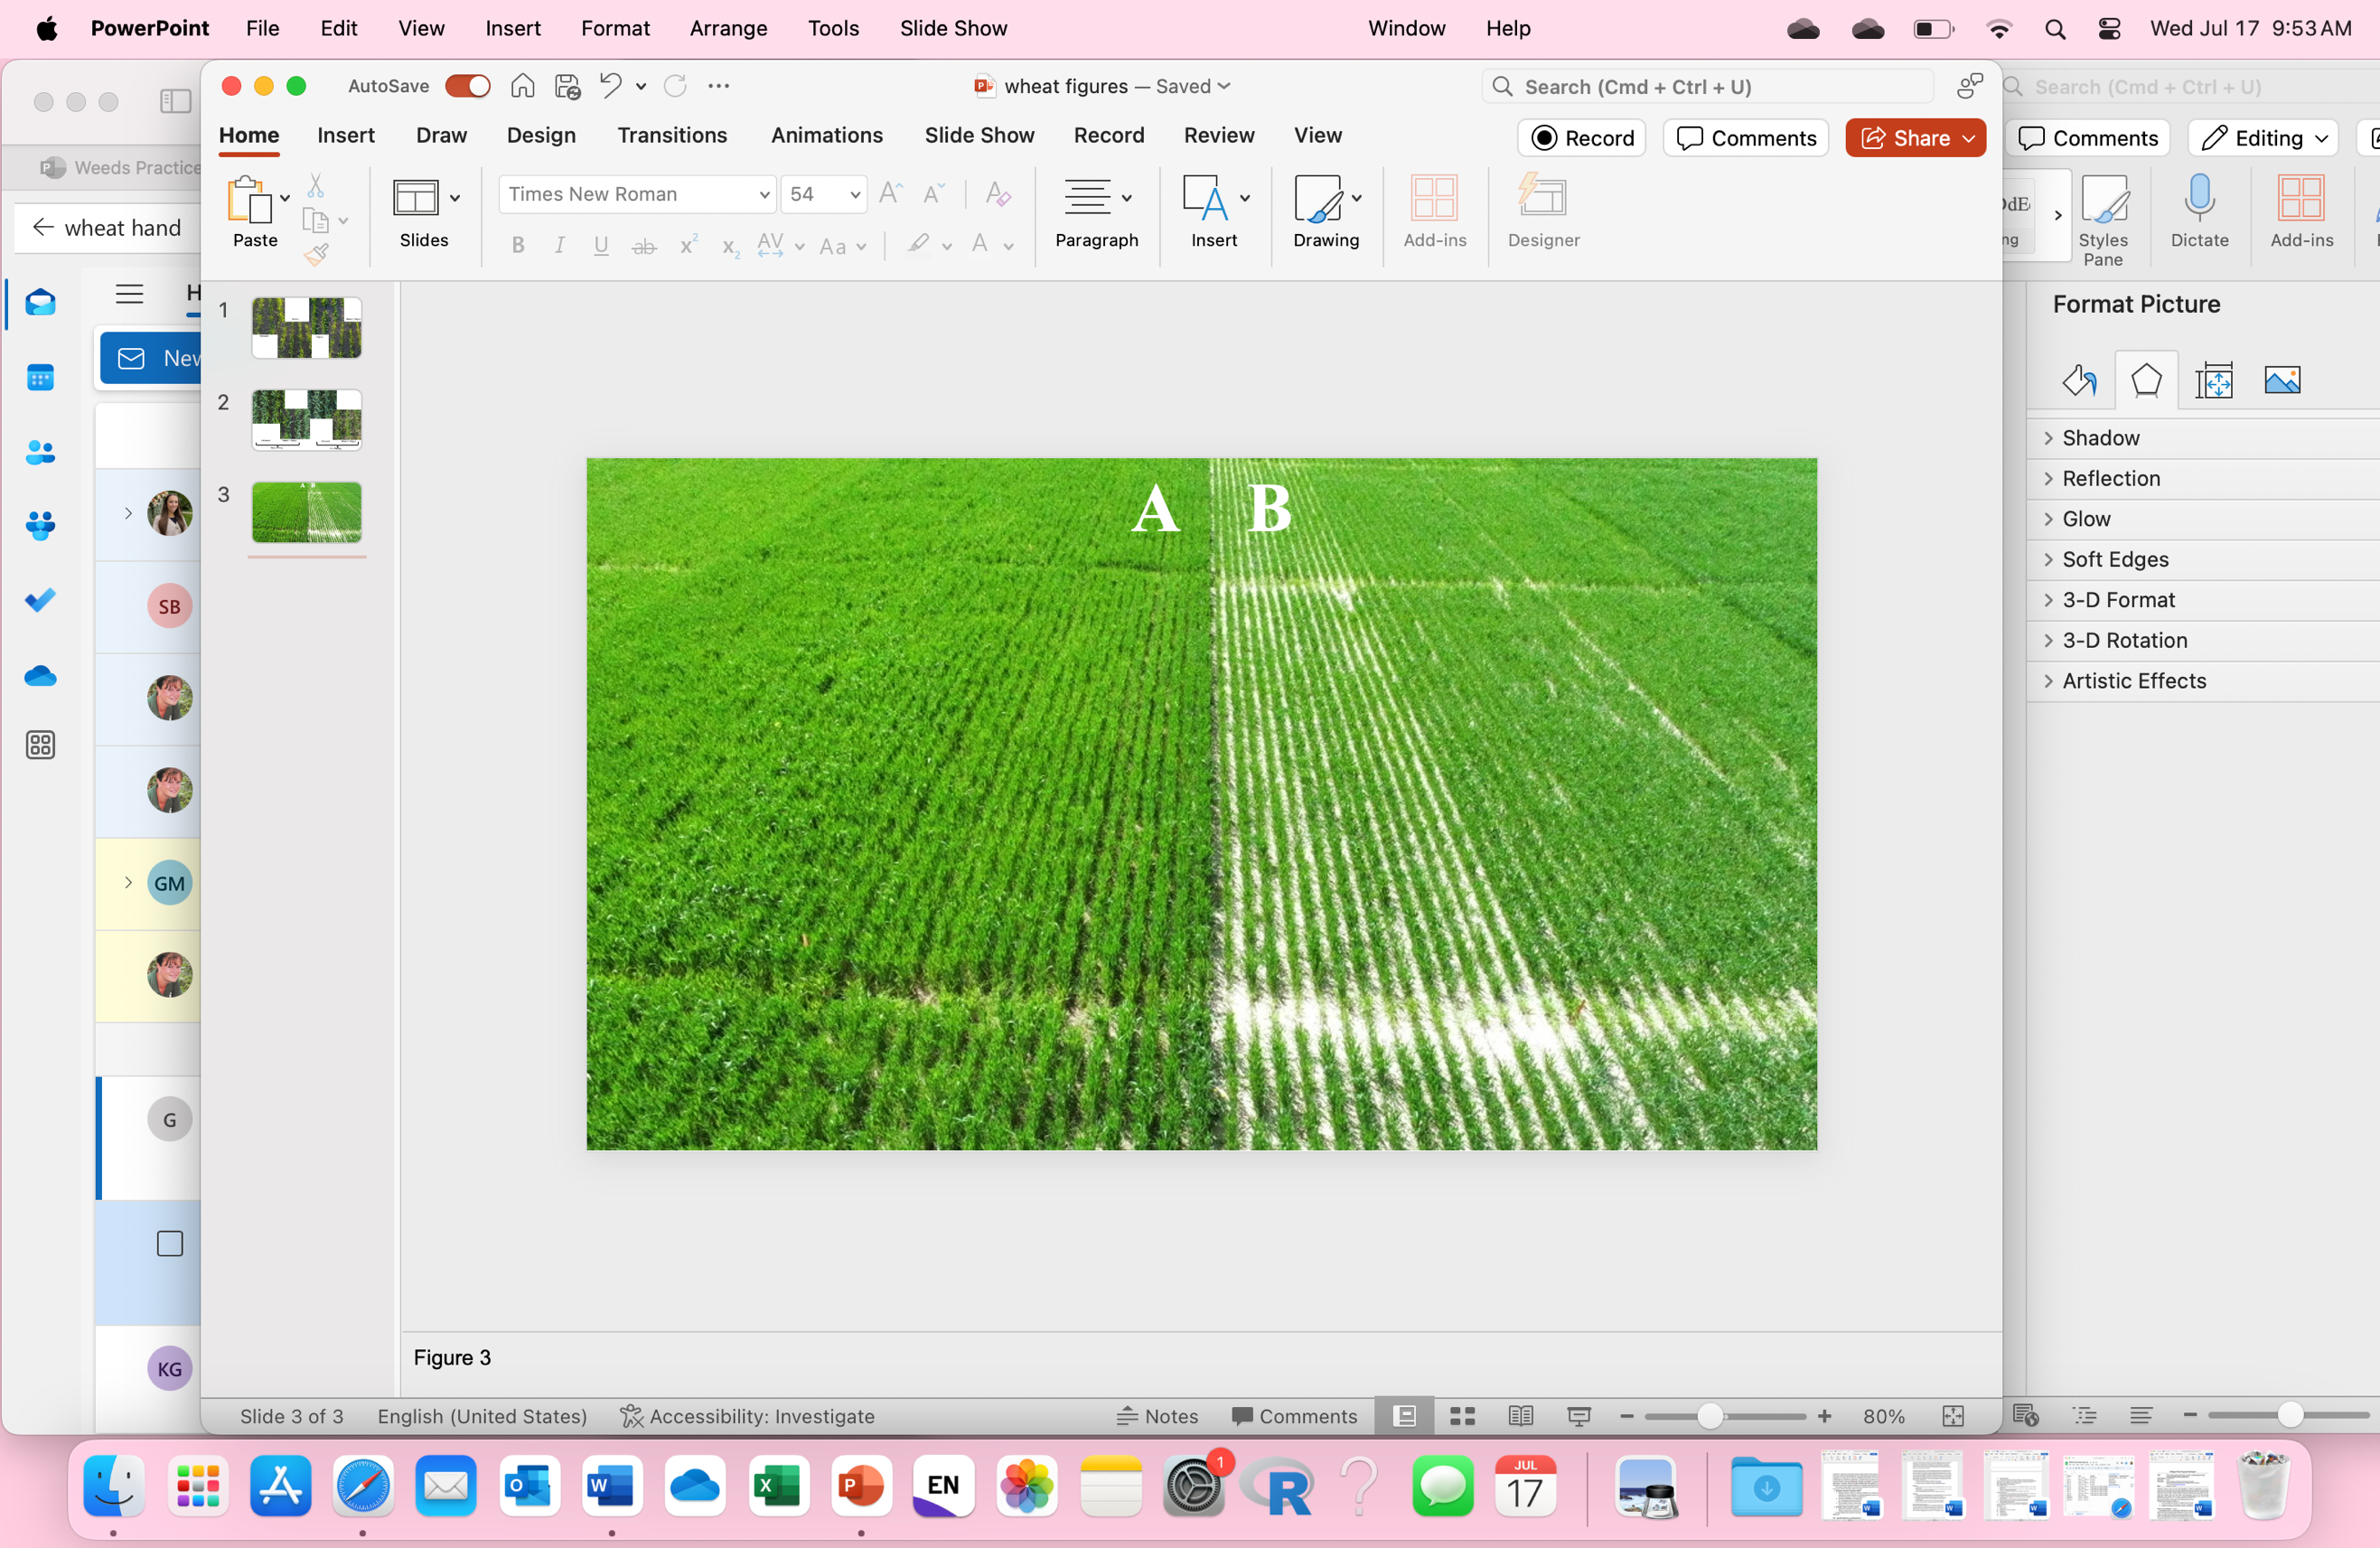
Figure 3. MSU. Canopy Closure May 2, 2024. (A) Early planted ~ 66% (B) Late planted ~ 52%

WEED CONTROL:
Weed biomass was harvested mid-season as a measurement of weed control from the different herbicide programs. At SVREC, weed numbers were low, so weed control and biomass were not evaluated. At campus, weed biomass was 1.2-times higher in the first planting date compared with the later planting date. Additionally, the main effect of application timing did not affect weed biomass. However, the combination of Osprey with Huskie reduced weed biomass 2.75 times more than Huskie alone.

WHEAT YIELD:
This year the effect of planting date on wheat yield was only significant at SVREC. Early planted wheat outyielded late-planted wheat by 5%, regardless of application timing. There were no difference in wheat yields at MSU-24, regardless of planting date or application timing. This was likely due to the occurrence of stripe-rust that appeared in early May, likely negating any advantage to early planting even with a fungicide application. Herbicide selection did not affect yield at either location.

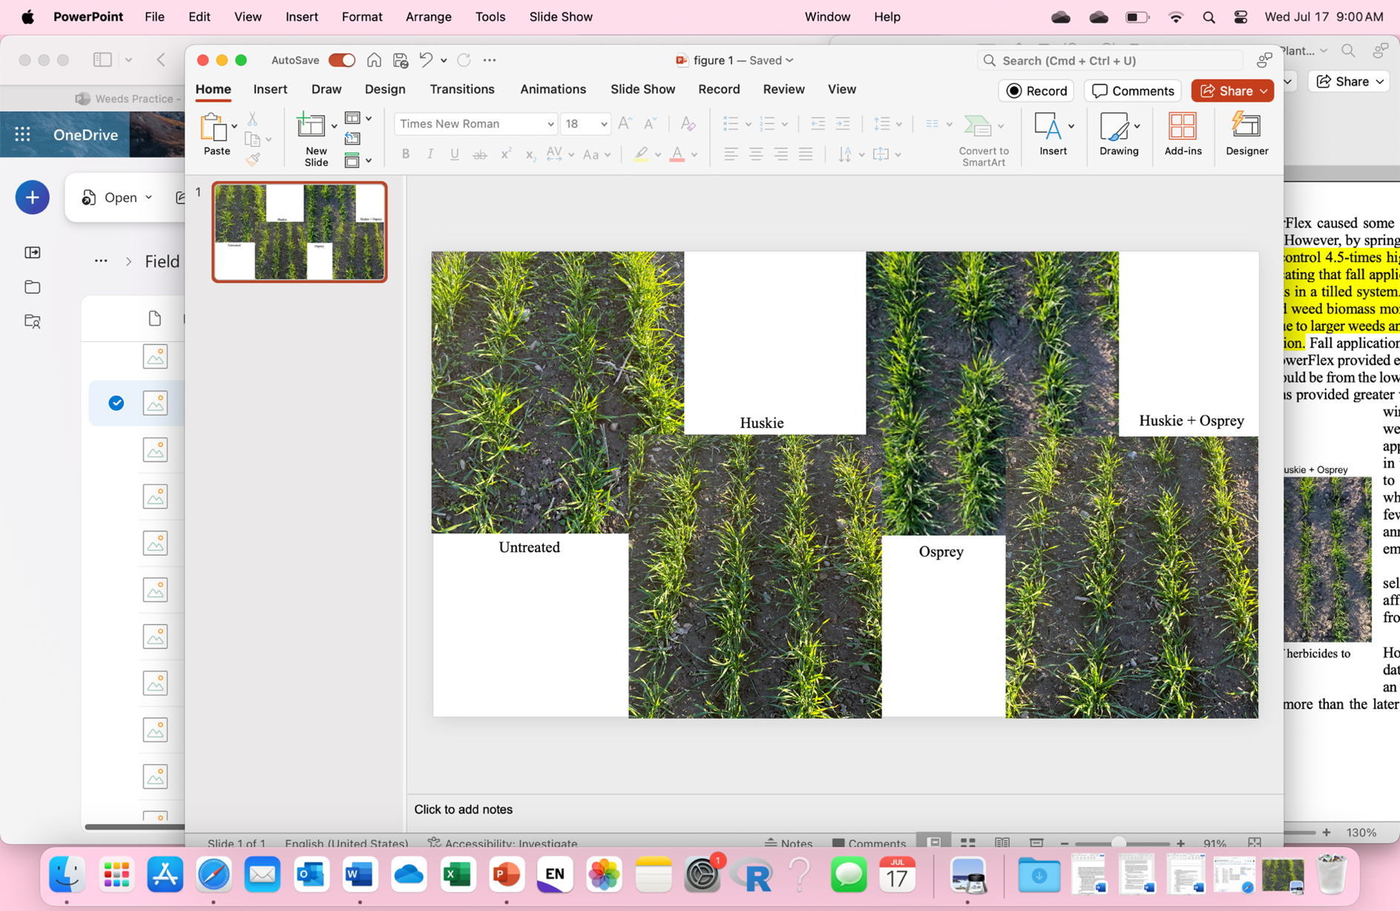

Figure 1. Wheat injury and weed control from the Oct. 24 fall application of herbicides to early planted wheat,
14 DAT.

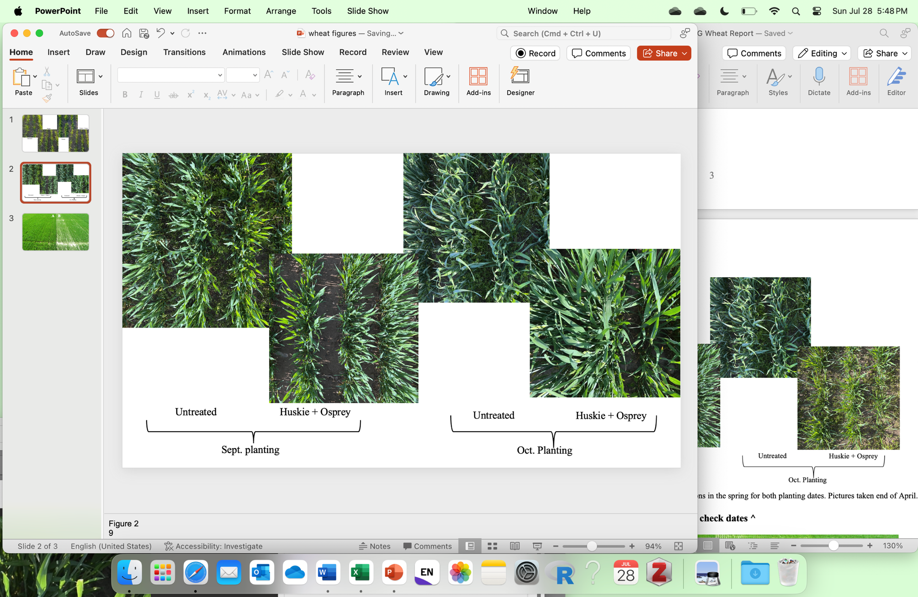

Figure 2. Winter wheat outgrew injury from fall applications in the spring for both planting dates.
Pictures taken end of April.

SUMMARY OF PROJECT – YEAR 2:
There has been an increased interest regarding fall herbicide applications for weed control in winter wheat. Controlling weeds in the fall may be beneficial in overall wheat establishment leading vigorous wheat stands that may outcompete the spring emerging weeds, preventing the need for a spring herbicide application. More information is needed regarding the benefits of fall applications on early versus later planted wheat. This year, this research was conducted at two locations East Lansing, and at the Saginaw Valley Research and Extension Center (SVREC). Fall herbicide applications of various products were made to early and late planted wheat and also some of these treatments were applied in the spring as a comparison. This year, fall herbicide treatments that contained Osprey or PowerFlex caused some injury to wheat (yellowing and stunting), 14 days after application at East Lansing. However, by later spring this injury was not apparent. Overall, all other treatments had very little herbicide injury to wheat. Both spring herbicide applications provided good control of winter annual weeds, which is in contrast to out 2023 research where fall herbicide applications provided greater weed control of winter annual weeds than applications made in the spring. Due to the excellent wheat growth very few summer annual weeds emerged at both locations. Fall herbicide applications, particularly for early planted wheat, may be the best option to control weeds as spring weather often impacts the time of herbicide application. Additionally, early wheat planting will likely provide the greatest benefit planting of wheat likely will provide the greatest benefit for early canopy closure to help suppress summer annuals and maximize winter wheat yield. Overall, herbicide selection did not affect wheat yield from fall herbicide applications. Planting data had more of an effect on wheat yield. We are continuing with this research to develop recommendations that will help ensure successful weed management while maximizing wheat yield. The results from this research will be included in MSU Weed Control Guide for Field Crops (E-434), presented at extension meetings, presented MWP summer field day, in newsletter articles (i.e., Wheat Wisdom), and posted on www.MSUweeds.com.

FUTURE WORK:
We are planning on conducting this research in 2024/2025 field season at two locations – SVREC and the MSU Agronomy farm.

PROJECT CHANGES:
None requested.

BUDGET NARRATIVE:
On track.

INTELLECTUAL PROPERTY:
None developed.

APPROACH TO DISSEMINATE RESEARCH:
This research will be used to examine what effect fall applications have on weed control and crop tolerance of early and late planted winter wheat. This research will be used to develop recommendations on fall herbicide applications. This information will be shared with Michigan wheat farmers and will be included in the Michigan Weed Control Guide for Field Crops (E0434). Research data and resulting recommendations will be presented at extension meetings, MWP summer field day, in newsletter articles (i.e., Wheat Wisdom), and included in a factsheet on fall- herbicide applications in winter wheat, and on the web at www.msuweeds.com.

