*Stripe rust susceptibility of Michigan wheat varieties*

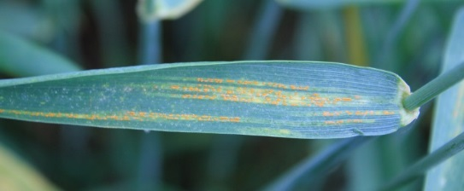

Wheat varieties grown in Michigan exhibit a wide range of susceptibility to stripe rust. Because of the severe outbreak of the disease during the 2016 season, members of MSU’s wheat breeding team were able to capture the level of resistance varieties were exhibiting at the Ingham and Tuscola sites of the MSU Performance trials

Below are the ratings for the soft white (Table 1) and soft red (Table 2) winter wheat varieties. The varieties were scored based on infection type (0 to 9 scale) and on the infection percent (the relative amount of disease on the flag leaves) to express the way varieties’ resistance is expressed. Based on these scores, each variety was given a relative score ranging from resistant (R) to susceptible (S). The experiences during 2016 suggests which varieties and their associated rust rating may benefit from the use of fungicides where stripe rust is found to be prevalent:

**Resistant (R)** varieties will likely lose little or no yield due to stripe rust.

**Moderately Resistant (MR)** varieties are at moderate risk to yield losses and, in some cases, may benefit from the use of a fungicide. This is especially true for varieties having infection percent levels (second column) above 10 percent.

**Moderately Susceptible (MS)** varieties will likely benefit from a fungicide application where the disease is found.

**Susceptible (S)** varieties will very likely benefit from the use of a fungicide where outbreaks occur.

Martin Nagelkirk,

MSU Extension [*nagelkir@msu.edu*](mailto:nagelkir@msu.edu)

*MSU is an affirmative action/equal opportunity employer. Michigan State University Extension programs and materials are open to all without regard to race, color, national origin, gender, gender identity, religion, age, height, weight, disability, political beliefs, sexual orientation, marital status, family status, or veteran status.*