Final Report: Improving wheat disease management through seed treatment, head scab and foliar fungicide evaluation

MWP No.: 21-08-02-AS
MSU No.: PD53395
Project Period: August 31, 2021 to December 31, 2022

Team leader: Martin Chilvers Cell: 517-898-3049 Email: chilvers@msu.edu
Project members: Janette Jacobs, Dr. Austin McCoy, William Widdicombe, Micalah Blohm
Collaborators: Kurt Steinke – wheat fertility x fungicide management

Project goals and value for Michigan Wheat Growers:

Disease management in wheat is a critical component of crop production from both a yield and quality perspective. In a previous project, the lab examined species composition and fungicide sensitivity of Fusarium species causing head scab. Thankfully, there appears to be no significant fungicide resistance in the Fusarium graminearum to the DMI fungicide products that have been used for a number of years, nor the recently released SDHI fungicide (pydiflumetofen), which is a component of Miravis Ace. Contrary to this, isolates of Zymoseptoria tritici (Septoria blotch) sent to international colleagues do appear to be resistant to some fungicide chemistries. We also completed a meta-analysis, which determined that there was on average a 4 bu/A advantage to a fungicide application in early spring, and a 6-7 bu/A advantage for either a flag leaf or flowering fungicide application. A combination of fungicide applications results in a 10-11 bu/A advantage over not treating. In this project, we will continue to examine aspects of wheat disease management, which will focus on seed treatments in collaboration with UW-Madison and Dennis Pennington. Foliar disease and head scab fungicide timing and product evaluations will also be conducted to create fungicide efficacy charts. We will work with Dr. Kurt Steinke to examine the role of inputs in high management of wheat under irrigation, including multiple fungicide applications. We will also work with growers, agribusiness and the diagnostic clinic to address disease issues as they arise during the season. For example, there appears to be a recent increase in the incidence of smut/bunt, which has resulted in the rejection of grain at the elevator.

Results of Project:

Wheat seed treatment
In collaboration with UW-Madison we initiated a wheat seed treatment trial in 2020/2021 season and repeated that in 2021/2022. The seed treatment trials were planted by Dennis Pennington at the wheat performance trial locations in 2020/2021 of Mason, Huron, Lenawee and SVREC, and in 2021/2022 of Mason, Huron, Montcalm, and SVREC. The seed treatments consisted of a non-treated control and four seed treatments on two varieties as listed in table 1. In the spring Canapeo measurements were taken and plants collected to conduct isolates to determine what potential root rot organisms were present. A number of fungi and oomycete species were recovered, and we are currently identifying them in the lab and determining their pathogenicity and fungicide sensitivity. Our colleagues at UW-Madison are assembling the multistate data for this study.

Table 1: Wheat seed treatment entry list.
Treatments | Seed treatment |  | Variety
1 | Control | N/A | Harpoon
2 | Raxil Pro Shield | Imidacloprid (insecticide), metalaxyl (oomycide), tebuconazole (fungicide), prothioconazole (fungicide) | Harpoon
3 | Cruiser Maxx Vibrance cereals | Thiamethoxam (insecticide), sedaxane (fungicide), difenoconazole (fungicide), mefenoxam (oomycide) | Harpoon
4 | Rancona | Ipconazole (fungicide) | Harpoon
5 | Stamina F4 Cereals | Fluxapyroxad (fungicide), pyraclostrobin (fungicide), triticonazole (fungicide), metalaxyl (oomycide) | Harpoon
6 | Control | N/A | Kaskaksia
7 | Raxil Pro Shield | Imidacloprid (insecticide), metalaxyl (oomycide), tebuconazole (fungicide), prothioconazole (fungicide) | Kaskaksia
8 | Cruiser Maxx Vibrance cereals | Thiamethoxam (insecticide), sedaxane (fungicide), difenoconazole (fungicide), mefenoxam (oomycide) | Kaskaksia
9 | Rancona | Ipconazole (fungicide) | Kaskaksia
10 | Stamina F4 Cereals | Fluxapyroxad (fungicide), pyraclostrobin (fungicide), triticonazole (fungicide), metalaxyl (oomycide) | Kaskaksia

The seed treatment trial is very timely given the increased issues with stinking smut/bunt that has occurred in Michigan over the last few seasons. Although multiple fungicide products are often used to treat wheat seed, from the limited literature it appears as though difenoconazole is one of the more effective products at reducing smut/bunt issues. An important element is also to identify the specific species that are causing issues. We are currently collaborating with Dr. Jan Byrne in the Diagnostic lab and Dr. Kelsey Anderson-Onofre of Kansas State to identify the causal agents in Michigan.

Fungicide efficacy
Both foliar fungicide efficacy and head scab fungicide efficacy trials were conducted. Including private trials for companies to examine products prior to release to market, and trials to examine product claims. Two winter wheat varieties are used to demonstrate the importance of variety selection for disease management. ‘Ambassador’ is used as a foliar disease and head scab susceptible variety, while ‘Wharf’ was used as a foliar and head scab resistant variety. We had low levels of both foliar and head scab disease in 2022. However, differences between treatments were still detected (Figure 1 and Figure 2).

Figure 1: Data from foliar MSU foliar fungicide trial, examining performance of fungicides on leaf diseases.

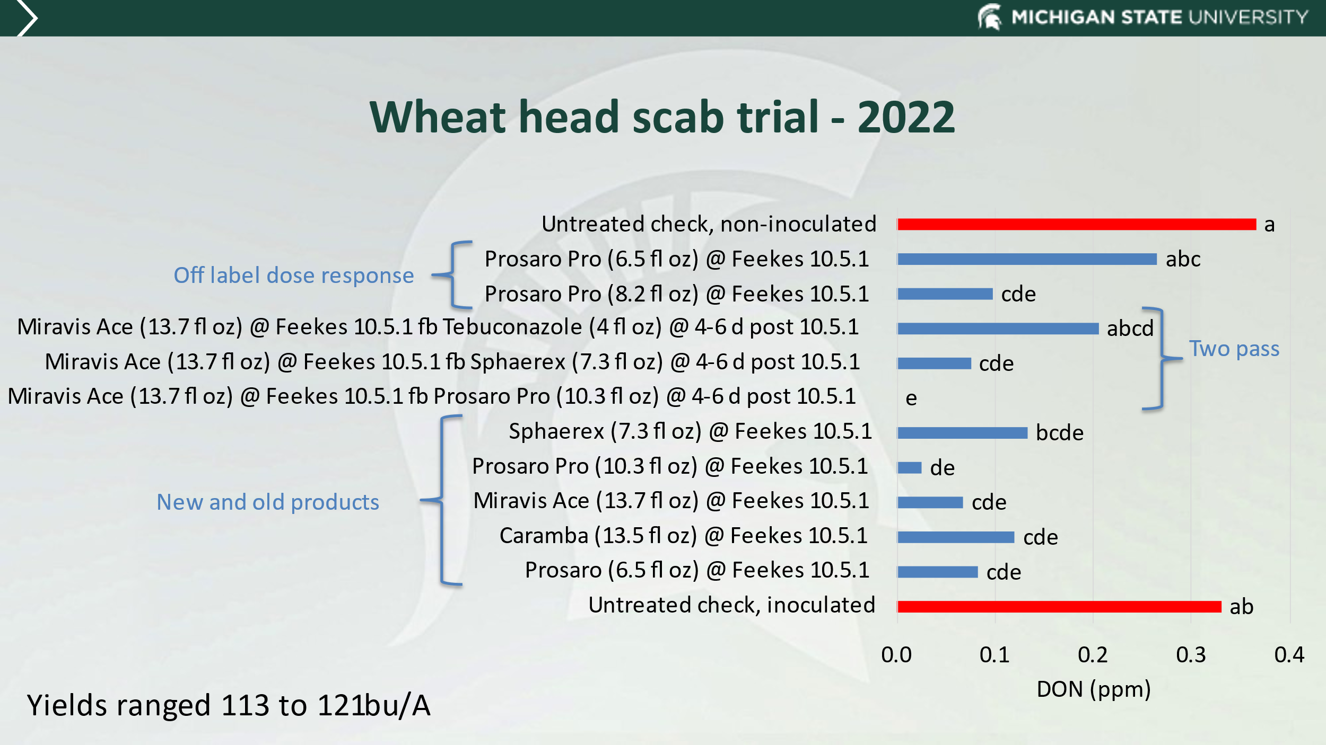
Figure 2: Results of MSU head scab fungicide trial, examining effect of rates, double applications and newer products for head scab management.

Data from foliar and head scab fungicide trials were used to update our multistate wheat fungicide efficacy chart:
https://cropprotectionnetwork.org/resources/publications/fungicide-efficacy-for-control-of-wheat-diseases

High management wheat and multiple fungicide applications
Over the last couple of years, Dr. Kurt Steinke and I have been working together on management of wheat to improve productivity and profitability. In a study conducted by Dr. Mikaela Breunig using data from Dr. Steinke, Martin Nagelkirk and my own program, we were able to look at 1,954 yield data points from trials to determine the average yield response to fungicide timing. Interestingly, the early season T1 timing on average resulted in a 4 bu/A advantage over not treating, while an application at flag leaf or flowering resulted in approximately 7 bu/A advantage. In combination, a T1 and T3 resulted in a 10.5 bu/A advantage (Table 2).

Table 2: Meta-analysis of yield response to fungicide. T1 (Fks 5-7), T2 (Fks 8-9), T3 (Fks 10.5.1)
Timing | Yield response bu/ac (${\overline{D}}_{t})$ |  | Among-study variance${\hat{σ}}^{2}$
T1 | 4.01 | A | 8.65
T2 | 6.93 | B | 37.16
T3 | 7.41 | B | 40.79
T3_L | 6.65 | B | 31.72
T1_T3 | 10.53 | C | 60.76
T2_T3 | 9.48 | CB | 64.14

To build upon this work Dr. Steinke and I have been examining the role of multiple fungicide applications together with fertility programs to maximize profitability. In 2022 we had issues with our newly installed linear irrigation system. But were able to implement some irrigation treatments.

Fungicide resistance monitoring
Mikaela Breunig for her PhD did a fantastic job at assessing which Fusarium species are responsible for head scab or wheat and ear mold of corn. Mikaela, also assessed these species for fungicide sensitivity to the commonly used DMI fungicides for head scab management, and the recent SDHI (pydiflumetofen) which is a component of Miravis Ace. Thankfully those Fusarium isolates screened all appeared sensitivity to the fungicides tested, with no practical resistance found. There was some variation in fungicide sensitivity, so there is potential for selection for resistance and this should be monitored. However, some isolates of Zymoseptoria tritici (Septoria blotch) sent to international colleagues do appear to be resistant to some fungicide chemistries. We may not have the capacity to immediately follow up on this work, however we do plan to begin collecting isolates and collaborating with colleagues to begin assessing this risk.
In 2022, we were successful in obtaining USWBSI funds to conduct a national screen of Fusarium species associated with head scab and their fungicide sensitivity. This project will help build upon previous MWP sponsored activities, which will benefit wheat farmers.

One Paragraph Summary of Project: One paragraph that details what was learned and its benefit to Michigan wheat growers. This paragraph should contain no business sensitive or confidential information and will be used to publicly describe research through our communications including our website, annual report and press releases.

The project enabled us to identify wheat pathogens in Michigan, and assess them for their fungicide sensitivity. We also conducted fungicide efficacy trials, and economic analysis of fungicide application timings. This information is critical to Michigan wheat producers as we strive to maximize quality, yield but also economics and sustainability of production.

Recommendations from Project: One to three paragraphs that detail what you would recommend based on this research. If you were in the field talking with a Michigan wheat grower, what would you tell them to do based on this research. Please include economic work about the economics of this project, as it is possible to increase yield and become too costly to make the bottom line work for the grower. This paragraph(s) should contain no business sensitive or confidential information and will be used to publicly describe research through our communications including our website, annual report and press releases. This information will also be used to update grower publications and to provide recommendations.

Use of IPM principles is critical to managing diseases and maintaining efficacy of disease management tools such as foliar fungicides. Foliar fungicide at Fks5-7 did yield on average a 4 bu/A advantage compared to no fungicide. However, it is of note that our colleagues in Ontario tend to only see a 1.5 bu/A advantage from a similar timing. If only one fungicide application is to be made, often the best timing is at flowering, where there is some suppression of head scab, but also foliar disease. However, there are situations where an earlier foliar fungicide is necessary to manage aggressive diseases such as stripe rust, which was problematic in 2016 and 2017.

Future work: Up to 1 page of discussion of next steps. If project is experiencing delays, please describe cause of delay and approach to achieve project goals. If you are requesting funding from MWP for next steps please state an approximate amount and briefly what would be achieved with additional funding.

Future work will include continued pathogenicity and fungicide sensitivity of fungal and oomycete species recovered from diseased wheat seedlings. Efforts will continue in monitoring for fungicide sensitivity, fungicide efficacy trials for head scab and foliar disease management, to continue refining recommendations based on changing product availability. A systematic viral disease survey should be conducted. However, this will require support from the board.

Project Changes: Please list any changes that impacted the project (e.g. publications, I.P., change of personnel, additional funding). [Note this reporting is in addition to any reporting and timing thereof as required through the Master Agreement.]
None

Budget narrative: Please describe any overage or shortfall for spending to date. If project is on target for spending projections, please state “On target.”
None

Intellectual property: Please describe any intellectual property that was developed during project. Explain approach and timing to secure intellectual property. [Note this reporting does not supersede any reporting and timing as required by the Master Agreement.]
None.

Approach to Disseminate Research: Please briefly describe strategy to disseminate research to interested parties including growers and the scientific community.
I routinely present at MSUE and ag industry meetings and field days. We also develop MSU and multistate extension publications. I also have an active Twitter account that I use to highlight critical disease management advice at timely points throughout the growing season. In addition, we do publish our research in peer reviewed publications, which is a critical element of developing rigorous research and recommendations.

Please Indicate which Month is appropriate and that you are able to provide an article with photos, graphs, charts other graphics for publication in the Michigan Wheat e-newsletter and for release through wheat and other media channels. What is your timeline and source for getting information to growers.
May – article on use of head scab management
June – article on wheat disease status, and screening for viral diseases
July – article on diseases as appropriate for the year, i.e. follow up on head scab or sooty mold etc as problems arise

